Presiding/Electoral Officer Manual

For Voting in Person Elections

June 2023

Published by the Department of Local Government, Sport and Cultural Industries.

**Department of Local Government, Sport and Cultural Industries**

Gordon Stephenson House

140 William Street

Telephone: (08) 6551 8700

Facsimile: (08) 6552 1555

Freecall: 1800 620 511 (Country Only)

Email: [info@dlgsc.wa.gov.au](mailto:info@dlgsc.wa.gov.au)

Web: [www.dlgsc.wa.gov.au](http://www.dlgsc.wa.gov.au)

Translating and Interpreting Service (TIS) - Tel: 13 14 50

ISBN 0-7309 2039 9

June 2023

**Copyright**

Copyright is reserved to the Department of Local Government, Sport and Cultural Industries, Perth, Western Australia. All or part of this document may be copied if required for personal use and not for financial gain. Due recognition of the source would be appreciated. Example documents do not need to include an acknowledgement.

**Disclaimer**

Although every care has been taken in the production of these documents, neither the Crown in the right of the State of Western Australia nor any servant or agent of the Crown accepts responsibility for any loss or damage suffered at any time by any person as a result of any error, omission or inaccuracy in the publication whether or not the error, omission or inaccuracy has resulted from negligence or any other cause.

Contents

1. Introduction 7

Welcome 7

Using this manual 7

Who the users are expected to be 7

How the manual is structured 7

2. Staffing the polling place 8

Presiding officers and electoral officers 8

Declarations to be made 8

3. Furniture and equipment 9

Presiding officer’s package 9

Heavy equipment 10

Checking equipment 11

Occurrence sheet 11

4. Setting up the polling place 12

Arrival time 12

First tasks 12

Direction signs 12

The 6 metre exclusion zone 12

Presiding officer’s discretion to change distance 13

Arranging equipment 13

Voting Screens 13

Electoral officers’ table and chairs 13

Ballot box 14

Stationery 14

Rubbish bins 14

Personal items 14

Display of profiles 14

Counting unused ballot papers 15

Sealing the ballot box 16

Lost or damaged seals 16

Opening for business 16

5. Setting up the polling place 17

Preparing electoral rolls 17

Votes processed before election day 17

Procedure - Marking early voters 17

Ruling names off the roll 17

6. Scrutineers and others 18

Appointment of scrutineers 18

Scrutineers appointment list 18

Scrutineers not authorised 19

Behaviour of scrutineers 20

Identification badges for scrutineers 20

Prohibition on candidates acting as scrutineers 20

Campaign helpers 21

7. Issuing ballot papers 22

Establishing a right to vote before issuing a ballot paper 22

Procedure - Establishing right to vote 22

Flowchart - Issuing a ballot paper 23

Number of votes per elector 24

Instructions to electors 24

Control of ballot papers 24

Procedure for casting a vote 24

Spoilt ballot papers 24

Procedure - Spoilt ballot papers 24

Elector names crossed off in error 25

Procedure - Correcting ruled off name 25

8. Names not on roll 26

Checking procedure 26

Procedure - Checking for names on the roll 26

9. Electors incorrectly recorded as casting a vote before election day 27

Errors in recording 27

10. Provisional votes 28

Reason a provisional vote application can be made 28

Omission from roll 28

Claim that vote not cast as recorded 28

About Form 16 29

Issuing a provisional ballot paper 29

Rejecting a claim 30

Flowchart - Issuing a provisional vote 31

11. Assistance to certain electors 32

Arrangements for people with impairment 32

Requests for assistance 32

Those people eligible to assist 32

Those people who must not assist 32

Procedures for providing assistance 32

Procedure - Providing assistance to vote 32

Procedure - Providing assistance outside the polling place 33

Flowchart - Assisting certain electors 34

12. Postal voting papers 35

Procedure for issuing replacement ballot papers 35

Procedure - Replacement ballot paper 35

Receiving unused postal voting papers 36

Receiving completed postal voting papers 36

13. Keeping voting screens clear 37

Removing how to vote cards 37

14. Close of poll 38

The precise closing time 38

Securing the ballot box 38

Packing up material 38

Presiding officer’s responsibility 38

Leaving the polling place 38

Deliveries to the count area 39

Attachment 40

1. Powers and duties of electoral officers 40

Presiding officers 40

Electoral officers 40

Power to keep order 40

2. Summary of eligibility to be enrolled to vote 40

Residents’ eligibility 40

Non-resident owner’s and occupier’s eligibility 41

Rateable property: ownership and occupation 41

Enrolment Claim 42

Expiry of enrolments 42

Accuracy of enrolments 42

Decision that eligibility to enrol has ended 42

# Introduction

## Welcome

The position of presiding officer or electoral officer is of paramount importance to the smooth running of an election. The way the duties of these functions are carried out will be under scrutiny on election day. There are likely to be scrutineers at the polling place who will be watching to see that the requirements of the *Local Government Act 1995* and the *Local Government (Elections) Regulations 1997* are met. In addition, every member of the community that comes in to vote will form an impression about the conduct of the election from actions of the electoral officers.

Presiding and electoral officers must act lawfully, professionally, impartially and with fairness, honesty and integrity and follow correct procedures. At the same time, officers are expected to behave with good public relations in mind and to project a friendly and welcoming atmosphere at the polling place.

While the responsibilities are great, it is hoped that all officers enjoy the day and welcome the opportunity to meet members of the community.

## Using this manual

This manual is a reference document. It is designed so that officers can go to any topic and start reading. Each section covers a specific aspect of the work of a presiding officer or electoral officer. It is broken down into easy to read subsections.

Copies of the types of forms and documents to be used are shown. Procedures are described clearly in plain English and sometimes a flowchart is provided to show the process step by step.

## Who the users are expected to be

In preparing this manual it is intended that it will be used by presiding officers and electoral officers that have been appointed to process votes at polling places for a voting in person election.

In addition to any briefing session that may have been attended with the returning officer, this manual is a guide and ready reference. However, it is essential that presiding and electoral officers also become familiar with the requirements contained in the *Local Government Act 1995* (Act) and the *Local Government (Elections) Regulations 1997* (Regulations) as they relate to their duties.

## How the manual is structured

Each section is devoted to a specific aspect of the duties of presiding and electoral officers. For example, the section on setting up the polling place covers everything from positioning furniture and equipment to getting the electoral roll ready to receive votes.

# Staffing the polling place

## Presiding officers and electoral officers

Each polling place must have a minimum of two staff – a presiding officer and an electoral officer. This is because one person may have to attend to a particular issue or assist an elector while the other electoral officer maintains security of the ballot box and ballot papers and continues processing other votes. Additional electoral officers can be appointed for busy polling places.

The presiding officer is the senior electoral officer at the polling place and electoral officers must obey the instructions of the presiding officer. The Act prescribes some specific powers and duties of the presiding officer and these are discussed later in this manual.

**s. 4.63(1) of the Act**

## Declarations to be made

Before acting, presiding officers and electoral officers must complete the “Declaration by Electoral Officer” (prescribed **Form 1** of the *Local Government (Elections) Regulations 1997*). This is absolutely essential and presiding officers must check that all electoral officers and any temporary electoral officers that may be assigned to the polling place have completed the declaration before allowing them to mark any voting papers or participate in the conduct of the election (for instance, issuing ballot papers).

**regulation. 7**

# Furniture and equipment

## Presiding officer’s package

The presiding officer will need a package containing:

Ballot box(es)

Copies of candidate profiles

Electoral rolls for current year

Electoral rolls for preceding year

Seals for ballot box (to be recorded and signed for)

Padlocks and keys for ballot boxes (if keyed type)

Keys to gain entrance to polling place

Issue of ballot papers (to be signed for)

Supply of blue and red pens

Supply of rulers

Stapler

Packet of drawing pins (for profiles and notices)

Supply of pencils suitable for use in voting screens

Pencil sharpener

Supply of rubber finger stalls

Scissors

Felt pens

Roll of adhesive tape

Roll of packing or binding tape

2 plastic garbage bags for bins

1 plastic garbage bag for return of materials

Paper polling place signs

Paper polling place entrance sign

Paper ballot box signs

Notepad or blank paper sheets

Envelope for cancelled ballot papers

Supply of large envelopes for storage of electoral material

Presiding/electoral officer manual (see <https://www.dlgsc.wa.gov.au/local-government/local-governments/council-elections> )

Copy of Guide for Scrutineers (see <https://www.dlgsc.wa.gov.au/local-government/local-governments/council-elections> )

List of scrutineers appointed before the election to act

Copy of lists of electors who voted via absent, early or postal voting

Map showing ward boundaries (if needed)

Supplies of prescribed Form 1 – Declaration by electoral officer

Supplies of prescribed Form 18 – Appointment and declaration by scrutineers

Supplies of prescribed Form 16 – Provisional voter’s declaration

Supplies of provisional voting envelopes

Supplies of ballot paper envelopes

Supplies of prescribed Form 15 – Application for replacement postal voting papers

Supplies of “Occurrence Sheet” (example below)

Supplies of WA Electoral Commission’s “Correction to electoral roll” forms if available

Supplies of tally sheets to tick off number of ballot papers issued

Chalk for marking out 6 metre zone (optional)

List of useful phone contacts

Forms mentioned above can be found in the Regulations at <https://www.legislation.wa.gov.au/>

## Heavy equipment

The polling place should be equipped with the following:

2 voting screens

A trestle sized table for electoral staff

A table for the ballot box

Sufficient chairs for electoral staff (minimum of 2)

A screen or notice board for profiles

Sufficient direction signs for outside the polling place

A clean rubbish bin for inside the venue

A clean rubbish bin for outside the venue

Chair for each scrutineer (optional)

## Checking equipment

It is a good idea to check that all the necessary equipment to operate the polling place is there. If materials are missing contact the deputy returning or designated officer who will make arrangements to deliver what is necessary.

Should all the equipment and materials not be available, the polling place must still be opened at 8.00am sharp.

## Occurrence sheet

One of the most important sheets in the presiding officer’s package is the “occurrence sheet”. This is the place to record activities that occur at the polling place during the day. If the election result is contested, entries on the occurrence sheet will provide a diary of events at the polling place and this may be very important. It may be necessary for other electoral officers to mark an entry if a matter was not observed by the presiding officer. This manual stipulates a number of instances where entries should be made on the occurrence sheet.

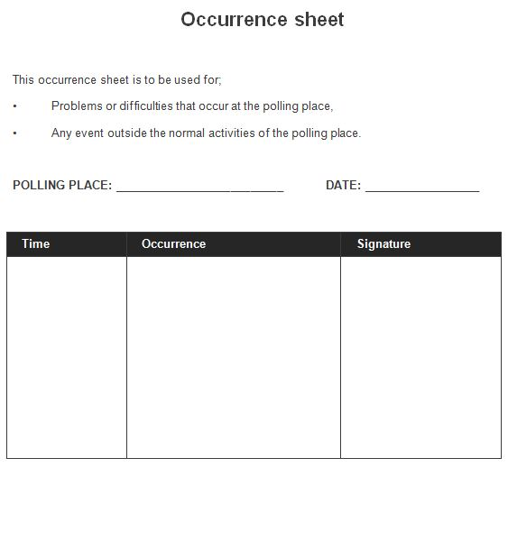

# Setting up the polling place

## Arrival time

It is recommended that electoral staff arrive no later than 7.30am on the election day as this time will be needed to set up the polling place before electors arrive at 8.00am.

## First tasks

Ensure entrance gates are unlocked where appropriate. Deactivate security alarms if appropriate and unlock an external door to the polling place. If there is more than one entrance to the room being used, only unlock one door unless it is expected to be very busy and you have sufficient electoral staff to be on duty at an exit door.

Check the following:

• location of fire exits

• location of toilets

• location of power supply

• location of telephone if a mobile phone is not supplied.

## Direction signs

Put out the direction signs so that it is obvious from the street that the polling place is there. Several signs may be needed if there is more than one street frontage. If the polling place is a school, more signs may be needed for people who are not familiar with the layout of the buildings. Decisions about the number of signs will have been made before the election and there should be sufficient signs to meet needs. If there are any problems, contact the deputy returning officer or returning officer.

## The 6 metre exclusion zone

It is an offence (penalty $2,000) for people to canvass for votes, pass out “how to vote cards”, or interfere with an elector’s right to make a free choice in a polling place or within 6 metres of the entrance to a polling place. Presiding officers must enforce this.

The measurement of 6 metres is taken from the entrance of the polling place specified in the election notice. The entrance to the polling place can be taken to be a doorway that gives entrance to the polling place from the outside.

If there is any doubt about the location of the 6 metres the presiding officer should state categorically what is the entrance to the polling place and take the measurement from there. In difficult locations such as shopping centres it is recommended that a sign be set up declaring a particular point as the entrance. An understanding should be reached with campaign helpers on exactly where the line is drawn or some physical mark should be made with chalk.

**s. 4.89**

The 6 metres is not a single point – it is measured as a 6 metre radius of the doorway.

Presiding officers should inform candidates and campaign helpers that people cannot be in a polling place or within 6 metres from the entrance to a polling place:

• canvass for votes;

• solicit the vote of an elector;

• induce an elector not to vote for a particular candidate; or

• induce an elector not to vote at the election.

### Presiding officer’s discretion to change distance

Where it is appropriate the presiding officer may give approval for campaign helpers to be within 6 metres of the entrance to the polling place. This might be done where physical problems such as roadways make it impossible to otherwise comply. Any alteration must be applied to all in a fair and consistent manner.

## Arranging equipment

Organise the equipment for the polling place as soon as possible. In positioning furniture and equipment pay particular attention to:

• ensuring access by voters;

• expected number of voters; and

• avoiding congestion.

### Voting Screens

Set up the voting screens so that:

• each elector’s right to secrecy is protected;

• electoral officers can see all the voting screens;

• each elector can conveniently place his or her completed ballot paper in the ballot box before leaving; and

• the screens do not obstruct the view electoral officers have of the ballot box.

### Electoral officers’ table and chairs

Position the electoral officers’ table and chairs so that they:

• command a view of the whole of the polling place;

• are conveniently located for electors to present themselves;

• do not restrict electoral officers in accessing all areas of the polling place;

• leave floor space so that scrutineers can stand or sit at a reasonable distance to view proceedings;

• do not obstruct doorways.

### Ballot box

Put the ballot box so that it is:

• in full view of electoral officers at all times;

• at a comfortable height on a table;

• positioned so that each elector can conveniently place his or her completed ballot paper in the ballot box;

• does not obstruct entry into any of the voting screens;

• is not close to an outside doorway.

### Stationery

Arrange stationery so that it is convenient for electoral officers. Maintain security of official forms.

Ensure voting screens are equipped with sharp pencils or pens attached by string.

### Rubbish bins

The rubbish bins are for people to place how to vote cards. There should be a bin, preferably a paper recycling bin, inside the doorway of the polling place and one outside to avoid littering.

### Personal items

Personal belongings of electoral officers should be stowed securely.

### Display of profiles

Profiles are to be pinned up in the sequence of names on the ballot papers. This can be left to right or top to bottom. Position profiles so that electors can conveniently see them before they enter the voting screens. Consider whether they can be seen by a number of voters at one time. The polling place may have been provided with a mobile pin up board if the venue does not have suitable pin up boards or other display area.

Make sure that the profiles can be seen by the electoral officers to ensure that they are not removed or defaced during the day.

Effective from the 2023 election, candidates now also have the option of submitting an additional profile consisting of 2,000 characters (including spaces) to the returning officer. This may be displayed alongside the official candidate profiles as space permits.

## Counting unused ballot papers

Count the ballot papers that have been issued and record the number of ballot papers issued at the start on the presiding officer ballot papers return.

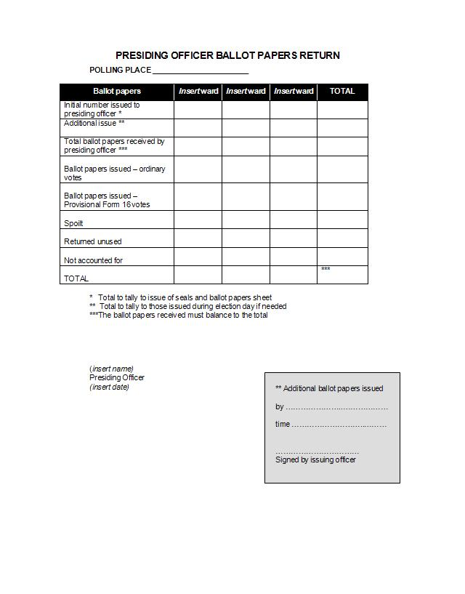

It is possible that the number of ballot papers entered on the presiding officer’s ballot paper return will not be exactly the same amount that has been entered onto the issue of seals and ballot papers sheet held by the ballot box manager (or deputy returning officer).

This is because a package of ballot papers may not contain exactly the number marked on the band or enclosure, as the printing and collation process may not be accurate. For this reason the ballot papers must be counted before any are issued to electors.

## Sealing the ballot box

Immediately before 8.00am and before any votes are taken, show the empty ballot box to any scrutineers and other electoral staff. The presiding officer should seal the ballot box by placing an electoral seal so that it seals the inner lid. If possible, also padlock the inner lid.

Ask the witnesses to the sealing of the box to complete and sign the witness form.

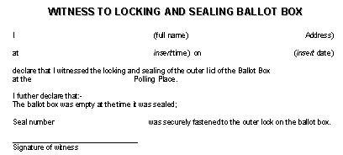

## Lost or damaged seals

If seals become damaged, lost or misplaced the presiding officer must still seal the ballot box. Create a temporary seal by using a length of tape placed through the clasp or fixing of the inner lid. Tie this and then seal the ends to the sides of the ballot box in such a way that they would require any person opening the box to break the seal. This procedure can be done using sealing wax if supplied or as a minimum, use adhesive tape liberally. The presiding officer should then sign their name across the tape and the box so that it would show that the signature had been disturbed if someone opened the box. Record these actions on the occurrence sheet.

Obtain a further supply of the correct seals as soon as possible. Without breaking the temporary seal, add the correct seal to the ballot box for additional security.

## Opening for business

It is imperative that the polling place is ready to receive votes at 8.00am. If ready before this time do not process any votes until 8.00am.

**reg. 61**

# Setting up the polling place

## Preparing electoral rolls

As it is necessary to retain rolls actually used in an election for a period of four years, it is important to identify which have been used at the election. Spare rolls can then be kept for general use.

Before using an electoral roll:

• write the name of the polling place on it

• write the word ‘used’ on every roll that is actually used.

## Votes processed before election day

Before any ballot papers are issued electoral officers should mark the electoral roll that is going to be used in the polling place to show which electors have already cast an early or absent vote and those that have received postal voting papers (election packages).

### Procedure - Marking early voters

To mark early voters on the electoral roll:

• take a red pen

• using the photocopied lists included in the presiding officer’s package mark in the margin opposite the elector’s name some initials indicating the type of vote that has already been processed:

Early vote cast – E.V.

Absent vote received – A.V.

Election package issued – E.P.I.

Election package issued and postal vote received – P.V.

This information is used when the electoral officer is required to be satisfied about the eligibility of a person to claim a vote.

## Ruling names off the roll

It is suggested that a red pen is used to make margin notes described above. However, use a blue pen for ruling off names and address of those electors that vote on election day.

It is recommended that a single electoral officer should complete the entire process of issuing a vote – that is cross off the name and address of the elector, authenticate the back of the ballot paper and hand the vote to the elector.

Do not authenticate ballot papers in advance of issuing them as experience shows that this causes problems.

# Scrutineers and others

## Appointment of scrutineers

A scrutineer observes the conduct of an election on behalf of a candidate. They should not be confused with “campaign helpers” who do not enter polling places or the count area. After an election is called and polling places are identified the candidate can appoint scrutineers to act at any of the polling places. Any number of scrutineers may be appointed but only one may be present in any one polling place at any one time. It is up to the presiding officer to ensure that this requirement is complied with.

**reg.69**

In particular, scrutineers tend to linger in the polling place when they are handing over to another scrutineer. Be fair and consistent in handling the situation. The best course of action is to be firm but polite in requesting scrutineers to immediately leave the polling place if another scrutineer for the same candidate enters.

## Scrutineers appointment list

The presiding officer’s package should contain a list of scrutineers that have been appointed by candidates to attend the polling place. This list will show that the returning officer is aware of the appointment and the scrutineers have completed a declaration.

When a scrutineer arrives, check the list to make sure they are duly authorised. Scrutineers should be carrying a copy of their appointment and if there are any doubts about the person’s status ask to see the copy of their appointment. It must be produced by the scrutineer for inspection.

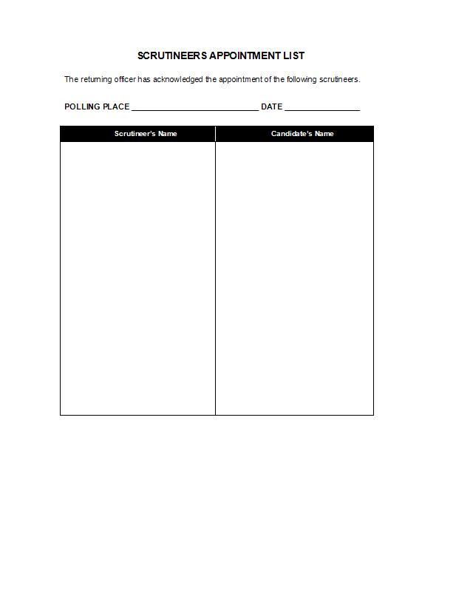

There is no time restriction on when scrutineer appointments must be given to the returning officer. Therefore, some may happen on election day. This means that the appointment may be authorised but the returning officer will not have time to add them to the pre-prepared list. This is an obvious case where the presiding officer must ask to see the copy of the appointment.

## Scrutineers not authorised

If a scrutineer attends the polling place and his or her name is not on the pre-prepared list and they do not have a duplicate copy of their appointment give them both the original and copy of prescribed Form 18 from the presiding officer package and ask them to have the candidate complete and sign it.

The completed form can be returned to the presiding officer at the polling place. When the presiding officer receives the form they must witness the declaration by the scrutineer on the prescribed Form 18 if a relevant person has not already witnessed it. The presiding officer then signs the acknowledgement of appointment and retains the original of the copies. A record of this action should be entered onto the occurrence sheet.

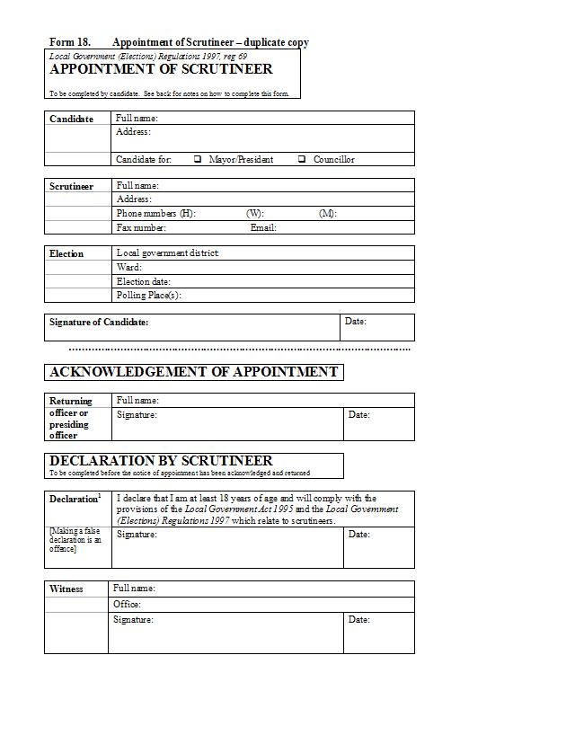

## Behaviour of scrutineers

Scrutineers are more likely to behave in a correct manner if the presiding officer assists them to feel comfortable in their role.

When a scrutineer arrives, greet them pleasantly and show them a suitable place to stand or sit so that they can see what is going on. Their job is to observe proceedings and electoral officers have a duty to ensure that this is possible.

Scrutineers must obey all reasonable requests made by any electoral officer. Note the words “reasonable” and “requests”. Only the returning officer has the power to force scrutineers to comply with directions. However, if the scrutineer is disrupting or may disrupt the poll, the presiding officer may remove or exclude that person from the polling place.

Scrutineers must not take part in the election processes in any way. They must not ask electoral officers to repeat the names of electors or to tell them who has voted. If they do this the presiding officer should explain that this is an offence. Scrutineers must not write down the names of electors or any information given by an elector.

Scrutineers must not approach any elector, nor speak to them. Some scrutineers may greet people they know and if this happens the presiding officer must ask them to stop doing so.

Scrutineers must not hover in the doorway or obstruct the access way to the polling place. They must not canvass for votes in the polling place itself nor in the 6 metre exclusion zone.

If scrutineers cause problems the matter may be referred to the deputy returning officer or the returning officer.

**reg. 71 and reg. 72**

## Identification badges for scrutineers

Scrutineers must wear an identification badge showing they have been appointed as a scrutineer whilst they are acting in that capacity. Presiding officers should ensure that this is happening.

**reg. 70**

## Prohibition on candidates acting as scrutineers

Candidates must not act as scrutineers in polling places.

**reg. 69**

## Campaign helpers

Each candidate may have campaign helpers outside the polling place who will give out “how to vote” cards and generally try to win support for their candidate.

Campaign helpers are not scrutineers and do not have to be formally appointed by the candidate.

Campaign helpers and their campaign material – such as posters – must remain outside the 6 metre exclusion zone and presiding officers should check this periodically throughout the day.

The presiding officer’s attitude to campaign helpers should be professional, courteous and polite. This should be maintained all through the day until the close of the poll.

The attitude and treatment of campaign helpers by presiding officers must be consistent so that there can be no perception that any candidate has had preferential treatment.

# Issuing ballot papers

## Establishing a right to vote before issuing a ballot paper

A ballot paper must not be issued unless the electoral officer is satisfied the person has a right to vote.

### Procedure - Establishing right to vote

1. Ask electors to identify themselves by stating their name in full and their address.

2. Ask the elector if he or she has already voted at that election.

3. Look to see whether or not the name of the person with that address appears on the electoral roll and that there is no margin notation indicating voting before election day.

4. If the name cannot be found, follow the procedure in part 13.7 of this chapter. If there is a margin note indicating a vote may have already been processed follow the procedure in part 13.8. If satisfied they are entitled to a vote, follow the procedure shown in steps 6 to 9 of this list.

5. Rule through the name and address of the elector using a blue pen.

6. Take a ballot paper and initial the back in a consistent manner for each ballot paper (or such other authentication as approved by the returning officer). It is preferable not to pre-authenticate ballot papers in advance of their use.

7. Give the ballot paper to the elector.

8. Record the issue of the ballot paper on the tally sheet:

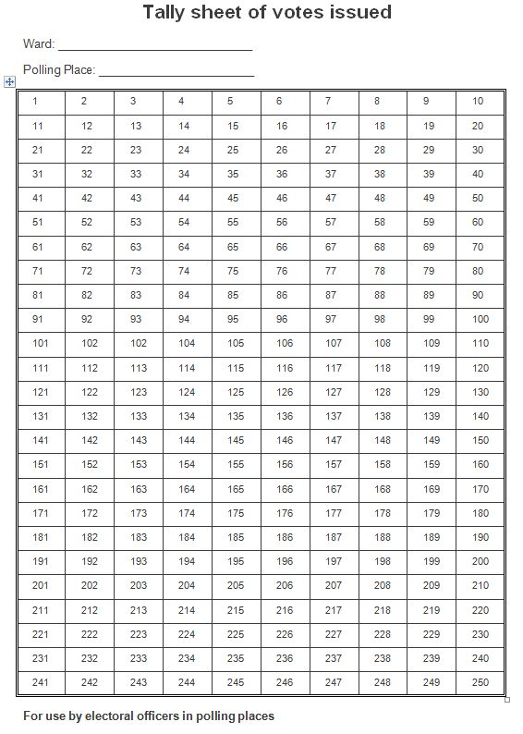

### Flowchart - Issuing a ballot paper

Ask electors to identify themselves by

stating their name in full and their address

Ask the elector if they have already voted

at that election and if in doubt about age

ask whether they are aged 18 years or over

name and address on the roll Name and address not

with no margin note indicating they on roll

may have previously voted

Follow procedures in

section 8

Rule through the name and address

of the elector using a **blue** pen

Take a ballot paper and

authenticate it

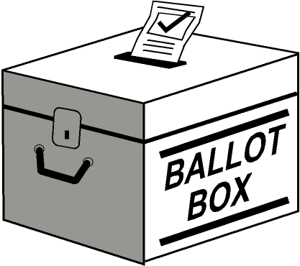

Give the ballot paper to the elector

who casts their vote

Record the issue of the ballot paper

on the tally sheet.

Margin notation indicating

voted before election day

follow procedures in section 9

## Number of votes per elector

Each elector is entitled to one vote only in each election in the district (or ward if wards are used). There are no exceptions to this. However, if the local government is operating with wards an elector may be eligible to vote in multiple wards as each ward is treated as a separate election.

## Instructions to electors

The electoral officer should point out to electors that the voting procedure is shown on the ballot paper. The count method used in this election is Optional Preferential Voting, which requires electors to select their first preference by indicating a number ‘1’ in the square alongside the candidate of their choice, they may indicate further consecutive numbers from number ‘2’ onwards in the squares opposite the names of remaining candidates in the order of their preference. Electoral officers should point out the voting screens and the position of the ballot box. Electors must go alone into the voting screen (unless the presiding officer authorises them to have assistance).

## Control of ballot papers

Electoral officers must ensure that no elector leaves the polling place with a ballot paper. If a ballot paper has been issued and the elector then declines to vote the electoral officer should take the blank ballot paper and place it in the ballot box.

## Procedure for casting a vote

When a ballot paper has been issued, the elector – without leaving the polling place – is to go alone into the voting screen to mark the ballot paper. They are then to place the marked ballot paper in the ballot box (unless the ballot paper is spoiled by mistake).

## Spoilt ballot papers

When an electoral officer is satisfied that a ballot paper is spoilt, either by mistake or mishap, a replacement can be issued.

### Procedure - Spoilt ballot papers

1. Take a new ballot paper and initial the back (or such other authentication as approved by the returning officer).

2. Give the new replacement ballot paper to the elector. Retain the spoilt paper – see ‘4’ below.

3. Ask the elector to proceed to vote and place the successfully completed ballot paper in the ballot box.

4. Endorse the word “spoilt” on the spoilt ballot paper.

5. Place the endorsed spoilt ballot paper in the envelope provided in the presiding officer package.

6. Record the vote in the space provided on the presiding officer’s ballot paper return (do not re-mark the tally sheet).

7. Give the envelope with the spoilt ballot papers to the ballot box manager (or returning officer) at the count to be retained as part of the record of the election.

## Elector names crossed off in error

If the electoral officer rules off a name in the electoral roll by mistake this can be corrected in the following manner:

### Procedure - Correcting ruled off name

1. Write the word “stet” in the margin next to the name ruled off in error.

2. Rule through the correct name and address of the elector.

3. Take a ballot paper and initial the back in a consistent manner for each ballot paper (or such other authentication as approved by the returning officer).

4. Give the ballot paper to the elector.

5. Record the issue of the ballot paper on the tally sheet.

The word “stet” means “let it stand” and is an accepted printers’ correction to ignore the alteration.

# Names not on roll

## Checking procedure

If the electoral officer does not immediately find the name of the elector it is prudent to go through a checking procedure before concluding that the name is not present.

### Procedure - Checking for names on the roll

1. If wards are used, check the correct roll is being searched.

2. Check the spelling of the name with the elector.

3. Check whether the given name has been transposed with the surname.

4. If pronunciation is difficult to understand ask the elector to write his or her name down.

5. If it is still not possible to locate the person’s name on the roll, check the roll for the previous election. If the name appears on that roll and they are still at the same address then follow the procedure outlined under provisional votes.

6. If their name is not on the current or previous roll, they may still be entitled to a vote. In these circumstances follow the procedures outlined for provisional votes.

Note: An additional check can be made to the Western Australian Electoral Commission by telephone. They will check their records to establish the status of the prospective elector.

If the person is not eligible to be given a vote, but wants to be enrolled, they can be given a prescribed Form 2 (Enrolment Eligibility Claim) or an enrolment update form from the Western Australian Electoral Commission (if available). If completed there and then, the Form 2 can be passed on to the local government to be processed for future elections.

# Electors incorrectly recorded as casting a vote before election day

## Errors in recording

If there is a margin note stating elector has voted before election day – point this out to them and explain that the returning officer provides pre-prepared lists and electoral officers have made the margin notes from these lists.

An elector may claim that it has been incorrectly recorded:

• that a postal vote envelope or declaration envelope relating to the election has been accepted from him or her; or

• that he or she has cast an early vote or voted in person already at the election.

Two situations could occur. The first is that the electoral officer discovers that an error has been made in the margin notes whilst transposing the information from the pre-prepared lists. This can be corrected by ruling through the margin note and initialling the change. The ballot paper can then be issued in the ordinary way.

The second situation is that the electoral officer can become satisfied that the claim made by the elector is justified even though it is not possible to verify it at the polling place – in this case a provisional vote is issued.

**Checking procedure – Errors in recording**

1. Check the list of early votes cast, and the list of election packages issued that includes postal vote certificates accepted, to see whether the margin note in the roll has been incorrectly recorded.

2. If satisfied that it has been incorrectly transcribed from either list, cross out the margin note and initial the change.

3. Issue a ballot paper in the ordinary way.

4. If the electoral officer is not satisfied that an error has occurred in transcribing the margin note but it is possible that an error could have occurred in the lists, follow the procedure for issue of a provisional ballot paper in part 10 of this manual.

# Provisional votes

## Reason a provisional vote application can be made

Electors may claim:

1. to be an elector whose name was omitted from the electoral roll in error; or

2. that it has incorrectly been recorded:

(a) that a postal vote envelope or declaration envelope relating to the election has been accepted from him or her; or

(b) that he or she has cast an early vote or voted in person at the election.

## Omission from roll

It is necessary for the elector to satisfy the electoral officer of their entitlement to a provisional vote.

**reg. 62**

1. Begin this process by asking some basic questions and consider the responses. For example ask:

• When did they last vote and what sort of election was this (State, Federal, local government)?

• Was his or her name on the electoral roll at that time or did they need to complete a form?

• How long has he or she lived at the current address (was it before the electoral roll closed for this election)?

• Does he or she have any documentation to prove they have been accepted for enrolment?

2. Check the previous electoral roll issued in the presiding officer’s package.

3. Check any documentation submitted by the elector.

4. If satisfied that the person’s name could have been omitted in error, follow the procedures to issue the provisional ballot paper.

## Claim that vote not cast as recorded

Explain to the person the system for recording the names and address of people that:

• have applied for postal voting papers and the method of recording when these are received back by the returning officer; or

• have presented themselves in person to cast an early vote.

If satisfied by their response that an error could have occurred in recording the name of the person on the list of election packages issued and postal votes received, or the list of early votes cast, follow the procedures to issue a provisional ballot paper.

**reg. 62**

## About Form 16

Form 16 is the prescribed form that must be used for provisional voting. It is a declaration completed by the elector stating the reason for the application. There is a section that must be completed by the electoral officer.

NB: Some local governments print the words from Form 16 onto an envelope and others print it onto a separate sheet. Put the ballot paper envelope containing the marked ballot paper into the envelope or attach the separate sheet to it in some way if it is not already attached (usually stapled).

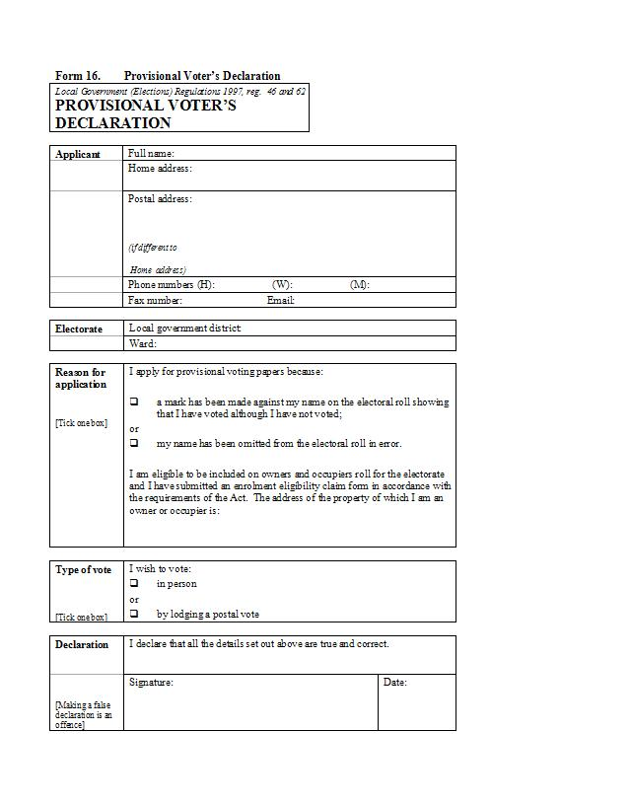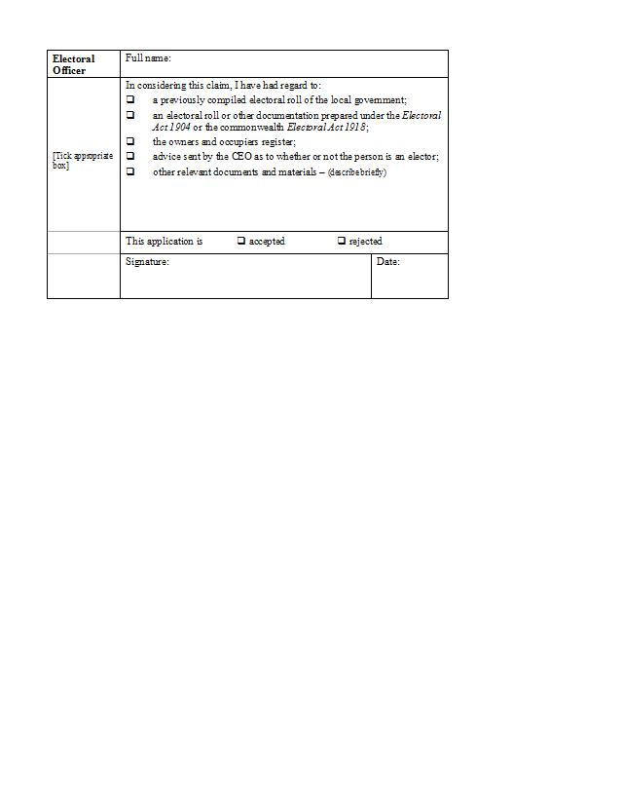

## Issuing a provisional ballot paper

If the electoral officer is of the view that the person may be eligible to vote because his or her name has been omitted in error, or that he or she has been recorded in error as casting an early vote or returning a postal vote, a provisional ballot paper should be issued.

1. Ask the elector to complete the prescribed Form 16.

2. Enter the full name of the electoral officer and tick the box on the form showing any documentation considered at the polling place.

3. Read the information on the form and, if satisfied the declaration on the form is true, take a ballot paper, initial the back (or add such other authentication as approved by the returning officer) and give the ballot paper and a ballot paper envelope to the elector.

4. The elector is to enter the voting screen to mark the ballot paper and put this into the ballot paper envelope.

5. Make a record of issuing the provisional ballot paper on the application (do not tick the acceptance box – this is done at the count).

6. Record the ballot paper in the space provided on the presiding officer’s ballot papers return (not the tally sheet).

7. When the elector has voted take the ballot paper envelope containing the marked ballot paper and put it in the envelope used for the prescribed Form 16 (if a separate printed Form 16 is used, staple this to the ballot paper envelope).

8. Put the ballot paper envelope with the declaration in the ballot box.

All declarations are further checked against records held at the local government before the vote is entered into the count. A declaration can be supported by any of the following:

(a) a previously compiled electoral roll of the local government, or an electoral roll or other document prepared under the *Electoral Act 1907*;

(b) a prescribed Form 3 (Notice of Acceptance of Enrolment Eligibility Claim) dated not less than 50 days prior to the election;

(c) any other documentation or material considered relevant.

## Rejecting a claim

If the electoral officer forms the view that the claim for a vote should be rejected, the elector must be advised of this decision and refused a vote. A record of the rejection must be made on the completed application (prescribed Form 16).

### Flowchart - Issuing a provisional vote

elector to complete prescribed form 16

Enter on the completed form 16

the full name of electoral officer

and tick material able to be considered at

the polling place

if satisfied the declaration on the form is true issue

an authenticated ballot paper

The elector enters voting screen to

mark the ballot paper and puts this into

the ballot paper envelope

Make a record of issuing the provisional

ballot paper on the application

but do ***not*** tick the acceptance box

Record that the provisional ballot paper

has been issued in the space on the

presiding officer’s ballot papers return

When the elector has voted

take the ballot paper envelope

containing the marked ballot paper

and put it in the envelope prescribed form 16

***or*** staple separate form 16 to

the ballot paper envelope

and place them in the ballot box



# Assistance to certain electors

## Arrangements for people with impairment

A voting screen may have been provided that is modified to suit the needs of people in wheelchairs or using motorised scooters (or similar). If so, make sure this is clearly identified.

## Requests for assistance

Any request for assistance must come from the elector or someone acting on the elector’s behalf and be made to the presiding officer. Assistance can be provided if the elector cannot vote without it because of impairment of sight or any other impairment or condition affecting the person’s ability to read or write. The impairment could include a language barrier.

## Those people eligible to assist

Assistance can be provided by:

• the presiding officer;

• an electoral officer specifically authorised by the presiding officer to do so; or

• another person nominated by the elector or someone acting on behalf of the elector.

## Those people who must not assist

A candidate, scrutineer or anyone authorised to act on behalf of a candidate must not assist an elector to cast a vote.

## Procedures for providing assistance

The procedures for providing assistance are set down in the regulations and must be followed specifically.

### Procedure - Providing assistance to vote

1. Clearly identify the person who is to provide the assistance – one person only.

2. Identify where the vote will be cast. This should be within the voting screen but if the elector is not capable of entering the voting screen the presiding officer can approve another place that is in close proximity to the voting screen or in close proximity to the polling place.

3. Make a note on the Occurrence Sheet of the elector’s name, and details of the assistance provided.

4. Issue a ballot paper in the ordinary way, making sure that the name is ruled off, then initial the back (or authenticate it as approved by the returning officer) and record it on the tally sheet.

5. Either the elector or the person assisting them places the marked ballot paper in the ballot box.

### Procedure - Providing assistance outside the polling place

If an elector is so incapacitated that he or she is not able to enter the polling place, the presiding officer can approve another place that is in close proximity but outside the polling place.

If this occurs the electoral roll and the ballot paper can be taken outside to the approved place so that the elector can vote.

The ballot box should not be taken outside. When the ballot paper has been marked, the person assisting the elector is to enter the polling place and put the ballot paper in the ballot box.

### Flowchart - Assisting certain electors

Presiding officer should take charge

Identify who is going to provide the assistance.

If it is an electoral officer the presiding officer

must appoint them to do so

Identify where the vote will be cast

Inside voting screen or in close proximity

to the voting screen or the polling place

Note actions on the occurrence sheet

Issue authenticated ballot paper in usual way

and ballot paper is marked

Either the elector or the person assisting them

places the marked ballot paper in the ballot box



# Postal voting papers

## Procedure for issuing replacement ballot papers

On election day a person that has previously applied for a postal vote can present himself or herself at the polling place to ask for a replacement ballot paper.

The circumstances where this can occur are:

• that they received an election package but it did not contain the ballot paper;

• that they did receive a ballot paper but that it has subsequently become lost, destroyed or spoilt; or

• that they did not receive the postal voting papers applied for.

### Procedure - Replacement ballot paper

1. Give the person a prescribed Form 15 to complete.

2. Re-check that the person is on the electoral roll.

3. Check the list of election packages issued.

4. Check the lists of early, absent and postal votes received to make sure the person has not already voted.

5. Be satisfied that the claim is true.

6. Issue a ballot paper in the usual way by ruling off the name on the roll and ensuring that the back is initialled (or uses such other authentication as approved by the returning officer).

7. Make a record of any actions on the application and on the Occurrence Sheet.

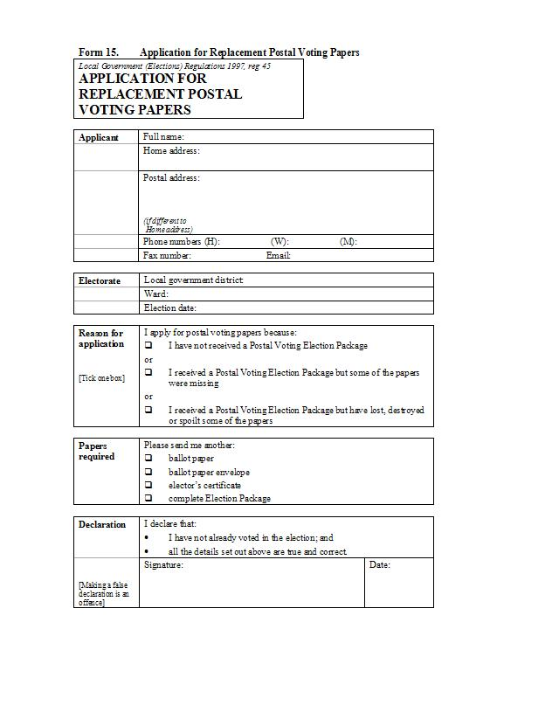

## Receiving unused postal voting papers

If a person brings into the polling place an elector’s certificate and ballot paper they have received in an election package that they have not used, and if the electoral officer is satisfied that the person is entitled to vote and has not already voted, they can be issued with a ballot paper in the ordinary way.

The elector’s certificate and ballot paper are to be retained by the presiding officer and delivered to the returning officer at the close of voting.

A record of the actions of the electoral officer should be made on the occurrence sheet.

## Receiving completed postal voting papers

Postal voting papers can be received up to 6.00pm on election day. Therefore, they may be delivered to a polling place.

If postal voting papers are received by an electoral officer at a polling place, they are to be placed in the ballot box with the other marked ballot papers.

Electoral officers do not process postal voting papers received in any way as the returning officer will check them after the close of the poll.

# Keeping voting screens clear

## Removing how to vote cards

Electoral officers should ensure that electors do not leave how to vote cards or other election material in voting screens. Check screens regularly. Remove how to vote cards or other material and place these in a rubbish bin. Presiding officers may choose to take the rubbish bin outside periodically so that campaign helpers can clear the bin and reuse the material. Do not allow campaign helpers to enter the polling place to clear the bin.

Check through the how to vote cards as sometimes ballot papers are left behind. If found, these should be cancelled and a record of the action recorded on the occurrence sheet.

# Close of poll

## The precise closing time

Presiding officers are required to have an accurate means of establishing the correct time.

At 6.00pm precisely, the polling place doors are to be closed. Those persons inside the polling place at that time are entitled to vote, if eligible to do so.

## Securing the ballot box

After the people inside the polling place have cast their vote (if eligible to do so) the presiding officer is to close, lock and seal the outer lid of the ballot box. If numbered electoral seals are being used, one is to be placed through the clasp of the outer lid. If used, a padlock is also to be placed through the clasp so that the outer lid is both locked and sealed. This procedure should be done in front of a witness and the box witness sheets completed. The presiding officer should put the ballot box keys in a safe place ready to deliver them to the returning officer.

## Packing up material

1. The ballot papers return should be completed and signed.

2. Place the presiding officer’s ballot papers return in a separate envelope with the tally sheets and completed sealing of box witness sheets as these will be needed on arrival at the count area.

3. Place in separate large envelopes the used electoral rolls, unused ballot papers, declaration forms, and the occurrence sheet and any other materials that provide a record of the day’s proceedings.

4. Pack up in the plastic bag provided all the remaining stationery and materials used during the poll.

## Presiding officer’s responsibility

The presiding officer remains responsible for the ballot box and electoral material until they are delivered to the count area. The presiding officer is not to unseal the ballot box unless authorised at the count to do so by the returning officer or another officer delegated to authorise that boxes be opened.

## Leaving the polling place

Returning officers should instruct electoral staff to leave polling places in a tidy condition. They should be locked and if necessary security systems activated.

Some returning officers may instruct presiding officers to obtain signed time sheets from the electoral officers.

## Deliveries to the count area

Presiding officers should deliver separately to the count area:

ballot box(es)

ballot box keys

envelope(s) containing ballot paper return, tally sheets, witness sheets and other papers required immediately at the count;

the polling place keys; and

stationery and other materials used at the polling place.

Arrangements should be made for other material to be stored when it arrives at the count area until it can be sorted out after counting has finished. There is provision in the regulations for ballot papers to be transmitted by electronic means to an electronic counting place. If this is required, the returning officer will advise you of arrangements.

At the count area, arrangements should be made for other material to be stored until it can be sorted after the count.

# Attachment

## Powers and duties of electoral officers

### Presiding officers

Presiding officers have a responsibility for the orderly conduct of the election at their polling place. They should ensure that intending voters are able to exercise their voting rights without harassment or undue delay.

Presiding officers have a responsibility to ensure that all polling is carried out in accordance with the provisions of the *Local Government Act 1995* and the *Local Government (Elections) Regulations 1997*. This includes ensuring that candidates, scrutineers and campaign helpers do not overstep the boundaries of the limitations placed on their actions during polling as specified in the Act.

### Electoral officers

Electoral officers typically assist the presiding officer in handling voting processes. Electoral officers must be fully informed to ensure that everything they do contributes to the lawful processes involved in the election.

### Power to keep order

Presiding officers have power to remove a person who is being disorderly, is obstructing the approaches to a polling place, or fails to obey the lawful order of the presiding officer. Naturally a prudent presiding officer will persuade rather than attempt the use of force. If a difficult situation occurs, the presiding officer would usually call on the returning officer or deputy returning officer for advice and assistance.

For the purposes of keeping order the presiding officer may call on a member of the police service for assistance. The police are required to assist if called on to do so.

## 2. Summary of eligibility to be enrolled to vote

### Residents’ eligibility

(1) A person is eligible to be enrolled to vote at elections for a district or ward (the electorate) if the person is enrolled as an elector for the Legislative Assembly or the House of Representatives in respect of a residence in the electorate.

(2) For the purposes of subsection (1) a person is to be regarded as being enrolled as an elector for the Legislative Assembly or the House of Representatives even if his or her name has been omitted in error from the relevant electoral roll under the *Electoral Act 1907*.

**s. 4.29**

### Non-resident owner’s and occupier’s eligibility

(1) A person is eligible to be enrolled to vote at elections for a district or ward (the electorate) if the person:

(a) is enrolled as an elector for the Legislative Assembly or the House of Representatives in respect of a residence outside the electorate;

(b) owns or occupies rateable property within the electorate;

(c) is the nominee of a corporate body;

(d) has made an enrolment eligibility claim which has been accepted under section 4.32 and still has effect under section 4.33.

**s. 4.30**

(2) For the purposes of subsection (1)(a) a person is to be regarded as being enrolled as an elector for the Legislative Assembly or the House of Representatives even if his or her name has been omitted in error from an electoral roll under the *Electoral Act 1907* or the *Commonwealth Electoral Act 1918*.

### Rateable property: ownership and occupation

This is a lengthy section and is summarised below:

(1) Where a rateable property is split across local government boundaries the elector is eligible to vote in each local government area.

(2) Where a rateable property is split across wards the elector has a choice or if no choice is made the CEO will decide in which ward they are enrolled.

(3) To be eligible as an occupier the person must have a right of continuous occupation under a lease, tenancy agreement or other legal instrument.

(4) Occupancies can relate to a separate building or portion of a building or some other separate and distinguishable portion of the rateable property.

(5) If more than 2 people own or occupy rateable property in conjunction with each other the owners must nominate 2 of them to be enrolled.

(6) If a company owns or occupies rateable property, those eligible to vote are 2 people that have been nominated by the company.

(7) If multiple properties are involved in 5) or 6) the same two people have to be nominated for all the properties.

**s. 4.31**

### Enrolment Claim

How people can apply to go on the roll.

(1) A person may complete a Form 2 - Enrolment eligibility claim and send it to the CEO of the local government.

(2) An occupier must have right of occupation for the next 3 months.

(3) The CEO must accept or reject the claim within 14 days.

(4) The CEO can make any enquiries on the matter.

(5) The CEO is to record his or her decision in the register and must advise the claimant in writing giving reasons if the claim is rejected.

(6) The claimant may appeal to the WA Electoral Commissioner against the CEO’s decision to reject a claim.

**s. 4.32**

### Expiry of enrolments

(1) Unless paragraph (2) applies, an enrolment eligibility claim expires on the day after the holding of the second ordinary elections of the local government after the claim is accepted under section 4.32 (4) or (8).

(2) If an enrolment eligibility claim is accepted under section 4.32 (4) or (8) after the 50th day before the election day for ordinary elections of the local government, the claim expires on the day after the holding of the third ordinary elections of the local government after the claim is accepted, or if the council of the local government is suspended, the day the third ordinary election of the local government would have been held but for the suspension.

**s. 4.33**

### Accuracy of enrolments

This section states that the CEO is to ensure information is up to date and accurate.

**s. 4.34**

### Decision that eligibility to enrol has ended

(1) The CEO may decide that a person is no longer eligible under section 4.30 to be enrolled to vote at elections for a district or ward if:

(a) the person has given the CEO written notice that the person is no longer eligible to be so enrolled;

(b) the CEO is satisfied that the person is dead; or

(c) the CEO is satisfied that the person is no longer eligible to be so enrolled.

(2) The CEO is to give written notice to the person before making a decision under subsection (1)(c) and is to allow 28 days for the person to make submissions on the matter.

(3) If the CEO makes a decision under subsection (1)(c) the CEO is to give written notice of it to the person.

(4) If dissatisfied with the decision, the person may appeal to the Electoral Commissioner in accordance with regulations and the Electoral Commissioner can confirm or reverse the decision.

(5) On receipt of advice of the Electoral Commissioner’s decision on an appeal, the CEO is to take any action that is necessary to give effect to that decision.

(6) If, after considering submissions made under subsection (1), the CEO decides that the person is still eligible under section 4.30 to be enrolled to vote at elections for the district or ward, the CEO is to give written notice of that decision to the person.

(7) The CEO is to record any decision under subsection (1) or (6) in the register referred to in section 4.32(6).

**s. 4.35**