Accounting Guideline – Non-Current Physical Assets

Contents Page
1.0 Purpose 4
2.0 Scope 4
3.0 Definition of terms and abbreviations 5
4.0 Guidance 7
4.1 Introduction 7
4.2 Associated Legislation 8
4.2.1 AASB 116 – Property, Plant and Equipment 9
4.2.2 Local Government (Financial Management Regulations) 1996 10
4.3 Definition of Non-Current Assets 12
Diagram 1 – Definition Criteria of a Non-Current Asset 13
4.4 Classes of Assets 14
4.4.1 Work in Progress 16
4.4.2 Investment Property 16
4.4.3 Intangible Assets 17
4.4.4 Right of Use Assets 17
4.4.5 Land under Roads 17
4.5 Accounting for Assets on Acquisition 18
4.5.1 Cost of Acquisition 18
4.5.2 Cost Elements 18
4.5.3 Capitalisation Threshold 20
4.5.4 Portable and Attractive Assets 22
Diagram 2 – Accounting for Assets on Acquisition 23
Example 1: Application of Diagram 2 – Accounting for Assets on Acquisition 23
4.6 Accounting for Assets after Acquisition 25
4.6.1 Depreciation 25
Diagram 3 – Determining Depreciation of a Non-Current Asset 29
Example 2: Application of Diagram 3 – Determining Depreciation of a Non-Current Asset 29
4.6.2 Expenditure after Acquisition (Subsequent Costs) 31
4.7 Valuing Assets 33
4.7.1 Measurement after Recognition 33
4.7.2 Fair Value 34
4.7.3 Impairment 35
4.8 Disposal (De-Recognition) of Assets 39
4.9 Managing, Recording, and Controlling Non-Current Physical Assets 43
4.9.1 Asset Policy 43
4.9.2 Asset Register 43
4.9.3 Recording the Location of Assets 44
4.9.4 Individual Road Valuations 45
4.9.5 Reconciliation of Assets 45
4.9.6 Asset Stock Takes 45
4.10 Avoid Common Mistakes 46
4.11 Appendices and Templates 49
Appendix 1 – Worked Examples 50
Appendix 2 – Example Asset Classifications 61
Template 1 – Checklist for Asset Accounting 63
Template 2 – Impairment Test Questionnaire 65
Template 3 – Reconciliation of Asset Ledger to General Ledger 66
5.0 Related Guidance 67
6.0 Disclaimer 67
7.0 Version Control 67

Purpose
The purpose of this guideline is to assist local governments with accounting for their non-current physical assets as required under the local government financial reporting framework and Australian Accounting Standards (AAS).
This guide is not intended to be prescriptive. Local government specific circumstances should be considered when applying the requirements under relevant AAS and the Local Government Act 1995 (the Act) and associated regulations.

Scope
This guide deals with the accounting treatment of non-current physical assets under the Australian Accounting Standard Board’s AASB 116 - Property, Plant and Equipment and the applicable requirements under the Act and Local Government (Financial Management) Regulations 1996 (FM Regulations).
Non-current physical assets are material, tangible assets that are expected to be used for more than one year in the operations of a Western Australian local government.
The guide does not deal with:
- AASB 138 Intangible Assets such as licenses, patents, trademarks, goodwill or internally developed software
- AASB 102 Tangible current assets such as stores and inventories
- AASB 140 Investment Property
- AASB 5 Non-current Assets Held for Sale and Discontinued Operations.

Definition of terms and abbreviations
Term | Definition | Reference
AAS | Australian Accounting Standards
AASB | Australian Accounting Standards Board
Act | Local Government Act 1995
Asset | A resource:  - controlled by an entity as a result of past events; and  - from which future economic benefits are expected to flow to the entity. | AASB 138.8
Carrying Amount | The amount at which an asset is recognised after deducting any accumulated depreciation and accumulated impairment losses. | AASB 116.6
Cost | The amount of cash or cash equivalents paid, or the fair value of the other consideration given to acquire an asset at the time of its acquisition or construction or, where applicable, the amount attributed that asset when initially recognised in accordance with the specific requirements of other AAS. | AASB 116.6
Depreciation | The systematic allocation of the depreciable amount of an asset over its useful life. | AASB 116.6
Depreciable Amount | Cost of an asset, or other amount substituted for cost, less its residual value. | AASB 116.6
Fair Value | The price that would be received to sell an asset or paid to transfer a liability in an orderly transaction between market participants at the measurement date. | AASB 116.6
FM Regs | Local Government (Financial Management) Regulations 1996
Intangible Asset | An identifiable non-monetary asset without physical substance | AASB 138.8
Investment Property | Property (land or a building—or part of a building—or both) held (by the owner or by the lessee as a right-of-use asset) to earn rentals or for capital appreciation or both, rather than for:  - use in the production or supply of goods or services or for administrative purposes; or  - sale in the ordinary course of business. | AASB 140.5
Property, plant and Equipment | Tangible items that:  - are held for use in the production or supply of goods or services, for rental to others, or for administrative purposes; and  - are expected to be used during more than one period. | AASB 116.6
Residual Value | The estimated amount that an entity would currently obtain from disposal of the asset, after deducting the estimated costs of disposal, if the asset were already of the age and in the condition expected at the end of its useful life. | AASB 116.6
Right-of-Use Asset | An asset that represents a lessee’s right to use an underlying asset for the lease term. | AASB 16 Appendix A
Useful Life | Is defined as:  - the period over which an asset is expected to be available for use by an entity; or  - the number of production or similar units expected to be obtained from the asset by an entity | AASB 116.6

Guidance

4.1 Introduction
Assets are fundamental to a local governments service delivery to the community. It is therefore important to manage those assets in a responsible and effective way. This involves recording their existence, location and depletion over time as a method of assessing future renewal requirements. The development and implementation of effective and efficient asset management policies and procedures is critical for the long-term sustainability of all local governments.
Applying the correct accounting treatment for property, plant and equipment allows users of the financial statements to discern information about an entity’s investment in its property, plant and equipment and the changes in such investment. The principal issues in accounting for property, plant and equipment are the recognition of the assets, the determination of their carrying amounts and the depreciation charges and impairment losses to be recognised in relation to them.
The requirements of the AAS and the Act and its associated Regulations determine how local governments in Western Australia are to account for their Non-Current Physical Assets.

4.2 Associated Legislation
In this section, key sections of relevant legislation in regard to accounting for non-current physical assets is outlined. The application of the legislation is further explained in the relevant sections throughout this document.
The two key pieces of legislation are the Act (and associated Regulations) and the AAS.
Part 6 – Financial Management of the Act provides for the financial management by a local government of its assets.
6.10. Financial management regulations

Regulations may provide for —

(a) the security and banking of money received by a local government; and

(b) the keeping of financial records by a local government; and

(c) the management by a local government of its assets, liabilities and revenue; and

(d) the general management of, and the authorisation of payments out of —

(i) the municipal fund; and
(ii) the trust fund, of a local government.
Regulation 4(1) of the FM Regulations states that AAS are to be applied except where there may be inconsistency between the AAS and the FM Regulations, in which case the FM Regulations are to prevail.
4. AAS, effect of

(1) These regulations are in addition to and not in derogation of the requirements of the AAS.

(2) If a provision of the AAS is inconsistent with a provision of these regulations, the provision of these regulations prevails to the extent of the inconsistency.

(3) All words in the Act or these regulations that import revenue or expenditure are to be interpreted to permit compliance with the requirements of the AAS.
Inconsistencies exist in the areas of:
- Measurement after recognition (cost model vs fair value) – see section 4.7
- Setting of a minimum capitalisation threshold – see section 4.5.3
- Requirement to keep a register of portable and attractive items – 4.5.4
- Disclosure requirements in the annual budget and annual financial report over and above that of the AAS. – FM Reg 27. and FM Reg 36.

4.2.1 AASB 116 – Property, Plant and Equipment
AASB 116 Property, Plant and Equipment is the core Standard applicable to accounting for Physical Non-Current Assets (Property, Plant and Equipment). This Standard shall be applied except when another Standard requires or permits a different accounting treatment.
AASB 116 does not apply to:
(a) property, plant and equipment classified as held for sale in accordance with AASB 5 Non-current Assets Held for Sale and Discontinued Operations.
(b) biological assets related to agricultural activity other than bearer plants (see AASB 141 Agriculture). This Standard applies to bearer plants but it does not apply to the produce on bearer plants.
(c) the recognition and measurement of exploration and evaluation assets (see AASB 6 Exploration for and Evaluation of Mineral Resources).
(d) mineral rights and mineral reserves such as oil, natural gas and similar non-regenerative resources.
However, this Standard applies to property, plant and equipment used to develop or maintain the assets described in (b)–(d).
AASB 116.6 defines property, plant and equipment as:
“tangible items that:
(a) are held for use in the production or supply of goods or services, for rental to others, or for administrative purposes; and
(b) are expected to be used during more than one period.”

4.2.2 Local Government (Financial Management Regulations) 1996
The FM Regulations 17A,17B, 27 and 36 prescribe additional criteria to that of the AAS when accounting for the valuation of certain assets, managing portable and attractive assets, and notes that may be required in the Annual Budget and Annual Financial Report.
Outlined below are the applicable regulations impacting Non-Current Physical Assets, that will be discussed further in the relevant section of this document.
17A. Valuation of certain assets for financial reports

      - In this regulation — carrying amount, in relation to a non-financial asset, means the carrying amount of the non-financial asset determined in accordance with the AAS; fair value, in relation to a non-financial asset, means the fair value of the non-financial asset measured in accordance with the AAS; right-of-use asset, of a local government, includes the local government’s right to use —

- Crown land; or

- other land that is not owned by the local government, that is vested in the local government at nil or nominal cost for an indefinite period for the purpose of roads or for any other purpose; vested improvement, in relation to a local government, means a pre-existing improvement on land of which the care, control or management is vested in the local government at nil or nominal cost for an indefinite period.

      - A local government must show in each financial report for a financial year ending on or after 30 June 2020 —

- the fair value of all of the non-financial assets of the local government that are —

- land and buildings that are classified as property, plant and equipment; or
- investment properties; or
- infrastructure; or
- vested improvements that the local government controls; and

- the carrying amount of all of the non-financial assets of the local government that are plant and equipment type assets measured using the cost model in accordance with the AAS; and

- the carrying amount of all of the right-of-use assets of the local government (other than vested improvements referred to in paragraph (a)(iv)) measured using the cost model in accordance with the AAS.

      - [Deleted]

      - A local government must revalue a non-financial asset of the local government referred to in subregulation (2)(a) —
- whenever the local government is of the opinion that the fair value of the asset is likely to be materially different from its carrying amount; and

- in any event, within a period of no more than 5 years after the day on which the asset was last valued or revalued.

      - A non-financial asset is to be excluded from the assets of a local government if the fair value of the asset as at the date of acquisition by the local government is under $5 000.

17B. CEO to take steps to protect excluded portable and attractive assets

A CEO must take all reasonable steps to prevent the theft or loss of —
- a non-consumable asset that is susceptible to theft or loss due to its portable nature and attractiveness for personal use or resale; and

(b) an asset referred to in regulation 17A(5).

27. Notes to annual budget, when required
…
(d) in relation to the disposal of a class of assets —
- the net book value of that class of assets; and
- an estimate of the sale price of the class of assets; and
- an estimate of the profit or loss on the sale of that class of assets;

….

(n) in relation to depreciation on non-current assets, an estimate of the depreciation for the financial year included in the operating expenditure for each program in the income statement.

36. Annual financial report, content of (Act s. 6.4(2))
….
(e) in relation to the disposal of a class of assets —
- the net book value of that class of assets; and
- the sale price of that class of assets; and
- the profit or loss on the sale of that class of assets;

4.3 Definition of Non-Current Assets
AASB 101.66 provides that:
“An entity shall classify an asset as current when:
(a) it expects to realise the asset, or intends to sell or consume it, in its normal operating cycle;
(b) it holds the asset primarily for the purpose of trading;
(c) it expects to realise the asset within twelve months after the reporting period; or
(d) the asset is cash or a cash equivalent (as defined in AASB 107) unless the asset is restricted from being exchanged or used to settle a liability for at least twelve months after the reporting period.
An entity shall classify all other assets as non-current.”
The above criteria requires an understanding of what an asset is before any assessment can be made about its current or non-current status.
AASB 138.8 provides the following definition of an asset.

“An asset is a resource:
(a) controlled by an entity as a result of past events; and
(b) from which future economic benefits are expected to flow to the entity.”
As defined above, an asset does not require the local government to legally own the property, plant or equipment for it to be classified an asset, the local government only needs to have control of the item and be able to direct its use to achieve its strategic goals and receive future benefits.
To be recognised as an asset the following criteria must be met:
- it is probable that the future economic benefits embodied in the asset will eventuate; and
- the asset possesses a cost or other value that can be measured reliably.

Meaning, it must be probable that future economic benefits will flow from the asset, and the cost or value must be able to be reliably measured before an asset can be recognised.

Diagram 1 – Definition Criteria of a Non-Current Asset
The above requirements of the definition of a Non-Current Asset, in accordance with the AAS is illustrated in the decision tree below:

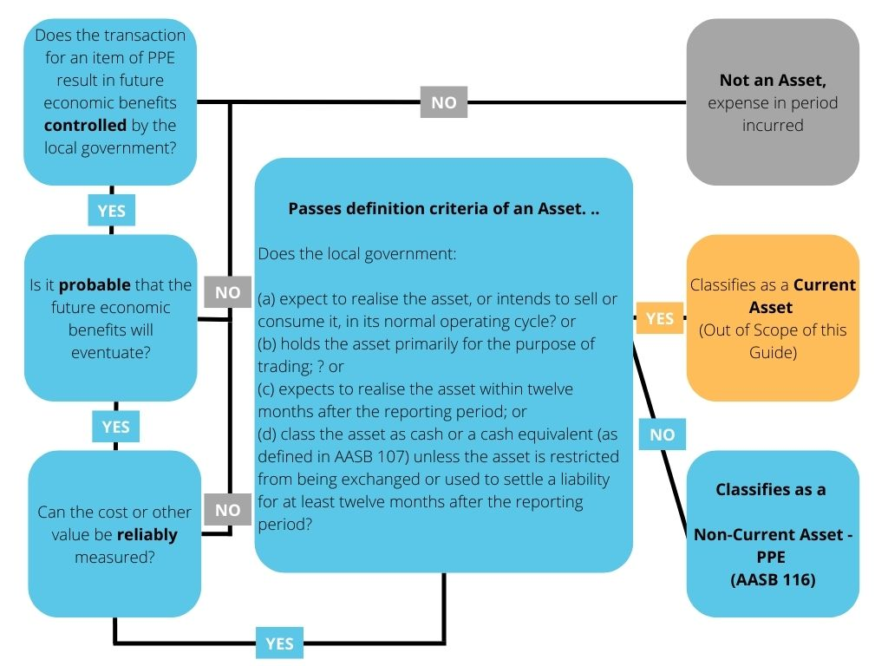
While you may have determined that you have a Non-Current Asset to account for, it is too early to be accounting for the asset in the local governments Asset Register as Property, Plant and Equipment. More must be considered before moving ahead.

4.4 Classes of Assets
A class of property, plant and equipment is a grouping of assets of a similar nature and use in a local government’s operations. The following are examples of separate classes as provided in AASB 116.37:
(a) land
(b) land and buildings
(c) machinery
(d) ships
(e) aircraft
(f) motor vehicles
(g) furniture and fixtures
(h) office equipment and
(i) bearer plants.

Defining a class of assets is important under the Standards as this term is used to define the disclosure requirements and restrict opportunistic revaluations occurring to individual assets.
Local governments differ from many other organisations in that in addition to having assets which are used for operational purposes – property, plant and equipment, they also hold assets to meet the community’s need for economic and social facilities and services, for example - infrastructure.
The vast majority of a local government’s assets are usually infrastructure assets. Infrastructure assets are physical assets used to meet the public’s need for access to major economic and social facilities and services. By nature, infrastructure assets are typically large, interconnected networks or portfolios of composite assets. The components of these assets may be separately maintained, renewed and/or replaced, so that the required level and standard of service from the network of assets is continuously sustained. Generally, the components and hence the assets, have long lives, are fixed in place and often have no market value.
Sub-classes are usually also used to manage the various groupings under each class.
When developing a local governments Asset or Accounting Policy the definition of the classes and sub classes adopted should be clearly outlined.
An example table of classifications (class and subclass) is provided in Appendix 2. Not every local government will fit the example range of asset classes and sub classes. The individual needs of the local government should be considered when developing classes and sub classes to be included as part of their Asset or Accounting Policy.
Separable Assets/Components of Assets
AASB 116.43 states that a part of an item of property, plant and equipment with a cost that is significant in relation to the total cost of the item shall be depreciated separately. Parts that make up an asset may have differing useful lives, residual values and depreciation rates that are significant, requiring them to be depreciated separately.
For example, road seals typically have significantly shorter lives than pavements. By contrast road formations (earthworks) may have indefinite lives. A similar approach can be applied to drainage, where pits and pipes may have different useful lives; and to buildings, where plant such as lifts, and air conditioning may be replaced during the building’s life.
Land and buildings are separable assets and are accounted for separately, even when they are acquired together. With some exceptions, such as quarries and sites used for landfill, land has an unlimited useful life and therefore is not depreciated. Buildings have a limited useful life and therefore are depreciable assets.
When determining the classes, sub-classes and ultimate depreciable categories for the local government, AASB 116.43 must be considered to ensure that depreciation is able to be applied correctly to separable parts of each asset.
It is important to understand how the finance system (or ERP) of a local government is able to deal with the need to account for separable/components of assets. Some systems may not be developed in a way that easily captures this information or has the ability to perform the calculations and reporting required. In some instances, work arounds may be required until the finance system is upgraded or replaced.
For example, where sub-assets are not able to be created, an individual asset may need to be created for each component and reflected in the asset numbering or grouping; or a further detailed register may be kept in an alternative system such as Microsoft Excel or RAMM. In these scenarios, regular reconciliation between the systems will need to be conducted and processes put in place to ensure that each register is maintained and reflective of the other.
In addition, to assist with the marrying of the financial asset system and the asset management system, it is important to discuss closely with the local government’s Asset Management team to ensure that the components of assets determined, where possible, work harmoniously between the systems and users’ needs of the systems.

4.4.1 Work in Progress
Under certain circumstances projects being undertaken by a local government may not be physically complete at the reporting date. The work in progress category accrues expenditure at the time of reporting when the asset is not available for use. Upon commissioning the full value is allocated to the appropriate category, such as infrastructure assets.

4.4.2 Investment Property
Whilst Investment Property is listed in the Asset Classes example at Appendix 2, it is not dealt with in detail in this document. Investment property guidance is provided in AASB 140 Investment Property and is defined as:
“property (land or a building—or part of a building—or both) held (by the owner or by the lessee as a right-of-use asset) to earn rentals or for capital appreciation or both, rather than for:
- use in the production or supply of goods or services or for administrative purposes; or
- sale in the ordinary course of business.”
However, a not-for-profit exemption is provided at AASB 140. Aus9.1 as follows:
“In respect of not-for-profit entities, property may be held to meet service delivery objectives rather than to earn rental or for capital appreciation. In such situations the property will not meet the definition of investment property and will be accounted for under AASB 116, for example:
(a) property held for strategic purposes; and
(b) property held to provide a social service, including those which generate cash inflows where the rental revenue is incidental to the purpose for holding the property.”
Local governments will need to ensure that their specific circumstances are considered for properties that meet the definition of an Investment Property and provide a clear position on whether it is captured by AASB 140 or is exempt under AASB 140. Aus9.1 and therefore accounted for under AASB 116.
An example of this may be where a regional local government provides freehold land and building under a nominal commercial lease for a service such as a medical service. While the property is held, likely to have capital appreciation and earns rental income (nominal); the reason the local government is providing the facility for this service is to ensure that the community has access to medical services not already provided for – meeting both Aus9.1(a)(b) held for a strategic purpose and held to provide a social service and therefore accounted for under AASB 116 and not AASB 140.

4.4.3 Intangible Assets
Similar to Investment Property, Intangible Assets have been included in the example of asset classes provided in Appendix 2 however, are not dealt with in detail in this document. Intangible asset guidance is contained in AASB 138 and provides a definition of an intangible asset as:
“an identifiable non-monetary asset without physical substance.”

4.4.4 Right of Use Assets
Right of Use Assets are not dealt with in this document. A Right of Use Asset is
“an asset that represents a lessee’s right to use an underlying asset for the lease term.”
Guidance on how to account for these assets is contained in AASB 16 Leases.

4.4.5 Land under Roads
Changes to the FM Regs effective from 1 July 2019 resulted in a local government’s right to use vested land (or crown land), including land under roads, as a right-of-use asset.
In most instances land under roads is measured at zero cost, meaning the previous inconsistency with AASB 1051 in regard to the non-recognition of land under roads acquired on or after 1 July 2008 has been removed; even though at zero cost land under roads is not shown on the statement of financial position.
17A. Valuation of certain assets for financial reports

- In this regulation —
carrying amount, in relation to a non-financial asset, means the carrying amount of the non-financial asset determined in accordance with the AAS;
fair value, in relation to a non-financial asset, means the fair value of the non-financial asset measured in accordance with the AAS;
right-of-use asset, of a local government, includes the local government’s right to use —

(a) Crown land; or
(b) other land that is not owned by the local government, that is vested in the local government at nil or nominal cost for an indefinite period for the purpose of roads or for any other purpose;
vested improvement, in relation to a local government, means a pre-existing improvement on land of which the care, control or management is vested in the local government at nil or nominal cost for an indefinite period.

4.5 Accounting for Assets on Acquisition

4.5.1 Cost of Acquisition
AASB 116.15 requires an item of property, plant and equipment to be measured at:
- its cost if it qualifies to be an asset, or
- if the item has no or a nominal cost, such as donated items, then it is to be valued at its ‘fair value’.

Contributed infrastructure items by developers are examples of donated items and are required to be valued at fair value in accordance with AASB 13 Fair Value Measurement.
AASB 116.23 outlines the cost of an item of property, plant and equipment as the cash price equivalent at the recognition date. If payment is deferred beyond normal credit terms, the difference between the cash price equivalent and the total payment is recognised as interest over the period of credit unless such interest is capitalised in accordance with AASB 123 Borrowing Costs.

4.5.2 Cost Elements
The cost of an asset includes:
- its purchase price, including import duties and non-refundable purchase taxes, after deducting trade discounts and rebates.
- any costs directly attributable to bringing the asset to the location and condition necessary for it to be capable of operating in the manner intended by management.
- the initial estimate of the costs of dismantling and removing the item and restoring the site on which it is located, the obligation for which an entity incurs either when the item is acquired or as a consequence of having used the item during a particular period for purposes other than to produce inventories during that period.

Purchase Price
Purchase price includes any non-refundable taxes and charges such as goods and services tax (GST) less any discounts and rebates, all costs associated with bringing the asset to the location and to working order and any initial estimates for dismantling and removal of the asset.
The purchase price of a self-constructed asset is determined using the same principles as for an acquired asset. Any internal profits are eliminated in arriving at the cost. Similarly, the cost of abnormal amounts of wasted material, labour, or other resources incurred in self-constructing an asset is not included in the cost of the asset. Interest on certain borrowings may also be recognised as a component of cost.

Directly Attributable Costs
Directly Attributable Costs include:
- costs of employee benefits (as defined in AASB 119 Employee Benefits) arising directly from the construction or acquisition of the item of property, plant and equipment
- costs of site preparation
- initial delivery and handling costs
- installation and assembly costs
- costs of testing whether the asset is functioning properly (i.e. assessing whether the technical and physical performance of the asset is such that it is capable of being used in the production or supply of goods or services, for rental to others, or for administrative purposes), and
- professional fees.
Restoration Costs
Restoration costs are an element of cost which is particularly relevant to licensed landfill operations. An estimate of remediation and restoration costs is required for all active landfills when they commence operation or are held ready for operation. Other assets, for example, road and drainage networks, it is unlikely that this element of cost will apply on initial construction unless it is known that the network asset has a fixed life and will not be renewed.
Excluded Costs
Examples of costs that are not included in the cost of acquisition of an asset are:
- costs of opening a new facility
- costs of introducing a new product or service (including costs of advertising and promotional activities)
- costs of conducting business in a new location or with a new class of customer (including costs of staff training) and
- administration and other general overhead costs.

It is important to interrogate the transactions contained within the capital expenditure accounts to ensure that excluded costs are not caught up in the cost of acquisition of the asset when considering the capitalisation of an asset to the asset register.

4.5.3 Capitalisation Threshold
The cost of acquiring an asset is recorded in the balance sheet. This is called the asset’s initial “carrying value” (sometimes also referred to as an “initial book value”).
However, not all assets acquired need to be recorded in the balance sheet. If an individual asset or component of an asset is not “material” the cost of acquisition may be shown as an expense in the period, it was incurred. For example, without such limits, items like a $25 calculator may be included as an asset, as it would meet all the relevant recognition criteria. This level of asset recording does not present an efficient use of the local government’s resources and would be classed as immaterial.
It is common practice to establish a dollar amount as a materiality or capitalisation threshold for each class of asset. Where the cost of an asset or a component of an asset falls below this threshold it is expensed.
What is “material” is defined in AASB 101.7 Presentation of Financial Statements as follows:
“Information is material if omitting, misstating or obscuring it could reasonably be expected to influence decisions that the primary users of general-purpose financial statements make on the basis of those financial statements, which provide financial information about a specific reporting entity.”
Materiality depends on the nature or magnitude of information, or both. A local government needs to assess whether information, either individually or in combination with other information, is material in the context of its financial statements taken as a whole.
What may be material for one local government may be different to another local government of differing scale and size. It is not appropriate therefore to specify a common threshold to apply to all local governments or even for one local government to use the same threshold each year without reconfirming its relevance and suitability.
When considering the capitalisation threshold and materiality applicable to your local government, it is important to note that the FM Regulations 17A(5) prescribes that a non-financial asset is to be excluded from the assets of a local government if the fair value of the asset as at the date of acquisition by the local government is under $5,000.
In essence, the minimum capitalisation threshold that a local government can adopt is $5,000 for non-financial assets. Assets that are acquired for less than $5,000 are expensed in the year of acquisition.
Grouping or Aggregation of Assets
As AASB 116.9 does not prescribe a unit of measure for recognition (i.e. what constitutes an item of property, plant and equipment), only that judgement is required in applying the recognition criteria to an entity’s specific circumstances. Circumstances may exist where a local government should apply the asset capitalisation threshold of $5,000 to the collective value of a group or network of assets.

A group is a collection of similar assets, and a network is a chain of interconnected but dissimilar assets for the provision of one simultaneous service, for example a purchase of computer and IT hardware or office furniture.
Individually each asset value may be below the threshold but collectively the cost of the items in the group or network exceeds the threshold. Consideration of a grouping or aggregation of assets is usually only given where they have long useful lives and material aggregate values.
Comparing patterns of asset consumption with patterns of asset replacement expenditure assists to identify whether there is a material periodic difference between the depreciation expense and the ongoing expensing of acquisitions. For example, where the straight-line method of depreciation is used, yet asset replacement expenditure is at periodic intervals and of material value, there may be a case for capitalising the group or network of assets.
Other examples of a group of assets that may individually fall below a capitalisation threshold are:
- Book collections at a library.
- IT Equipment - Computers/Laptops/Monitors.
- Office fit-outs and/or furniture.
- A purchase of a group of minor plant and equipment (i.e. tools).

Consideration to the applicability of grouping or aggregating these assets must be given in the context of each local government.
NOTE: Importantly local governments should include the capitalisation threshold adopted in an Asset or Accounting Policy which is reviewed for relevance and materiality each year.
AUDIT TIP: Auditors will expect to see the thresholds within a policy reflected in the treatment of assets acquired, as well, as evidence of the review of the Asset or Accounting Policy taking place each year. Where you have grouped or aggregated assets for capitalisation, ensure that you record is captured in a workpaper or position paper and provide the reasoning for this.

4.5.4 Portable and Attractive Assets
Assets that fall under the $5,000 threshold are not expensed and then forgotten.
FM Reg 17B prescribes that the CEO of a local government must take all reasonable steps to prevent the theft or loss of a non-consumable asset that is susceptible to theft or loss due to its portable nature and attractiveness for personal use or resale and is less than the capitalisation threshold of $5,000 set in FM Regulations 17A(5).
At a minimum it would be expected that a register of portable and attractive items is kept and regularly monitored and reviewed to ensure that the assets classed as portable and attractive remain in the control and safe custody of the local government. Other measures may be implemented at each local government dependent on the risk level of each item.
Examples of items that may be classed as portable and attractive assets are:

- Laptops/Computer Equipment.
- Photography Equipment (Cameras/Drones).
- Handheld Radios.
- Mobile Telephones.
- Bicycles.
- Minor Plant and Equipment such as tools, brush cutters, chainsaws, lawnmowers, etc.

Diagram 2 – Accounting for Assets on Acquisition
Following on from Diagram 1, the next stages of accounting for an asset on acquisition is illustrated in the below decision tree.
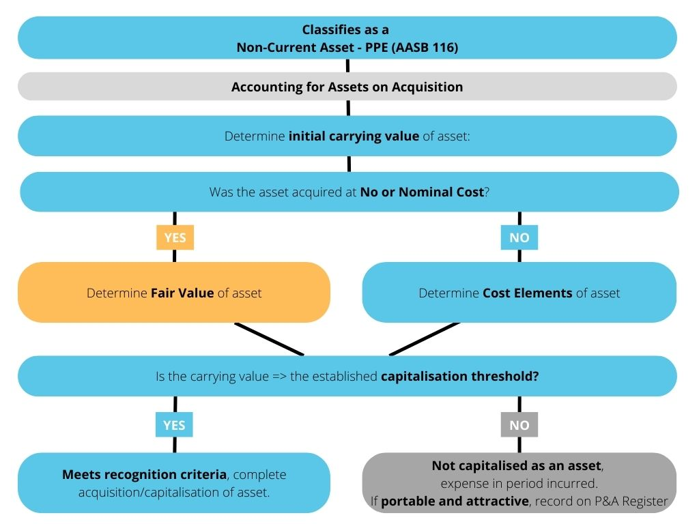

Example 1: Application of Diagram 2 – Accounting for Assets on Acquisition
The above diagram can be applied to the following example of a purchase of a light vehicle.
Case Study
- On 1 July 2022 the Shire of City-Country paid cash for Light Fleet Vehicle 1 (LF1) of $43,000 at market value. The invoice outlined the items that make up the value of the purchase as follows:

Vehicle: $40,000
Additional Tinting: $ 2,000
Delivery: $ 1,000
Total: $43,000

- The Shire’s capitalisation threshold for light fleet vehicles is $5,000.
- The useful life of light fleet vehicles is 3 years in accordance with the asset changeover policy of the Shire.
- The Shire utilises www.redbook.com.au to provide estimates for residual values of light fleet vehicles. They base the search on looking for information on the same model of vehicle, with an age of 3 years, in a condition expected of vehicles turned over by the Shire after 3 years, at a trade in value – as the Shire uses an auction house to sell their light fleet vehicles. Evidence was sourced showing an expected future sale value of $19,000.
- The Shire has determined the straight-line method of accounting is appropriate for light fleet vehicles and is stated in their policy.

Applying the steps of Diagram 2

Step 1: Determine Initial Carrying Value of Asset

1(a): Was the asset acquired for no or nominal cost?

No, LF1 was purchased at market value, with the Shire paying cash ($43,000)

1 (b): Determine cost elements of asset:

The purchase of the vehicle was made up of the vehicle cost ($40,000), tinting ($2,000), and delivery ($1,000).

Initial carrying value/cost = $43,000

Step 2: Is the initial carrying value/cost equal to or greater than the capitalisation threshold?

Yes, the Shire’s capitalisation threshold is $5,000 for light vehicles. The total of the cost elements is $43,000.

$43,000 > $5,000

Step 3: Meets recognition criteria – complete acquisition/capitalisation of asset.

The journal entry for the acquisition is as follows:

DR Non-Current Assets – PPE – Light Fleet $43,000

CR Cash at Bank $43,000

Being the purchase of LF1

Additionally, the Assets subsidiary ledger details are added as follows:

Asset # | Acquisition Date | Cost | Estimated Useful Life | Estimated Residual Value
LF1 | 1 July 2022 | $43,000 | 3 years | $19,000

4.6 Accounting for Assets after Acquisition

4.6.1 Depreciation
Depreciation is the process of systematically allocating the cost (or fair value) of a tangible asset over its expected useful life and is defined in AASB 116.6 as:
“the systematic allocation of the depreciable amount of an asset over its useful life.”
Depreciable amount is the cost of an asset, or other amount substituted for cost, less its residual value.
In accounting terms, depreciation is an accrued expense which is charged to the statement of comprehensive income (profit and loss) and is recorded against the value of an asset as accumulated depreciation – unless it is included in the carrying amount of another asset. The aim of progressively charging an asset's value to a local government’s operation is to apportion the consumption or loss of future economic benefit of the asset over the period to which it provides a benefit to the local government.
The annual depreciation expense does not represent a cash outflow in that year – the cash outflow occurred when the asset was acquired. It also is not an indication of how much is needed to be spent on future asset acquisition (replacement or renewal) or on asset maintenance.
The annual depreciation expense is often compared to annual outlays on capital acquisition to give an indication of the quantum of the gap between the actual and required levels of renewal of existing assets. Such raw comparisons (even over a number of years) are not a good measure of the renewal gap. For example, capital expenditure will include not just asset renewals but also upgraded or extended assets.
Residual Value
The residual value of an asset is the estimated amount that would be obtained today from disposal of the asset, after deducting the estimated costs of disposal.
AASB 116.6 defines the residual value of an asset as:
“the estimated amount that an entity would currently obtain from disposal of the asset, after deducting the estimated costs of disposal, if the asset were already of the age and in the condition expected at the end of its useful life.”
When deciding on the residual value consideration needs to be given to salvage or scrap value, as well, as to second hand market values. In the unlikely event that the residual value of an asset happens to increase to a value equal to or greater than the asset's carrying amount, the depreciation charge is zero and this is until its residual value subsequently decreases to an amount below its carrying amount.
In practice, the residual value of many assets or components is often insignificant and therefore immaterial in the calculation of the depreciable amount.
An example of where residual values may be significant dependent on the expected useful life, is a motor vehicle. If a residual value is material to the calculation of an asset, ensure that evidence of the methodology of determining the residual value is kept in the local governments workpapers.
NOTE: AASB 116.51 requires that the residual value and the useful life of an asset is to be reviewed at least at each financial year-end and, if expectations differ from previous estimates, the change(s) shall be accounted for as a change in an accounting estimate in accordance with AASB 108 Accounting Policies, Changes in Accounting Estimates and Errors.
AUDIT TIP: Auditors will expect evidence or a position paper on how this review has been conducted each year as part of your Audit Papers.
Useful Life
The expected useful life relates to the expected period or consumption levels that a particular local government uses an asset - not how long the asset can be used unless they are the same.
Therefore, the useful life to a local government may differ from the asset’s potential physical life or economic life. For example, local governments may renew road assets when they reach a certain condition rating, notwithstanding that they could continue to be used. Alternatively, the local government may continue to use a road past the point when it would be optimum to renew it, due to resource constraints.
AASB 116.6 provides:
“Useful life is:
(a) the period over which an asset is expected to be available for use by an entity; or
(b) the number of production or similar units expected to be obtained from the asset by an entity.”
It is usual to express the useful life of a class of assets as a range, for example from 20 to 40 years; however, a definitive useful life must be selected for each individual asset in each class to arrive at a percentage rate to be used to depreciate the asset, for example 37 years.
The estimation of the useful life of the asset is a matter of judgement based on the experience of the local government with similar assets.
The useful life of an identical asset may be different in the hands of individual local governments. Previous versions of asset guidance have provided example useful life ranges and depreciation rates however, for this reason has been excluded from this document. Each local government will need to assess the useful life appropriate to each asset based on their own specific asset management policy, utilisation rates, environmental and other conditional impacts.
Useful life may be measured either by its duration (the period over which an asset or component will be used), which is the most common method or usage (the expected capacity or outputs it will produce).
Methods of Depreciation
Once the depreciable amount has been determined by reference to the asset or its component’s residual values; and the useful life has been determined by reference to the expected life of the asset or component to the entity; the amount of depreciation that is charged as an expense each year has to be determined.
The method of allocating the depreciable amount over the useful life of the asset is required by the accounting standards (AASB116.60) to reflect the pattern of consumption of the economic benefits by the local government (or service potential) embodied in the asset.
There are many different depreciation methods that can be used to depreciate physical non-current assets, but the three main methods are:
- Straight-line method
The Straight-line method of depreciation assumes that the economic benefits embodied in the asset, or the component are consumed evenly over its useful life.
This method uses a uniform annual depreciation charge which is calculated by simply dividing the useful life into the total cost of the asset, minus the estimated residual value, if any.
Depreciation Expense = (Total Cost – Residual Value) / Useful Life
- Diminishing balance method
The Diminishing balance method of depreciation requires the application of a constant rate of depreciation each year to the carrying value of the asset at the close of the previous period. The amount of depreciation charged in each year therefore progressively reduces with the written down value of the asset.
This method of depreciation assumes that the benefits provided by an asset will be greater in the initial years, and hence apportions a greater share of the cost to those earlier years of the asset's expected useful life.
Depreciation Expense = Written Down Value x Depreciation Rate
Where not provided, to calculate the Depreciation Rate the formula is as follows:
Depreciation Rate = $1-\sqrt[n]{r/c}$
Where:
n = useful life
r = residual value
c = Cost or Fair Value of Asset
- Units of production method
This method requires the application of units such as machine hours, kilometres or physical consumption which reflects the utilisation of the asset. This method is best applied when the economic benefit of an asset is expected to be utilised in proportion to its use.
Depreciation Expense = (Total Cost – Residual Value) x (number of units consumed for the period / the expected total number of units consumed)
All depreciation methods endeavour to do the same thing; accurately reflect the pattern of benefits received from a non-current asset and matching the appropriate cost of those benefits against the revenue earned or the period to which the consumption of future economic benefit has taken place.
The most common depreciation method in use by local governments is the straight-line method however, whichever method is determined as the most suitable requires a clear rationale and demonstrable explicit linkages to the rate of consumption of economic benefits to each asset.
NOTE: AASB116.61 requires that the depreciation method applied to an asset shall be reviewed at least at each financial year-end and, if there has been a significant change in the expected pattern of consumption of the future economic benefits embodied in the asset, the method shall be changed to reflect the changed pattern. Such a change shall be accounted for as a change in an accounting estimate in accordance with AASB 108.
AUDIT TIP: Auditors will expect evidence or a position paper on how this review has been conducted each year as part of the Audit Papers even where there is no change as a result of the review.

Diagram 3 – Determining Depreciation of a Non-Current Asset
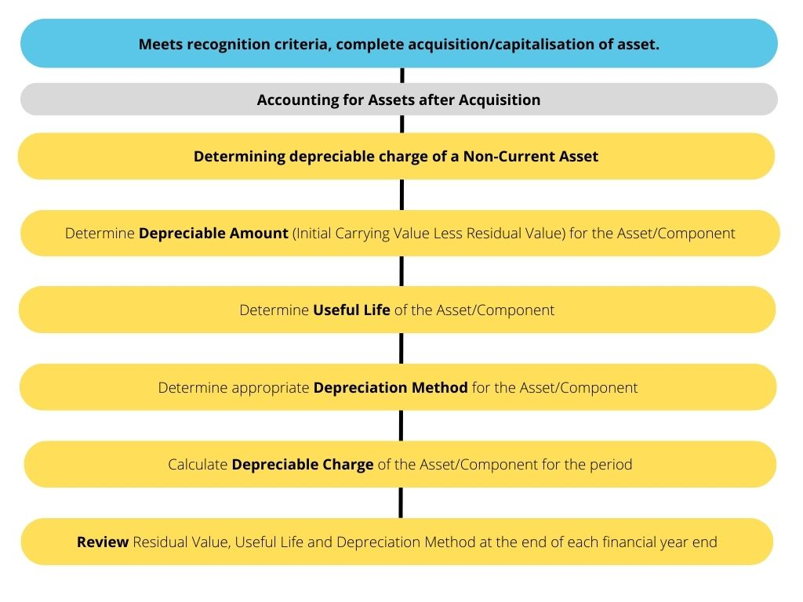

Example 2: Application of Diagram 3 – Determining Depreciation of a Non-Current Asset
Following on from the case study used in Example 1, Diagram 3 can be applied to calculate and post a journal for the depreciation charges for the 3 years of the life of the asset.
Step 1: Determine Depreciable Amount
Depreciable amount = initial carrying value less residual value
Depreciable amount = $43,000 - $19,000
= $24,000

Step 2: Determine Appropriate Depreciation Method
The Shire’s accounting policy states that the straight-line method of accounting is used for light fleet vehicles.

Step 3: Calculate Depreciable Charge (Depreciation Expense) for each Period – being monthly in this case
Depreciation Expense = (Total Cost – Residual Value) / Useful Life
= Depreciable amount / Useful Life
= $24,000 / 3
= $8,000 per year
= $8,000 / 12
= $666.67 per month

Year | Cost of LF1 | Carrying Amount Opening Balance | Depreciation Expense | Accumulated Depreciation | Carrying Amount Closing Balance | Monthly Depreciation Charge
1 | $43,000 | $43,000 | $8,000 | $8,000 | $35,000 | $666.67
2 | $43,000 | $35,000 | $8,000 | $16,000 | $27,000 | $666,67
3 | $43,000 | $27,000 | $8,000 | $24,000 | $19,000 | $666.67

The journal entry for the monthly depreciation expense is as follows:

DR Depreciation Expense – Light Fleet $666.67

CR Accumulated Depreciation – Light Fleet $666.67

Being recognition of the monthly depreciation expense – LF1

4.6.2 Expenditure after Acquisition (Subsequent Costs)
After an asset is acquired the treatment of any subsequent expenditure on the asset needs to be determined. AASB 116.12-14 details the requirements for subsequent costs of an asset.
Expenditure on an asset incurred after it comes into service and prior to, or on its disposal, must either be accounted for as recurrent expenditure and expensed or as capital expenditure and added to the carrying amount of the asset when it is incurred. The decision as to whether the expenditure is expensed or capitalised depends on its relative size (materiality) and how long it is likely to continue to provide benefits. Small, immaterial expenditure and that with benefits unlikely to last for 12 months are generally expensed. Relatively large, material expenditure with benefits likely to last for more than 12 months are generally capitalised.
Maintenance, Repairs and Operating Costs
The costs of maintenance, repairs and operations are generally expensed.
Maintenance is actions taken to ensure that the asset or component achieves its original intended useful life at its desired service level standards.
Cleaning carpets; painting buildings and bridges; and clearing drains are examples of maintenance. The useful life of an asset is normally determined assuming appropriate levels of maintenance and appropriate intervals. A similar principle applies to minor repairs, such as treating cracking in spray seals or repairing a lift.
Similarly, the cost of operating an asset, such as cost of staff to run a facility; fuel and power; and the cost of routine inspections are not capitalised but expensed when it is incurred.
Capital Costs
Some subsequent costs incurred over the life of an asset may meet the recognition criteria and be recorded as part of the carrying value of the asset. The criteria to be applied to determine whether costs should be capitalised is whether, when compared to the original asset, the expenditure:
- is material;
- extends the useful life of the asset; and/or
- provides additional economic benefits or service potential.

The simplest example of a subsequent cost that may be capitalised is the replacement of a major component – for example, replacing the seal on a sealed road segment. The seal is designed to keep water out of the sub-grade or pavement. Water reduces the load carrying capacity of the pavement and sub grade. If a seal is not replaced it will become brittle and crack allowing water ingress. This will seriously reduce the useful life of the road asset segment. Regularly replacing seals will extend the useful life of a pavement and such expenditure should therefore be capitalised where it satisfies the capitalisation threshold criteria (materiality).
A similar principle applies to expenditure on other asset components such as gravel re-sheets and re-roofing.
Examples of added economic benefit include lane and shoulder widening, or additional lanes on roads or bridges.
The Standards (AASB 116.14) also clarify the situation in relation to major periodic inspections, particularly where these are an operating requirement – for example for safety reasons. If above the capitalisation threshold (i.e. material), the cost of such inspections is to be capitalised and depreciated. The full cost of the inspection will usually be fully depreciated (i.e. no residual value) over the period between the date of the inspection and the date of the next planned inspection.

4.7 Valuing Assets

4.7.1 Measurement after Recognition
AASB 116.29 requires assets that were originally recognised at cost to be subsequently measured using either the cost model or revaluation model (fair value).
However, the FM Regulations 17A(4) requires local governments to revalue at fair value (revaluation model) assets relating to:

- land and buildings that are classified as property, plant and equipment; or
- investment properties; or
- infrastructure; or
- vested improvements that the local government controls.

Whenever the local government is of the opinion that the fair value of the asset is likely to be materially different from its carrying amount; and in any event, within a period of at least 3 years but not more than 5 years after the day on which the asset was last valued or revalued.

Therefore, all asset classes are required to be subsequently measured at fair value except for Plant and Equipment and Right-of-Use Assets, which are to be measured using the cost model. (FM Regulations 17A (2)(b)&(c)).

17A. Valuation of certain assets for financial reports
….
(2) A local government must show in each financial report for a financial year ending on or after 30 June 2020 —

(a) the fair value of all of the non-financial assets of the local government that are —

(i) land and buildings that are classified as property, plant and equipment; or
(ii) investment properties; or
(iii) infrastructure; or
(iv) vested improvements that the local government controls; and

(b) the carrying amount of all of the non-financial assets of the local government that are plant and equipment type assets measured using the cost model in accordance with the AAS; and

(c) the carrying amount of all of the right-of-use assets of the local government (other than vested improvements referred to in paragraph (a)(iv)) measured using the cost model in accordance with the AAS.

[(3) deleted]

(4) A local government must revalue a non-financial asset of the local government referred to in subregulation (2)(a) —

(a) whenever the local government is of the opinion that the fair value of the asset is likely to be materially different from its carrying amount; and

(b) in any event, within a period of no more than 5 years after the day on which the asset was last valued or revalued.
Cost Model
Assets determined to be carried utilising the cost model in Western Australian local government cases; are all assets originally at recognition until the subsequent measurement requirements under 17A(4) of the FM Regulations that commenced in 2013. Then in accordance FM Regulations 17A(2)(b) and (c) plant and equipment and right-of-use assets shall be carried at its cost less any accumulated depreciation and any accumulated impairment losses.

4.7.2 Fair Value
Fair Value is defined in AASB 116.6 as:
“the price that would be received to sell an asset or paid to transfer a liability in an orderly transaction between market participants at the measurement date.”
AASB 13 Fair Value Measurement is the AAS that details the accounting treatment for fair value.

The key aspects of AASB 13 Fair Value Measurement include:

- Determining the Asset Class
- Unit of Account
- Exit Price
- Characteristics
- Determining the Market
- Identifying potential market participants
- Establishing the valuation premise
- Selecting the valuation technique
- Inputs
- Hierarchy of inputs
- Adjusting for condition and comparability

Fair Value is the best estimate of the price reasonably obtainable in the market at the date of the valuation. The estimate specifically excludes an estimated price inflated or deflated by special terms or circumstances such as typical financing, sale and leaseback arrangements, or concessions granted by anyone associated with the sale.
Underlying the definition of fair value is a presumption that the local government is a going concern without any intention or need to liquidate, to curtail materially the scale of its operations or to undertake a transaction on adverse terms. Similarly, to determine the fair value of an asset, it is assumed that the asset is exchanged after an adequate period of marketing to obtain its best price.
The fair value of an asset is determined by reference to its highest and best use, that is, the use of the asset that is physically possible, legally permissible and financially feasible, and as such results in the highest value. Opportunities that are not available to the entity are not considered.
A principal test in determining the fair value of an asset is whether there is an active and liquid market available for the asset. Where a quoted market price in an active and liquid market is available for an asset, that price represents the best evidence of the asset’s fair value.
For many infrastructure assets, the fair value of the asset is not able to be determined from market-based evidence. “The market buying price and market selling price of an asset differ materially because the asset is usually bought separately in the new asset market, but if sold separately could only be sold for its residual value. In other circumstances the fair value of the asset is not able to be determined from market-based evidence, as there is no market evidence of the asset’s market selling price. These circumstances will usually arise where the transaction price evidence arises in a monopoly context or the asset is specialised and rarely sold, except as part of a continuing business”.
Many infrastructure assets in the local government sector have few or no alternative uses in the existing socio-political environment. The assets are extremely specialised and have been established to meet the community’s need for economic and social facilities and services.
If the fair value of an item cannot be reliably determined using market- based evidence, its fair value is measured at its market buying price.
The best indicator of an asset’s market buying price is either:
- depreciated replacement cost (CRC less Accumulated Depreciation), or
- an income approach (Net Present Value).
Current market prices for the same or similar assets can usually be observed for land and non-specialised buildings. For land and buildings these prices can also be derived from observable market evidence (e.g. observable current market rentals) using discounted cash flow analysis.
For infrastructure assets such as roads, the best indicator of fair value is depreciated replacement cost. This is the “current cost of replacement (CRC) or reproduction of an asset less deductions for accumulated depreciation, physical deterioration and all relevant forms of obsolescence and optimisation”.

4.7.3 Impairment
The AAS that covers the issue of impairment of assets is AASB 136 – Impairment of Assets.
Whether an asset is subsequently measured at cost or is revalued to fair value, the AASs require that any “impairment loss” be recognised and also deducted from the carrying amount of the asset.
An asset is impaired when its carrying amount exceeds its recoverable amount.
At each reporting date a local government is required to assess if there is any indication of impairment on its assets, except for the following items:
(a) inventories (see AASB 102 Inventories);
(b) contract assets and assets arising from costs to obtain or fulfil a contract that are recognised in accordance with AASB 15 Revenue from Contracts with Customers;
(c) deferred tax assets (see AASB 112 Income Taxes);
(d) assets arising from employee benefits (see AASB 119 Employee Benefits);
(e) financial assets that are within the scope of AASB 9 Financial Instruments;
(f) investment property that is measured at fair value (see AASB 140 Investment Property);
(g) biological assets related to agricultural activity within the scope of AASB 141 Agriculture that are measured at fair value less costs to sell;
(h) deferred acquisition costs, and intangible assets, arising from an insurer’s contractual rights under insurance contracts within the scopes of AASB4 Insurance Contracts, AASB 1023 General Insurance Contracts and AASB 1038 Life Insurance Contracts; and
(i) non-current assets (or disposal groups) classified as held for sale in accordance with AASB 5 Non-current Assets Held for Sale and Discontinued Operations.
AASB 136.Aus 5.1 also provides that many assets of not-for-profit entities that are not held primarily for their ability to generate net cash inflows are typically specialised assets held for continuing use of their service capacity. Given that these assets are rarely sold, their cost of disposal is typically negligible. The recoverable amount of such assets is expected to be materially the same as fair value, determined under AASB 13 Fair Value Measurement, with the consequence that this Standard:
(a) does not apply to such assets that are regularly revalued to fair value under the revaluation model in AASB 116 and AASB 138; and
(b) applies to such assets accounted for under the cost model in AASB 116 and AASB 138.
Identifying Impairment
AASB 136.12-14 describes some indications of when an impairment loss may have occurred. If any impairment is discovered, then the asset is deemed to be impaired. There are two groups of indicators – external or internal.
External indicators that may be applicable are:
- observable indications that the asset’s value has declined during the period significantly more than would be expected as a result of the passage of time or normal use.
- significant changes with an adverse effect on the entity have taken place during the period, or will take place in the near future, in the technological, market, economic or legal environment in which the entity operates or in the market to which an asset is dedicated.
- market interest rates or other market rates of return on investments have increased during the period, and those increases are likely to affect the discount rate used in calculating an asset’s value in use and decrease the asset’s recoverable amount materially.
- the carrying amount of the net assets of the entity is more than its market capitalisation.

Internal indicators that may be applicable are:
- evidence is available of obsolescence or physical damage of an asset.
- significant changes with an adverse effect on the entity have taken place during the period, or are expected to take place in the near future, in the extent to which, or manner in which, an asset is used or is expected to be used. These changes include the asset becoming idle, plans to discontinue or restructure the operation to which an asset belongs, plans to dispose of an asset before the previously expected date, and reassessing the useful life of an asset as finite rather than indefinite.2
- evidence is available from internal reporting that indicates that the economic performance of an asset is, or will be, worse than expected.

The above list of internal and external factors is not exhaustive, and consideration needs to be given to any other indicators of impairment.
Examples of impaired assets include buildings damaged by flood or fire, a building closed due to identification of structural defects, computer software that is obsolete and so on.
If any indication is present an entity is required to make a formal estimate of recoverable amount. If the recoverable amount is less than the asset’s carrying amount, the carrying amount of the asset must be reduced to its recoverable amount.
No formal estimate of recoverable amount is required to be made if no indication of an impairment loss is present.
An example annual Impairment Test Questionnaire is provided at Template 2.
Recoverable Amount
The recoverable amount is the higher of an asset’s ‘fair value less costs to sell’ and its ‘value in use’. (AASB 136.6)
The ‘fair value less cost to sell’ is the amount obtainable from the sale of the Asset or Cash-Generating Unit (CGU) in an arm’s length transaction between knowledgeable, willing parties, less costs of disposal.
The ‘value in use’ is the present value of the future cash flows expected to be derived from an asset or CGU.
In respect of local governments (AASB 136.Aus32.1) where the future economic benefits of an asset are not primarily dependant on the asset’s ability to generate net cash inflows and where the entity would, if deprived of the asset, replace its remaining future economic benefits, value in use shall be determined as the depreciated replacement cost of the asset.
Due to the nature of most local government assets being service oriented, recoverable amount would more correctly be defined as the higher of an asset’s ‘fair value less costs to sell’ and its ‘depreciated replacement cost’.

4.8 Disposal (De-Recognition) of Assets
Prior to any accounting for the disposal of an asset, approval must first be granted for the disposal either by:
- Council – through resolution of a report or as part of the adoption of the Annual Budget or Revised Annual Budget reports.
- CEO – where delegated by Council – there are usually limits set by Council for the delegation. For example, that the carrying value of the asset is below a certain threshold and/or the disposal is listed in the Budget. The CEO may also further delegate this responsibility to other officers.
A local government must also ensure that the requirements under s3.58 of the LG Act are adhered to when disposing of property. Exemptions are outlined in regulation 30. of the Local Government (Functions and General) Regulations 1996.
3.58. Disposing of property

(1) In this section — dispose includes to sell, lease, or otherwise dispose of, whether absolutely or not; property includes the whole or any part of the interest of a local government in property, but does not include money.

(2) Except as stated in this section, a local government can only dispose of property to —

(a) the highest bidder at public auction; or

(b) the person who at public tender called by the local government makes what is, in the opinion of the local government, the most acceptable tender, whether or not it is the highest tender.

(3) A local government can dispose of property other than under subsection (2) if, before agreeing to dispose of the property —

(a) it gives local public notice of the proposed disposition —

(i) describing the property concerned; and
(ii) giving details of the proposed disposition; and
(iii) inviting submissions to be made to the local government before a date to be specified in the notice, being a date not less than 2 weeks after the notice is first given; and

(b) it considers any submissions made to it before the date specified in the notice and, if its decision is made by the council or a committee, the decision and the reasons for it are recorded in the minutes of the meeting at which the decision was made.

(4) The details of a proposed disposition that are required by subsection (3)(a)(ii) include —

(a) the names of all other parties concerned; and

(b) the consideration to be received by the local government for the disposition; and
(c) the market value of the disposition —

(i) as ascertained by a valuation carried out not more than 6 months before the proposed disposition; or
(ii) as declared by a resolution of the local government on the basis of a valuation carried out more than 6 months before the proposed disposition that the local government believes to be a true indication of the value at the time of the proposed disposition.

(5) This section does not apply to —

(a) a disposition of an interest in land under the Land Administration Act 1997 section 189 or 190; or

(b) a disposition of property in the course of carrying on a trading undertaking as defined in section 3.59; or

(c) anything that the local government provides to a particular person, for a fee or otherwise, in the performance of a function that it has under any written law; or

(d) any other disposition that is excluded by regulations from the application of this section.

30. Dispositions of property excluded from Act s. 3.58

(1) A disposition that is described in this regulation as an exempt disposition is excluded from the application of section 3.58 of the Act.

(2) A disposition of land is an exempt disposition if —

(a) the land is disposed of to an owner of adjoining land (in this paragraph called the transferee) and —

(i) its market value is less than $5 000; and
(ii) the local government does not consider that ownership of the land would be of significant benefit to anyone other than the transferee; or

(b) the land is disposed of to a body, whether incorporated or not —

(i) the objects of which are of a charitable, benevolent, religious, cultural, educational, recreational, sporting or other like nature; and
(ii) the members of which are not entitled or permitted to receive any pecuniary profit from the body’s transactions; or

(c) the land is disposed of to —

(i) the Crown in right of the State or the Commonwealth; or
(ii) a department, agency, or instrumentality of the Crown in right of the State or the Commonwealth; or
(iii) another local government or a regional local government; or

(d) it is the leasing of land to an employee of the local government for use as the employee’s residence; or

(e) it is the leasing of land for a period of less than 2 years during all or any of which time the lease does not give the lessee the exclusive use of the land; or

(f) it is the leasing of land to a person registered under the Health Practitioner Regulation National Law (Western Australia) in the medical profession to be used for carrying on his or her medical practice; or

(g) it is the leasing of residential property to a person.

(2a) A disposition of property is an exempt disposition if the property is disposed of within 6 months after it has been —

(a) put out to the highest bidder at public auction, in accordance with section 3.58(2)(a) of the Act, but either no bid is made or any bid made does not reach a reserve price fixed by the local government; or

(b) the subject of a public tender process called by the local government, in accordance with section 3.58(2)(b) of the Act, but either no tender is received or any tender received is unacceptable; or

(c) the subject of Statewide public notice under section 3.59(4) of the Act, and if the business plan referred to in that notice described the property
concerned and gave details of the proposed disposition including —

(i) the names of all other parties concerned; and
(ii) the consideration to be received by the local government for the disposition; and
(iii) the market value of the disposition as ascertained by a valuation carried out not more than 12 months before the proposed disposition.

(2b) Details of a disposition of property under subregulation (2a) must, for a period of 1 year beginning on the day of the initial auction or tender —

(a) be made available for public inspection; and

(b) be published on the local government’s official website.

(3) A disposition of property other than land is an exempt disposition if —

(a) its market value is less than $20 000; or

(b) the entire consideration received by the local government for the disposition is used to purchase other property, and where the total consideration for the other property is not more, or worth more, than $75 000.

When accounting for the disposal of an asset, AASB 116 paragraphs 67-72 deals with the de-recognition of assets.
The carrying amount of a non-current asset is removed from the statement of financial position if:
- it is disposed (e.g. on sale, trade or gifted or lost), or
- there is no further economic benefit expected from its use or disposal (e.g. technical obsolescence or exhaustion of capacity).
Removing the asset generates a profit or loss that is to be shown in the statement of comprehensive income. There may be an exception to this rule if the asset class is on the revaluation model.
To calculate if a disposal of an asset has generated a profit or loss involves taking the carrying value (sometimes referred to as the book value or written down value) away from the proceeds of sale, if any. The possible outcomes from the calculation are:
- If the proceeds are higher than the carrying amount, then a profit on disposal has resulted.
- If the proceeds are lower than the carrying amount a loss on disposal has occurred.
- If the carrying amount and proceeds are the same, then no profit or loss will result.

4.9 Managing, Recording, and Controlling Non-Current Physical Assets
4.9.1 Asset Policy
AASB 101.17 requires a local government to disclose its significant accounting policies comprising:
(a) the measurement basis (or bases) used in preparing the financial statements; and
(b) the other accounting policies used that are relevant to an understanding of the financial statements.
Whether a local government has one document containing all its Significant Accounting Policies or separate documents with policies on significant accounting items, most policies will outline at a minimum:
- Recognition criteria including capitalisation threshold
- Classes and Sub-Classes of Assets
- Treatment of Contributed Assets
- Depreciation methods used and useful life ranges
- Approach to revaluation and consideration of changes in fair value
- Management of Portable and Attractive Items
- Impairment and Disposal of Assets
- Treatment of Right of Use Assets and Leased Assets
- Recording requirements

Not only does developing a local governments policy around the recognition, depreciation and disposal of assets ensure AASB 101.17 is met, it assists users of financial statements to understand the estimates and measurements made by management when preparing the statements. It also assists preparers to ensure that they are applying key assumptions, accounting standards and management policy consistently.

4.9.2 Asset Register
All non-current assets are recorded in a financial register called an asset register. The purpose of an asset register is to record specific details about the non-current assets as well as reconcile its balance to a specific general ledger control account.
An asset register can take many different forms, but the basic information will be the same regardless of whichever register is used. When entering items into an asset register it is important to input meaningful descriptions so that the asset can be easily identified in future years. This will greatly assist in the process of asset management by allowing the local government to know what assets it has (or should have) and where they are located. Other details about the asset can be useful for future research, i.e. supplier details, especially if the asset is a specialised piece of plant or equipment.
Typical information that should be contained in an asset register is listed below:
- unique asset number (identification number),
- description of the asset,
- registration or engine number (if applicable),
- serial number of similar,
- location,
- purchase price (or fair value),
- cost of additions or revaluations,
- depreciation expense,
- accumulated depreciation,
- cost of disposals or write off’s,
- depreciation rate and method,
- date of purchase and revaluation
- date of disposal (if applicable),
- responsible officer,
- nature and type classification,
- statutory reporting program,
- asset type classification, and
- history of transactions.

Property, Plant and Equipment

Most of the necessary information can be obtained from supplier invoices when entering property, plant and equipment details into an asset register. The majority of assets under this classification will involve a single supplier invoice. If there is any relevant information missing from a supplier’s invoice, then a visual inspection of the asset may be necessary. It can also be advantageous to take photos of assets to assist in their identification for insurance purposes and replacement, especially if they are likely to be stolen or difficult to replace i.e. artwork.
Infrastructure
Infrastructure assets usually involve multiple supplier invoices and can include direct wages, overheads and plant charges. There may be a considerable amount of lead time before these assets can be constructed or otherwise acquired. They can also be acquired at nil or nominal cost from developers or other government agencies. Additional information about a particular infrastructure asset may be obtained for the local government’s technical or engineering services, if required.

4.9.3 Recording the Location of Assets
It can be difficult to identify the exact location of various assets. Infrastructure assets are sometimes very difficult to locate due to the nature of this classification of asset. Infrastructure assets can be very large, remotely located or have multiple locations. It may be beneficial to use a global positioning system (GPS) to identify the exact location of assets that may otherwise be difficult to record. This information could be included into an asset management module of a graphical information system (GIS) either immediately if the local government has the necessary software or at a later date, if required.

4.9.4 Individual Road Valuations
The ability of a local government to retain information about its assets is extremely important. Information about costs or valuations of individual assets such as roads should be maintained, either in the local government’s asset register or a suitable asset management program. This recording of individual road valuations is especially important when justifying valuations to the local government’s auditor and for asset renewal analysis.
Individual recording of asset valuations (including roads) is also needed for the purpose of asset disposal. When an asset is renewed, part of the previous asset may need to be disposed of during the process. It is a requirement of the Standards that the disposal of an asset or part thereof, is accounted for. For example, if a road is resealed and the old seal is removed or overlayed, then the original seal value and any accumulated depreciation will need to be removed from the local government’s asset register.

4.9.5 Reconciliation of Assets
A local government will need to reconcile the non-current asset control accounts in the general ledger with the asset register to track movements and verify the balances. It is best practice to do this as a minimum on a monthly basis and must be done annually. A template reconciliation can be found at Template 3 - Reconciliation of Asset Ledger to General Ledger.

4.9.6 Asset Stock Takes
An effective way to ensure the reliability of an asset register is to conduct regular stock takes and physically assessing what assets are still controlled by the local government. Various unique identification systems are commercially available to help with this process. Where discrepancies emerge from this physical assessment then these occurrences should be investigated to ensure control measures are sufficient to safeguard the local government’s assets and maintain the accuracy of the asset register.
NOTE: To ensure that all required processes and controls are followed it is important to have a checklist of activities. Template 1 – Checklist for Asset Accounting provides a checklist of activities to be conducted throughout the year regarding asset accounting. The checklist may also form part of other broader month-end or year-end finance checklists and is to be used as a guide to be tailored to each local government’s requirements.
AUDIT TIP: Auditors will expect to see evidence of the activities completed on the checklist to have suitable sign off by the preparer and a reviewer/approver.

4.10 Avoid Common Mistakes
Applying the requirements of the AASs, LG Act and FM Regulations is not always black and white when it comes to asset accounting however, to avoid common mistakes whilst not exhaustive, consider asking these questions on a regular basis and/or each time you are faced with applying the fundamentals of asset accounting:
- Does the expenditure relate to repairs and maintenance/is operating expenditure, or does it meet the criteria for recognition of an asset/capital expenditure?

Having a clear understanding documented of the main types of expenditure and how they are accounted for at your local government can assist in ensuring consistency is applied in determining whether a transaction should be expensed as operating expenditure in the period it was incurred or whether it is capital in nature meets the requirements for the recognition requirements of a physical non-current asset. For further explanation refer to sections 4.5 and 4.6.2 of this document.

- Does the depreciation expense, depreciation method and profits/losses realised on assets appear appropriate?

On occasions some profits or losses from an asset disposal can be very substantial however, where this appears sustained and excessive the following may apply:
- Excessive profits on disposal indicate that the local government’s depreciation rate is too low or possibly the depreciation methodology is not appropriate, and
- Excessive losses on disposal indicate that the local government’s depreciation rate is too high or possibly the depreciation methodology is not appropriate,
requiring a change to the depreciation method and/or depreciation rate (useful life, and residual value) in use to ensure that in the future a more accurate result is achieved. If this occurs refer to AASB 108 for accounting for a change in estimate and be sure to document the reasoning for the changes in a position paper.
- Has the asset been commissioned/is available for use?

Depreciation of an asset begins when it is available for use, i.e. when it is in the location and condition necessary for it to be capable of operating in the manner intended by management. Accounting for assets in a timely manner and having a system of keeping track of when assets that may be classed as work in progress are ready for use will assist in ensuring depreciation is applied correctly.
Similarly, depreciation of an asset ceases at the earlier of the date that the asset is classified as held for sale (or included in a disposal group that is classified as held for sale) in accordance with AASB 5 and the date that the asset is derecognised. Local governments need to have a process in place for capturing when an asset is disposed of and accounting for the disposal in a timely manner.
- Has an annual review of the depreciation method, useful life and residual values been conducted?

Ensure that the annual reviews form part of the local governments usual annual processes. Developing a position paper outlining how the review was conducted and when, what factors/inputs were considered, and the outcome of the review will assist preparers of current and future years, management and auditors in ensuring that there are no material changes in estimates required to be applied.

A template position paper can be found in the toolkit developed by the Office of the Auditor General for Better Practice Public Sector Financial Statements. A link to the toolkit is provided in the Related Guidance section below.

- Has a review of fair value been considered for any material change?

A material change in fair value can impact not only the information contained in the financial report (such as asset values, equity position, depreciation expenses), it can also have a flow on impact to Asset Management practices within the local government and decisions of Council and Management in relation to the impacted assets.

Whilst most local governments adopt an approach of cyclical revaluations of asset classes held at fair value to meet the minimum requirement of FM Regulations 17A(4)(b), local governments need to ensure that there are processes in place to ensure sufficient reviews of fair value are performed to be able to form an opinion that the fair value of an asset is not materially different to that of its carrying amount (FM Reg 17A(4)(a)) each year. Including a position on how this is to be performed in the Asset Policy and developing and reviewing annually the position paper will assist preparers, management and auditors that this has been given sufficient consideration.

- Are the systems and processes of the local government appropriate and effective for managing, recording, and controlling the local governments assets?

- Start by ensuring local government specific appropriate policies are in place and reviewed regularly.

- Develop a process and detailed procedures for each step in the process of accounting for assets. Having another officer test the procedures is a good way to ensure that they are appropriate or whether further explanation or detail is required.

- Perform regular tests on the finance system to ensure that the accounting policies applied, i.e. Depreciation calculations, are performing in the manner expected.

- Review the appropriateness of the finance system. Does it enable users to be able to record and manage the assets appropriately and effectively. Where this is not the case, ensure there are sufficient other systems in place to fill this gap and consider a review of the financial system at the local government.

- To enable effective control of assets to be maintained ensure:

    - inspections/stock takes, and reconciliations are performed with sufficient regularity;
    - the physical security and level of insurance of the asset is appropriate to the risk of damage, theft or misplacement; and
    - the level of information held at the asset level is sufficient to be able to easily identify each asset, for example, Asset ID, location and responsible officer information, etc.

- Is further assistance, guidance, or advice needed for a transaction at your local government?
If uncertainty remains around how to account for a particular transaction seek further assistance - early. Some of the options available are:
  - Speak to the local government audit team.
  - Seek advice from other professionals in the industry.
  - Seek advice from experienced consultants/accountants.
  - Attend further training or seek further resources and materials.

4.11 Appendices and Templates
Provided in this section are appendices and templates that may assist local governments in implementing aspects of this guideline. Links to the soft copy versions of the templates are provided in the Related Guidance section of this document.

Appendix 1 – Worked Examples
Note: All examples are excluding the impact of GST and values stated are assumed as being excluding GST.
Worked Example 1 – Determination of Cost
The Shire of City-Country has acquired a piece of plant that is now installed at the depot. The following items were included in the cost of acquisition:
Cost of Plant | $55,000
Labour and travel costs for management to inspect the new item of plant and for negotiating for the purchase of the equipment | $3,000
Freight Costs | $3,000
Increase in Insurance Costs | $1,000
Costs of training staff to use the machine | $3,500
Costs of repairing the depot gate, which was damaged by the delivery of the item of plant | $750
Marketing costs updating the community on the new item of plant | $500
Total | $66,750

The following journal entries were required to record the acquisition of the piece of plant:

Determining | Calculation/Comments | Journal
Elements of Cost | Included Costs = $61,000  Cost of Plant $55,000  Labour and travel costs to purchase $3,000  Freight Costs $3,000  Excluded Costs (operating expense) = $5,750  Increase in insurance costs $1,000  Cost of repairing depot gate $750  Costs of staff training $3,500  Marketing costs $500 | Dr P&E Asset $61,000  Dr Insurance expenses $1,000  Dr Repairs Depot $750  Dr Staff Training $3,500  Dr Marketing $500  Cr Cash at Bank $66,750  To recognise acquisition of plant and associated operating expenditure not capitalised

Worked Example 2 – Depreciation
The Shire of City-County purchased an item of plant and equipment for $100,000, had a residual value of $10,000 and a useful life of 4 years. Over the assets 4-year life the expected output of the asset as follows:

Year | Units
1 | 17,000
2 | 15,000
3 | 12,000
4 | 6,000
Total | 50,000

The following journal entries are shown for the 4 years of the life of the asset for straight-line, diminishing balance and units of production method of depreciation, in practice only one method would be chosen for an individual asset:

Determining | Calculation/Comments | Journal
Straight-line Depreciation Expense (Years 1-4) | Years 1-4 (Calculation and Journal entry are the same each year)  Depreciation = (Cost less Residual Value) / Useful Life  Depreciation = ($100,000-$10,000)/4  Depreciation = $22,500 | Dr Depreciation Expense P&E $22,500  Cr Accumulated Depreciation $22,500  To recognise annual depreciation expense
Diminishing Balance Depreciation Expense (Years 1-4) | Depreciation Expense = Written Down Value x Depreciation Rate  Where not provided, to calculate the Depreciation Rate the formula is as follows:  Depreciation Rate = $1-\sqrt[n]{r/c}$  Where:  n = useful life  r = residual value  c = Cost or Fair Value of Asset  Depreciation Rate = $1-\sqrt[4]{\frac{10,000}{100,000}}$  Depreciation Rate = 43.77%  Year 1  Depreciation = $100,000 x 43.77%  Depreciation = $43,770  Carrying amount after depreciation = $100,000 – $43,770 = $56,230 | Year 1  Dr Depreciation Expense P&E $43,770  Cr Accumulated Depreciation $43,770  To recognise annual depreciation expense
 | Year 2  Depreciation = $56,230 x 43.77%  Depreciation = $24,612  Carrying amount after depreciation = $56,230 – $24,612 = $31,618 | Year 2  Dr Depreciation Expense P&E $24,612  Cr Accumulated Depreciation $24,612  To recognise annual depreciation expense
 | Year 3  Depreciation = $31,618 x 43.77%  Depreciation = $13,839  Carrying amount after depreciation = $31,618 - $13,839 = $17,779 | Year 3  Dr Depreciation Expense P&E $13,839  Cr Accumulated Depreciation $13,839  To recognise annual depreciation expense
 | Year 4  Depreciation = $17,779 x 43.77%  Depreciation = $7,781  However as this would take depreciation below the residual value of $10,000 ($9,998)  Depreciation = $17,779 - $10,000  Depreciation = $7,779  Carrying amount after depreciation = $17,779 - $7,779 = $10,000 | Year 4  Dr Depreciation Expense P&E $7,779  Cr Accumulated Depreciation $7,779  To recognise annual depreciation expense
Units of Production Depreciation Expense (Years 1-4) | Depreciation Expense = (Total Cost – Residual Value) x (number of units consumed for the period / the expected total number of units consumed)  Year 1  Depreciation = ($100,000-$10,000) x (17,000/50,000)  Depreciation = $30,600 | Year 1  Dr Depreciation Expense P&E $22,500  Cr Accumulated Depreciation $22,500  To recognise annual depreciation expense
 | Year 2  Depreciation = ($100,000-$10,000) x (15,000/50,000)  Depreciation = $27,000 | Year 2  Dr Depreciation Expense P&E $22,500  Cr Accumulated Depreciation $22,500  To recognise annual depreciation expense
 | Year 3  Depreciation = ($100,000-$10,000) x (12,000/50,000)  Depreciation = $21,600 | Year 3  Dr Depreciation Expense P&E $22,500  Cr Accumulated Depreciation $22,500  To recognise annual depreciation expense
 | Year 4  Depreciation = ($100,000-$10,000) x (12,000/50,000)  Depreciation = $10,800 | Year 4  Dr Depreciation Expense P&E $22,500  Cr Accumulated Depreciation $22,500  To recognise annual depreciation expense

Worked Example 3 – Revaluation of Assets
On 30 June 2022 the statement of financial position of the Shire of City-Country showed the following non-current assets after charging depreciation:

Buildings | $600,000
Accumulated Depreciation - Buildings | ($200,000)
Light Fleet Vehicles | $240,000
Accumulated Depreciation – Light Fleet Vehicles | ($80,000)

In accordance with the FM Regulations the Shire has adopted revaluation model for buildings and the cost model for light fleet vehicles. This has resulted in the recognition in prior years of an asset revaluation surplus for buildings of $28,000. On 30 June 2022, an independent valuer assessed the Shire’s assets as having a fair value of $320,000 for buildings and $180,000 for light fleet vehicles.
The following journal entries were required to record the changes in fair value:

Determining | Calculation/Comments | Journal
Gain/Loss on revaluation of Buildings and recording in the general ledger | Gain/(Loss) on Fair Value = Fair Value less carrying amount of asset  $320,000 - $400,000 = ($80,000)  AASB 116.40 provides in respect of not-for-profit entities, if the carrying amount of a class of assets decreased as a result of a revaluation, the net revaluation decrease shall be recognised in profit or loss. However, the net revaluation decrease shall be recognised in other comprehensive income to the extent of any credit balance existing in any revaluation surplus in respect of that same class of asset. The net revaluation decrease recognised in other comprehensive income reduces the amount accumulated in equity under the heading of revaluation surplus. | Dr Accumulated Depreciation $200,000  Cr Buildings $200,000  To write back the accumulated depreciation to the Asset – Buildings  Dr Loss on Revaluation (OCI) $80,000  Cr Buildings (Asset) $80,000  To recognise loss on revaluation of assets through other comprehensive income and write down value of building assets to fair value  Dr Revaluation Surplus $28,000  Cr Loss on Revaluation (OCI) $80,000  Dr Loss on Revaluation (P&L) $52,000  To reduce the balance of the revaluation surplus to the extent of any previous gains and recognise the remaining loss through profit and loss.
Gain/Loss on revaluation of light fleet vehicles and recording in the general ledger | As light fleet vehicles are carried using the cost model. No journal/change is required to be recorded in the general ledger.  Note: Insurance registers and insurers may require notification.
Worked Example 4 – Disposal of Assets
The Shire of City-Country held an item of Plant and Equipment (PE1) as at 30 April 2022 after all depreciation calculations had been recorded, with the following information held in the asset ledger:
P&E Item | Acquisition Date | Cost | Estimated Useful Life | Estimated Residual Value | Carrying Amount | Accumulated Depreciation
1 | 1 May 2019 | $74,600 | 5 years | $3,800 | $32,120 | $42,480
Due to a change in services, PE1 was no longer required by the Shire and was disposed of by way of auction on 1 May 2022. The gross sale value was $40,000, with auction fees of $3,000 incurred.
The following journal entries were required to record the disposal:
Determining | Calculation/Comments | Journal
Net Disposal Proceeds and recording in the general ledger | Net proceeds from sale = Gross sale value less costs to sell  $40,000-$3,000 = $37,000 | Dr Cash $37,000  Cr Proceeds from Sale of Asset $37,000  To recognise the cash received from sale of PE1
Profit/(Loss) on Disposal and recording in the general ledger | Profit/Loss on Sale = Net proceeds less carrying amount  $37,000 - $32,120 = $4,880 | Dr Accumulated Depreciation $42,480  Cr Plant and Equipment (PE1) $74,600  Dr Realisation on Sale of Asset $37,000  Cr Profit on Sale of Asset $4,880  To de-recognise asset - PE1 and recognise profit on sale of asset – PE1.
Note: the Proceeds on Sale of Asset and the Realisation on Sale of Asset are usually system generated accounts, and may be combined as one account or shown as two accounts. The end result is that these two accounts net off to zero.

Appendix 2 – Example Asset Classifications
Asset Type | Class | Sub-Class
Land and Buildings | Land | Land  Land held for resale
 | Buildings | Buildings  Heritage Buildings  Minor Structures
 | Investment Property | Residential  Commercial
Plant and Equipment | Plant and Equipment | Major Plant and Equipment  Light Vehicles  Other Plant and Equipment
 | Leased Plant and Equipment | Major Plant and Equipment  Light Vehicles  Other Plant and Equipment
Furniture and Equipment | Furniture and Equipment | Office Furniture and Equipment  Computers and Equipment  Other Furniture and Equipment
 | Leased Furniture and Equipment | Office Furniture and Equipment  Computers and Equipment  Other Furniture and Equipment
Intangible Assets | Class by Nature | Sub-Class by Nature
Infrastructure | Roads | Clearing, Earthworks & Formation  Pavements  Seal – Asphalt  Seal – Aggregate/Bitumen  Seal – Other  Kerbing  Road Furniture
 | Bridges | Deck  Substructure  Guardrails
 | Drainage | Underground pipes  Basins  Pollution control equipment
 | Parks, Gardens and Reserves | Sporting Fields Playgrounds  Fencing  Reticulation and Pumps  Playing Lights  Other (goals and signage etc)
 | Footpaths and Cycleways | Clearing and Earthworks  Pavement  Seal
 | Airports | Buildings and Structures  Air movement area – clearing and earthworks  Air movement area – Sealed  Air movement area – Unsealed  Lighting and Communications  Other (fuelling and fencing etc)
 | Sewerage | Pipes/Lines  Pumps  Inspection access  Storage and Treatment
 | Other Infrastructure | Waste Management  Marine assets, jetties, sea walls & boat ramps etc  Uncovered Car parks  Saleyards
Work in Progress | (By Class) | Separate into appropriate asset class

Template 1 – Checklist for Asset Accounting
ACTION | RELEVANT LEGISLATION | RESPONSIBLE OFFICER | STATUS | REVIEWER
MONTH END / AS EVENT REQUIRES
Have any Contributed (Donated) Assets been handed over to the local government in this period? If so, consider recognition criteria | AASB 116.15
All disposals and additions of fixed assets completed within the period to be processed through the fixed assets register in the finance system | AASB 116
Run/calculate depreciation for the period | AASB 116
Reconcile Assets Ledger to General Ledger for fixed assets, accumulated depreciation and depreciation expense
PRE-YEAR END
Complete a stock take on all physical non-current assets against what is held on the asset register. The stocktake report is prepared for management endorsement and register updated where required
Complete stocktake of portable and attractive items. The stocktake report is prepared for management endorsement and register updated where required
Review of Residual Values and Useful Lives of Assets – prepare evidence of review and place on audit file | AASB 116.51
Review of relevance of Depreciation Methods applied to Assets – prepare evidence and place on audit file | AASB 116.61
Review Assets for Impairment – prepare evidence and place on audit file | AASB 136.9
Review Significant Accounting / Asset Policy for relevance and any required changes
Review fair value of assets; where re-valuation required, conduct revaluation/engage valuers – this can usually be completed earlier in the year and then a minor review completed at 30 June to ensure no material changes to the valuations have occurred | AASB 116.31-42 / FM Reg 17A(4)
YEAR END
(In addition to completing all month end and pre-year end requirements, complete the following)
All disposals, additions and revaluations of fixed assets to be processed through the fixed assets register in the finance system
Run/calculate depreciation for the period
Reconcile Assets Ledger to General Ledger for fixed assets, accumulated depreciation and depreciation expense
Preparation of required disclosure notes – refer to Model Financial Statements

Template 2 – Impairment Test Questionnaire
Indicator Question | Yes | No | Comments
External Indicators
Are there observable indications that an asset’s value has declined during the period significantly more than would be expected as a result of the passage of time or normal use?
Have any significant changes with an adverse effect on the local government taken place during the period, or will take place in the near future, in the technological, market, economic or legal environment in which the local government operates or in the market to which an asset is dedicated?
Have market interest rates or other market rates of return on investments increased during the period; and those increases are likely to affect the discount rate used in calculating an asset’s value in use and decrease the asset’s recoverable amount materially?
Internal Indicators
Is there any evidence is available of obsolescence or physical damage of an asset?
Have any significant changes with an adverse effect on the local government taken place during the period, or are expected to take place in the near future, in the extent to which, or manner in which, an asset is used or is expected to be used?
Is there any evidence available from internal reporting that indicates that the economic performance of an asset is, or will be, worse than expected?
Other Indicators
Are there any other indicators of impairment not previously considered?
If any question has been answered “Yes” and any indication is present – make a formal estimate of recoverable amount. If the recoverable amount is less than the asset’s carrying amount, the carrying amount of the asset must be reduced to its recoverable amount.
If all questions have been answered “No” – no formal estimate of recoverable amount is required to be made if no indication of an impairment loss is present.

Template 3 – Reconciliation of Asset Ledger to General Ledger
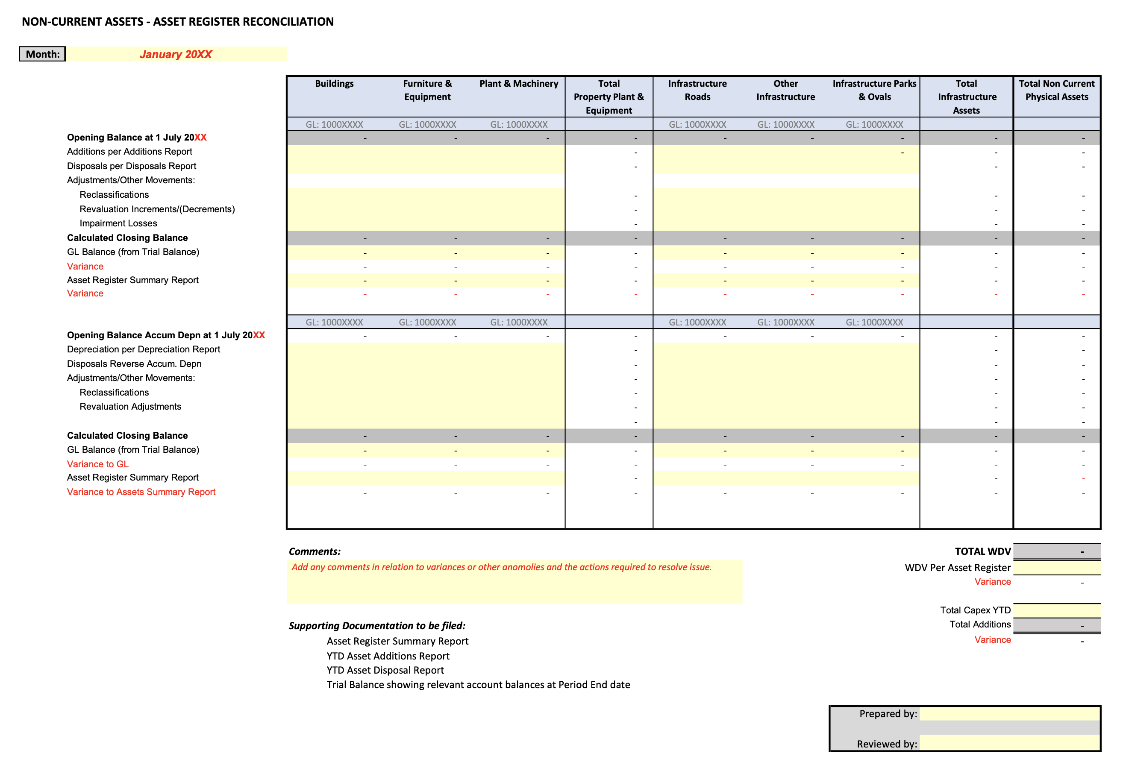

Related Guidance
Australian Accounting Standards Board (AASB) | https://aasb.gov.au/
Local Government Act 1995 and Associated Regulations | https://www.legislation.wa.gov.au/legislation/statutes.nsf/main_mrtitle_551_homepage.html
Office of the Auditor General – Better Practice Guide – Public Sector Financial Statements Toolkit | https://audit.wa.gov.au/reports-and-publications/reports/better-practice-guide-public-sector-financial-statements/
Template 1 – Checklist for Asset Accounting | https://www.dlgsc.wa.gov.au/docs/default-source/local-government/financial-policy-and-accounting/template-1---checklist-for-asset-accounting.docx
Template 2 – Impairment Test Questionnaire | https://www.dlgsc.wa.gov.au/docs/default-source/local-government/financial-policy-and-accounting/template-2---impairment-test-questionnaire.docx
Template 3 – Reconciliation of Asset Ledger to General Ledger | https://www.dlgsc.wa.gov.au/docs/default-source/local-government/financial-policy-and-accounting/template-3---reconciliation-of-asset-ledger-to-general-ledger.xlsx

Disclaimer
Although every care has been taken in the production of these documents, neither the Crown in the right of the State of Western Australia nor any servant or agent of the Crown accepts responsibility for any loss or damage suffered at any time by any person as a result of any error, omission or inaccuracy in the publication whether or not the error, omission or inaccuracy has resulted from negligence or any other cause.

Version Control
Doc  No | Version No | Primary Author(s) | Description of Version | Date Completed
001 | 0.1 | Scoutta Pty Ltd t/a Business Beanies | Initial Draft | Oct 2022
002 | 0.2 | Suleila Felton, Anton Prinsloo & Alan Carmichael | Final Version | Nov 2022
003 | 0.3 | Tim Fraser | Approved | Jan 2023
004 | 0.4 |  | Next Review Date | Dec 2024

Disclaimer: Should any legislative amendments relevant to this document take effect prior to the next review date that the Introduction to Local Government Accounting Guidelines be immediately reviewed.

Compiled AASB Standard – AASB 116.6 – Property, Plant and Equipment – 31 December 2018, Page 5
Compiled AASB Standard – AASB 116.6 – Property, Plant and Equipment – 31 December 2018, Page 6
Compiled AASB Standard – Presentation of Financial Statement – AASB 101.66 – July 2010, Page 30
Compiled AASB Standard – Intangible Assets – AASB 138.8 – October 2015, Page 7
Local Government: Accounting for non-current physical assets under AASB 116 – A guide – May 2006, Page 6
Compiled AASB Standard – AASB 116.6 – Property, Plant and Equipment – 31 December 2018, Page 11
Compiled AASB Standard – Investment Property – AASB 140 – August 2014, Page 12
Ibid, Page 13
Compiled AASB Standard – Intangible Assets – AASB 138.8 – October 2015, Page 7
Compiled AASB Standard – Leases – AASB 16 – December 2019, Appendix A, Page 20
Compiled AASB Standard – AASB 116.16 – Property, Plant and Equipment – 31 December 2018, Page 7-8
Compiled AASB Standard – AASB 116.6 – Property, Plant and Equipment – 31 December 2018, Page 6
Ibid
Compiled AASB Standard – AASB 116.51 – Property, Plant and Equipment – 31 December 2018, Page 11-12
Ibid, 116.6, Page 6
Compiled AASB Standard – AASB 116.61 – Property, Plant and Equipment – 31 December 2018, Page 12
Circular No 02-2018 – Guide to Local Government Auditing Reforms – June 2018, Page 2
Accounting Standard – Property, Plant and Equipment – AASB116.G4 – July 2004, Page 32
WA Local Government Accounting Manual, Edition 3 – Section 9 – Asset Accounting, Page 38
Ibid
Compiled Accounting Standard – Impairment of Assets – AASB136.2, Page 8-9
Compiled AASB Standard – Impairment of Assets – AASB 136.12(e)(f)(g), Page 9

