Introduction to Local Government Accounting

Contents Page
1.0 Purpose 4
2.0 Scope 4
3.0 Definition of Terms and Abbreviations 4
4.0 Guidance 5
4.1 Introduction 5
4.2 Roles and Responsibilities 6
4.2.1 Council and Councillors 6
4.2.2 Chief Executive Officer (CEO) 7
4.2.3 Audit Committee 9
4.2.4 Local Government Finance Team 11
4.3 Integrated Planning and Reporting 12
4.3.1 Background 12
4.3.2 Strategic Community Plan 14
4.3.3 Corporate Business Plan 14
4.3.4 Long Term Financial Plan 15
4.3.5 Budget 15
4.3.6 Budget Review 16
4.3.7 Monthly Statement of Financial Activity 18
4.3.8 Annual Financial Statements 19
4.3.9 Management Reporting 20
4.4 Internal Control and Risk Management 21
4.4.1 Risk Management 21
4.4.3 Segregation of Duties 25
4.4.4 Documented Procedures 26
4.4.5 Experience and Qualification of Staff 26
4.4.6 IT Controls 27
4.4.7 Monitoring and Control Activities 28
4.4.8 Application of Controls to Different Sized Local Governments 35
4.4.9 Lines of Defence Model 36
4.5 Policies, Procedures and Delegations 37
4.5.1 Policies 38
4.5.2 Procedures 45
4.5.3 Delegations 45
4.6 Local Government Accounting 46
4.6.1 Basic Accounting Concepts 46
4.6.2 Account Structures 47
4.6.3 Classification of Financial Transactions 50
4.6.4 Activity Based Costing (ABC) 52
4.6.5 Balance Day Adjustments 53
4.7 Procurement to Payment 55
4.7.1 Purchasing 55
4.7.2 Tenders 55
4.7.3 Payment of Accounts 56
4.7.4 Credit Cards 58
4.7.5 Identifying and Minimising Risk in Procurement 59
4.8 Audits and Reviews 61
4.8.1 Annual Financial Report Audit 62
4.8.2 Financial Management Regulation Review (FM Reg 5.) 62
4.8.3 Audit Regulation Review (Audit Reg 17) 63
4.8.4 Internal Audit 64
4.8.5 Other Audits 65
4.9 Appendices and Templates 66
Appendix 1 - Finance Reporting and Compliance Checklist - (the Act and Regulations) 66
Appendix 2 - Nature and Type Classifications 68
Appendix 3 - Program Classifications 69
Appendix 4 - Alphabetical List of Transactions – Program Classification 77
Template 1 - Example Budget Plan 91
Template 2 - Example Month End Checklist 92
Template 3 - Example Activity Based Costing Worksheet 93
5.0 Further Resources and Training 94
6.0 Related Guidance 95
7.0 Disclaimer 96
8.0 Version Control 96

1.0 Purpose
This guide provides a foundation understanding of accounting for local government finances.

It is not meant to be prescriptive or fully comprehensive. Users should ensure that they consider how each topic applies to their local government. They should also apply the requirements of the Local Government Act 1995 (the Act), its associated Regulations, the Australian Accounting Standards (AAS) and any other applicable laws.

2.0 Scope
This guide applies to all local government entities in Western Australia in accordance with the Act and its associated Regulations. It is designed to primarily assist local government finance officers and, where appropriate, non-finance officers, to understand the function and role of local government finance.

3.0 Definition of Terms and Abbreviations

Term | Definition
Admin Regs | Local Government (Administration) Regulations 1996
Annual Budget | means the annual budget adopted by a local government under section 6.2 of the Act and must consider all expenditure, revenue and income of the LG. (Act 1995 section 6.2(3))
AAS | Australian Accounting Standards - a framework for the administration and financial management of local government
Audit Regs | Local Government (Audit) Regulations 1996
Budget Deficiency | means, in relation to a financial year, the amount referred to in section 6.2(2)(c) of the Act
CEO | Chief Executive Officer (of a Local Government)
DLGSC | The Department of Local Government, Sport and Cultural Industries
F&G Regs | Local Government (Functions and General) Regulations 1996
FM Regs | Local Government (Financial Management) Regulations 1996
Financial Report | provides users of the report, (Council and the community) sufficient information in order to assess the financial performance and position of a local government at the end of each financial year
the Act | Local Government Act 1995
LG Professionals WA | Local Government Professionals Australia WA
LTFP | Long-Term Financial Plan
OAG | Office of the Auditor General
Trust Fund | means the trust fund established by a local government under section 6.9 of the Act
WALGA | Western Australian Local Government Association
WATC | Western Australian Treasury Corporation
COA | Chart of Accounts

4.0 Guidance

4.1 Introduction

Effective processes and procedures are critical for the efficient management of local governments, and for the protection of assets used for the delivery of services.

To achieve this, and to ensure the sustainability of a local government’s long-term financial performance and position, local governments should embrace the principles of good governance.

The Act and associated Regulations, and the AAS provide the framework for the administration and financial management of local government.

Excerpts of relevant legislation is included within this guide. To ensure good practice, users of this guide should always go to the source, such as the section of the Act being referred to, to ensure that it is read in context.

This will also ensure that no amendments of updates have been made since this guide was last reviewed. Western Australian legislation, including any subsidiary legislation, can be found at www.legislation.wa.gov.au.

The AAS can be found at https://aasb.gov.au/

4.2 Roles and Responsibilities

The Act and its associated Regulations define the roles and responsibilities of Council, Councillors, and the CEO. Also relevant to the local government finance officer are the roles and responsibilities of the Audit Committee and the OAG, which are also referred to in the Act.

The local government finance team plays a key role in enabling the CEO, Council and Councillors to fulfil their duties in the sustainability, safeguarding and financial management of a local government.

The Local Government Reform Agenda announced by the Minister of Local Government contains significant initiatives around:
- Earlier intervention, effective regulation and stronger penalties
- Reducing red tape, increasing consistency and simplicity
- Greater transparency and accountability
- Stronger local democracy and community engagement
- Improved financial management; and reporting
- Clearer Roles and Responsibilities
Further details can be found at: - https://www.dlgsc.wa.gov.au/local-government/strengthening-local-government/local-government-act-reform .

Readers of this document should monitor the DLGSC website for updates on the roll out and implementation of the Minister’s Local Government Reform Agenda.

4.2.1 Council and Councillors
To get the best outcomes for the local community Councils need to plan and take on the responsibilities for the local government’s financial performance and the allocation of its resources.

The roles and responsibilities of Council and Councillors are prescribed by the Act:

Council | Councillors
2.7. Role of council  (1) The council —  (a) governs the local government’s affairs; and  (b) is responsible for the performance of the local government’s functions.  (2) Without limiting subsection (1), the council is  to —  (a) oversee the allocation of the local government’s finances and resources; and  (b) determine the local government’s policies. | 2.10. Role of councillors  A councillor —  (a) represents the interests of electors, ratepayers and residents of the district; and  (b) provides leadership and guidance to the community in the district; and  (c) facilitates communication between the community and the council; and  (d) participates in the local government’s decision-making processes at council and committee meetings; and  (e) performs such other functions as are given to a councillor by this Act or any other written law.

Additional roles and responsibilities for the Mayor or President and the Deputy Mayor or Deputy President are outlined in sections 2.8 and 2.9 of the Act respectively.

Governing Finances

For Council to be in a position to ensure they are responsible for the financial affairs of a local government, information via reports to Council or an Audit Committee are provided throughout the year.

Examples of the reports that are prescribed for Council review and resolution are:

- Plan for the Future
- Annual Budget
- Annual Budget Review
- Annual Financial Statements
- Monthly Statement of Financial Activity
- Accounts for Payment and Credit Card Payment Reports
- Compliance Audit Return

The following Regulations refer to the effectiveness of a local government’s systems and procedures.

However, the Local Government (Financial Management) Regulations 1996 (FM Regs) relate to the CEO’s duties regarding financial management. The Local Government (Audit) Regulations 1996 (Audit Reg) refer to the requirement for the CEO to review certain systems and procedures.

- Review of Financial Management Systems (FM Reg 5), as referenced on Page 8.
- Review of Systems and Procedures (Audit Reg 17), as referenced on Page 8.

4.2.2 Chief Executive Officer (CEO)
General Functions of the CEO

The CEO is the chief non-elected officer of a local government. Their general function is to advise and provide information to Council in relation to the local government’s functions and ensure the resources of the local government are effectively and efficiently managed.

CEOs are also responsible for the employment, management, supervision, direction and dismissal of other employees and proper keeping of records and documents of the local government. The CEO’s functions are detailed in Section 5.41 of the Act.

Financial Management Responsibilities of the CEO

The specific duties of the CEO as they relate to the financial management of a local government are outlined in Regulation 5 of the FM Reg.
5. CEO’s duties as to financial management

(1) Efficient systems and procedures are to be established by the CEO of a local government —

(a) for the proper collection of all money owing to the local government; and

(b) for the safe custody and security of all money collected or held by the local government; and

(c) for the proper maintenance and security of the financial records of the local government (whether maintained in written form or by electronic or other means or process); and

(d) to ensure proper accounting for municipal or trust —
(i) revenue received or receivable; and
(ii) expenses paid or payable; and
(iii) assets and liabilities; and

(e) to ensure proper authorisation for the incurring of liabilities and the making of payments; and

(f) for the maintenance of payroll, stock control and costing records; and

(g) to assist in the preparation of budgets, budget reviews, accounts and reports required by the Act or these regulations.

(2) The CEO is to —

(a) ensure that the resources of the local government are effectively and efficiently managed; and

(b) assist the council to undertake reviews of fees and charges regularly (and not less than once in every financial year); and

(c) undertake reviews of the appropriateness and effectiveness of the financial management systems and procedures of the local government regularly (and not less than once in every 3 financial years) and report to the local government the results of those reviews.

Importantly, as prescribed in FM Reg 5(2)(c), the CEO is to undertake a review of the appropriateness and effectiveness of the financial management systems and procedures of the local government regularly (and not less than once in every 3 financial years). The CEO reports the results of those reviews to the local government. More information on what is commonly referred to as the FM Reg 5 review can be found at section 4.8.2 of this document.

CEO’s responsibility to review certain systems and procedures

Further to the review required under FM Reg 5, Audit Reg 17 requires a local government’s CEO to undertake a review of the appropriateness and effectiveness of a local government’s systems and procedures in relation to:

- risk management,
- internal control and
- legislative compliance.

The review may relate to any or all of the matters referred to in Audit Reg 17(1)(a)(b) and (c), but each of these matters is to be the subject of a review not less than every 3 financial years, with the findings reported to the local government’s audit committee.

This review is not solely focussed on areas regarding financial management but more broadly across the organisation. However, due to the level of risk the finance systems and procedures as they relate to risk management, internal control and legislative compliance are usually reviewed more regularly than other areas within local government. More information on this review can be found in section 4.8.3 of this document.

4.2.3 Audit Committee
Part 7 – Audit, of the Act requires that all local governments establish an Audit Committee. An Audit Committee plays a key role in assisting a local government to fulfil its governance and oversight responsibilities in relation to:

- financial reporting
- internal control structures
- risk management systems
- legislative compliance
- ethical accountability and
- internal and external audit functions.

7.1A. Audit committee

(1) A local government is to establish an audit committee of 3 or more persons to exercise the powers and discharge the duties conferred on it.

(2) The members of the audit committee of a local government are to be appointed* by the local government and at least 3 of the members, and the majority of the members, are to be council members.
* Absolute majority required.

(3) A CEO is not to be a member of an audit committee and may not nominate a person to be a member of an audit committee or have a person to represent the CEO as a member of an audit committee.

(4) An employee is not to be a member of an audit committee.

Members of an Audit Committee

In accordance with and further to section 7.1A of the Act; it is becoming common practice for local governments to appoint at least one independent member to the Audit Committee. This should be adopted by local governments as a best practice approach.

Functions of an Audit Committee
The role of the Audit Committee is to support Council in fulfilling its governance and oversight responsibilities.

The functions of an Audit Committee are prescribed in the Audit Regulations.

16. Functions of audit committee

An audit committee has the following functions —

(a) to guide and assist the local government in carrying out —
(i) its functions under Part 6 of the Act; and
(ii) its functions relating to other audits and other matters related to financial management;

(b) to guide and assist the local government in carrying out the local government’s functions in relation to audits conducted under Part 7 of the Act;

(c) to review a report given to it by the CEO under regulation 17(3) (the CEO’s report) and is to —
(i) report to the council the results of that review; and
(ii) give a copy of the CEO’s report to the council;

(d) to monitor and advise the CEO when the CEO is carrying out functions in relation to a review under —
(i) regulation 17(1); and
(ii) the Local Government (Financial Management) Regulations 1996 regulation 5(2)(c);

(e) to support the auditor of the local government to conduct an audit and carry out the auditor’s other duties under the Act in respect of the local government;
(f) to oversee the implementation of any action that the local government —
(i) is required to take by section 7.12A(3); and
(ii) has stated it has taken or intends to take in a report prepared under section 7.12A(4)(a); and
(iii) has accepted should be taken following receipt of a report of a review conducted under regulation 17(1); and
(iv) has accepted should be taken following receipt of a report of a review conducted under the Local Government (Financial Management) Regulations 1996 regulation 5(2)(c);

(g) to perform any other function conferred on the audit committee by these regulations or another written law.

More information on the appointment, function and responsibilities of Audit Committees can be found in Local Government Operational Guidelines Number 09 – Audit in Local Government. A link to this guideline is provided in section 6.0 - Related Guidance.

Office of the Auditor General (OAG)

In 2017, the Local Government Amendment (Auditing) Act 2017 came into force for the purpose of amending the Act to provide for the auditing of local governments by the Auditor General (OAG) and for related purposes.

The Auditor General’s role is detailed on the audit.wa.gov.au website as:

The Auditor General’s role is to audit the finances and activities of Western Australian State and local government entities and report their findings to Parliament.

Parliament seeks independent and impartial assurance from the Auditor General that public sector entities are providing services and using public money in accordance with Parliament’s purpose.

We provide this assurance through annual financial audits and a performance audit program. Our audit reports aim to increase transparency of the public sector, and where necessary make recommendations for improvements to an entity’s governance and efficiency and effectiveness of services.

To carry out their duties effectively, the Auditor General must act independently and be free from pressure, influence or interference from any source.

The OAG is responsible for conducting all financial audits of local governments in Western Australia.

The OAG also conducts other audits, such as performance audits, that may involve local governments.

Results of all of the audits (State Government and local government) that the OAG conducts along with other useful resources can be found on their website (www.audit.wa.gov.au).

These reports and resources hold useful information to ensure that your local government is conducting themselves in accordance with relevant legislation and to better practice standards.

4.2.4 Local Government Finance Team
In order to carry out its functions, a local government’s finance team usually includes the following key roles/areas of responsibility:

- Management and oversight.
- Financial accounting and reporting.
- Management accounting and reporting.
- Accounts receivable.
- Accounts payable.
- Rates.
- Treasury and banking.
- Payroll.
- Receipting.
- Fixed assets, plant and inventory management.
- Procurement, purchasing and tendering.

Depending on the size and scale of the local government, these may or may not be individual officer roles. At some local governments more than one area of responsibility will sit with an individual officer, some may be outsourced or a combination of all of these depending on the resources available at the time.

Importantly when combining roles and responsibilities sufficient segregation of duties must always be considered and maintained.

4.3 Integrated Planning and Reporting
The Local Government Reform Agenda announced by the Minister of Local Government contains proposals for simpler strategic and financial planning with a framework based around information being clear, transparent and easy to understand for all ratepayers and members of the public. Further details can be found at: - https://www.dlgsc.wa.gov.au/local-government/strengthening-local-government/local-government-act-reform .

Readers of this document should monitor the DLGSC website for updates on the roll out and implementation of the Minister’s Local Government Reform Agenda.

4.3.1 Background
The Act requires that each local government must have a ‘Plan for the Future’. The Plan for the Future should comprise of key documents, being a Strategic Community Plan and a Corporate Business Plan.

5.56. Planning for the future

(1) A local government is to plan for the future of the district.

(2) A local government is to ensure that plans made under subsection (1) are in accordance with any regulations made about planning for the future of the district.

The Strategic Community Plan sets out what the community would like their local government to achieve and the Corporate Business Plan outlines how the local government will go about achieving it.

Both the Strategic Community Plan and the Corporate Business plan require inputs from a local government’s other informing strategies, covering finances (Long Term Financial Plan, or LTFP), workforce, assets, service delivery and other key strategies.

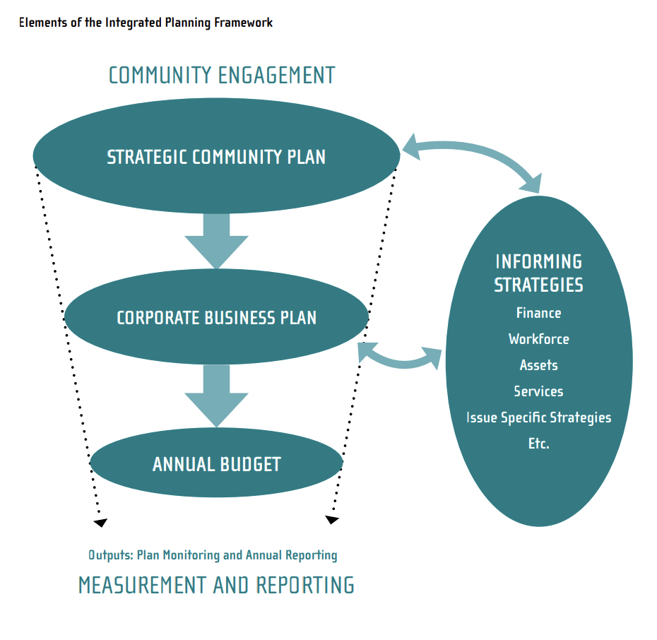
Various frameworks, guidelines and tools in relation to Integrated Planning and Reporting can be found on the DLGSC website. A link is provided in section 6.0 - Related Guidance of this document.

Some local governments have developed pictorial representations of the Integrated Planning and Reporting Framework, showing how the various strategies, plans, and reporting and management mechanisms link together to form the basis of the framework at their local government.

The following is an example from the City of Kwinana’s adoption of their Strategic Community Plan, Corporate Business Plan and Long-Term Financial Plan.

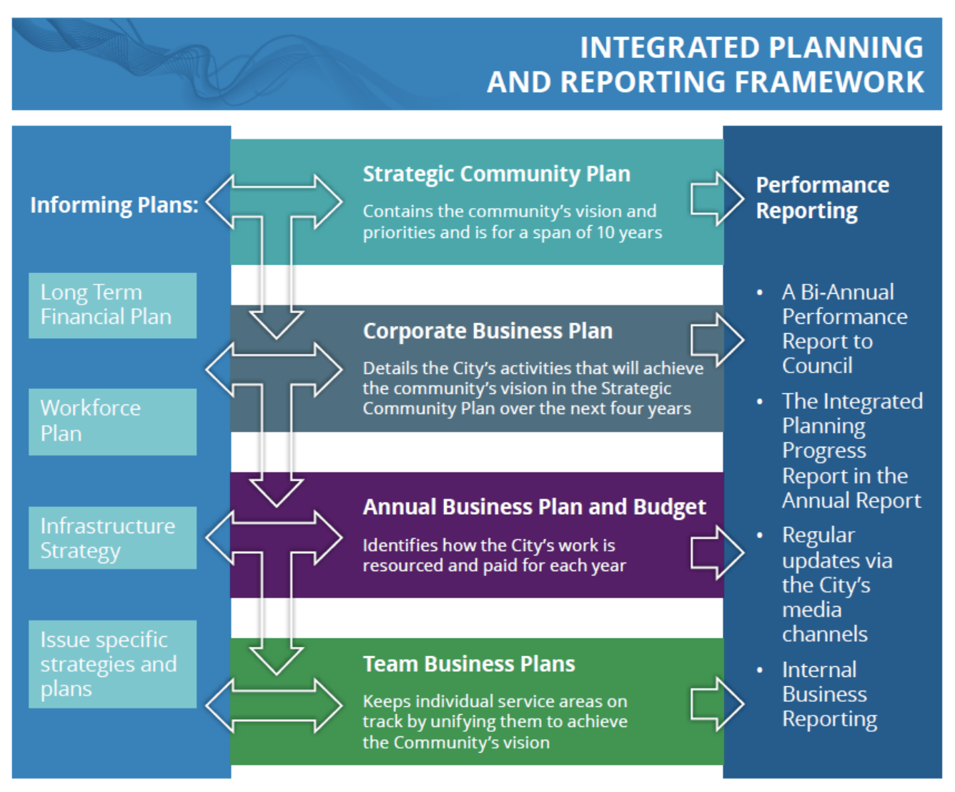
Source: https://www.kwinana.wa.gov.au/council/documents,-publications-and-forms/publications-and-forms-(all)/plans-and-strategies/2021/city-of-kwinana-long-term-financial-plan-2021-2041

4.3.2 Strategic Community Plan
The minimum requirements for the Strategic Community Plan are set out in Local Government (Administration) Regulations 1996 (Admin Reg) 19C. The Admin Regs require the Strategic Community Plan to go through a minor review every 2 years and a major review every 4 years.

The advertising requirements for the Strategic Community Plan are outlined in Admin Reg 19D.

4.3.3 Corporate Business Plan
The minimum requirements for the Corporate Business Plan are set out in Admin Reg 19DA. The Admin Regs require the Corporate Business Plan to cover a period of 4 years and is to be reviewed every year.

4.3.4 Long Term Financial Plan
Long term financial planning is a key element of the Integrated Planning and Reporting Framework. It enables local governments to set priorities, based on their resourcing capabilities, for the delivery of short, medium and long-term community priorities. The LTFP is a 10-year (minimum) rolling plan that informs the Corporate Business Plan to activate Strategic Community Plan priorities. From these planning processes, Annual Budgets that are aligned with strategic objectives can be developed.

The LTFP indicates a local government’s long term financial sustainability, allows early identification of financial issues and their longer-term impacts, shows the linkages between specific plans and strategies, and enhances the transparency and accountability of the local government to the community.

Developing a LTFP does involve extensive resources and a collaborative approach across the organisation. Including it, as part of the annual review process leading into the Budget, ensures that actions identified within the Strategic Community Plan and Corporate Business Plan can be achieved, as well as enabling management and Council to make decisions with an understanding of the longer-term financial impact on the local government. When done well, Year 1 of the LTFP should form the basis of the upcoming Annual Budget.

Like the LTFP, it is very likely that the finance team at a local government will be involved in developing other informing strategies such as the Asset Management Plans and Workforce Plans either as a standalone responsibility or in partnership with other departments. These plans are critical informing documents to the LTFP process.

More information on developing the Long-Term Financial Plan can be found in DLGSC Long Term Financial Planning Framework and Guidelines document. A link to these guidelines has been included in section 6.0 - Related Guidance of this document.

4.3.5 Budget
All local governments are required to adopt an annual budget in accordance with Part 6, Division 2 of the Act, Part 3 of the FM Regs and AAS.

The annual budget must be adopted between the period 1 June to 31 August each year (unless the Minister has provided for an extension to this timeframe).

6.2. Local government to prepare annual budget

- During the period from 1 June in a financial year to 31 August in the next financial year, or such extended time as the Minister allows, each local government is to prepare and adopt*, in the form and manner prescribed, a budget for its municipal fund for the financial year ending on the 30 June next following that 31 August.

*Absolute majority required.

Section 6.2(2) of the Act requires Council in formulating the budget, to have regard to the contents of the plan for the future of the district and prepare detailed estimates for the current year.

Section 6.2(4) of the Act sets out certain details that the annual budget is to incorporate and such other matters as prescribed.

Part 3, sections 22 and 33A of the FM Regs establish the form and content of the budget document and require a copy of the annual budget to be submitted to DLGSC within 30 days of adoption by Council.
The Local Government Reform Agenda proposes the adoption of a short Rates and Revenue Policy to provide greater clarity for ratepayers by linking the cost of services and the maintenance of assets (such as roads and recreation facilities) to the setting of rates.

Effective planning and control of a local government’s operations begins with the development of operational plans for achieving its organisational and financial objectives.

The budget is a detailed financial plan for the coming year covering all aspects of a Council’s operations and should reflect the resources generated by way of revenue and the resources consumed by way of expenditure.

The key objectives of budgeting in local government are:

- to provide a fiscal management tool for the carrying out of Council’s programs in the ensuing year
- to provide the means by which the Council is accountable to the community for the rates to be levied and
- to provide the basis for the setting of rates.

The annual budget is a short-term reflection of the local government’s plan for the future as outlined in the corporate business plan for that year. It represents, financially, the actions expected to be taken by the Council in achieving its objectives.

In addition to its planning aspects, the budget can and should be used by management as one of the benchmarks against which actual performance can be measured. This can be achieved by reporting actual results against budgeted figures to provide management and the Council with information on progress against its plan, use of resources and accountability for performance.

As a short-term operational plan, the annual budget is directed to the ultimate objectives of the Council and serves as a guide to maintaining a definite course of activity. It is imperative that all budget estimates such as capital works and new proposals are developed in accordance with the local government’s plan for the future. Managers must be motivated to achieve their individual operational objectives in line with the local government’s objectives.

Above all, the budget must be realistic and achievable at all levels within the local government if it is to be used as a benchmark against actual performance.

Developing the annual budget can take considerable time and resources not only from the finance team, but from all operational areas of the local government. An example project plan for the annual budget can be found at Template 1. Included in this example are the compliance and key dates associated with the annual budget.

4.3.6 Budget Review
Best endeavours to forecast for the upcoming 12 months of operations is anticipated, through the setting of a local government’s annual budget and the identification of variables changes. Income and expenditure that was expected to be received/incurred may change for a number of reasons throughout the year.

FM Reg 33A requires local governments to conduct a budget review between 1 January and 31 March each financial year. The intention of the legislation is to ensure local governments conduct at least 1 budget review between 6 and 8 months into a financial year.

33A. Review of budget

(1) Between 1 January and 31 March in each financial year a local government is to carry out a review of its annual budget for that year.

(2A) The review of an annual budget for a financial year must —

(a) consider the local government’s financial performance in the period beginning on 1 July and ending no earlier than 31 December in that financial year; and

(b) consider the local government’s financial position as at the date of the review; and

(c) review the outcomes for the end of that financial year that are forecast in the budget.

(2) Within 30 days after a review of the annual budget of a local government is carried out it is to be submitted to the council.

(3) A council is to consider a review submitted to it and is to determine* whether or not to adopt the review, any parts of the review or any recommendations made in the review.
*Absolute majority required.

(4) Within 30 days after a council has made a determination, a copy of the review and determination is to be provided to the Department.

A budget review is a detailed comparison of the year-to-date actual results with the adopted or amended budget, and a re-forecast/re-budget of the remainder of the year’s expected results. It establishes whether a local government continues meeting its budget commitments, is in receipt of income and incurs expenditure in accordance with the adopted budget.

Local governments should consider reviewing their budget on a regular basis, as well, as the statutory requirement between the above dates. Better practice would indicate that the budget is reviewed on a quarterly basis and be undertaken on a line-by-line basis, while ensuring that it is monitored through the monthly statement of financial activity and other reporting mechanisms.

It is extremely important for a local government to review the budget immediately following the annual financial statements being completed and audited. Very often the actual carried forward figure in the budget will differ from the audited actual carried forward figure and this should be adjusted by a budget variation adopted by Council.

Note: If prior budget reviews have been undertaken, the FM Reg 33A budget review must still cover the period from 1 July and also cover any adjustments made as a result of prior reviews. This can usually be addressed by including an additional column in the statutory review headed ‘Previous Budget Review’ or ‘Current Budget’ or similar.

4.3.7 Monthly Statement of Financial Activity
A local government is to prepare a Statement of Financial Activity each month as prescribed by section 6.4 of the Act and FM Reg 34. This report is a key tool for a Council to be able to monitor the performance of a local government and to carry out their duties in respect to financial management.

The monthly statement of financial activity is to include a comparison of actual results with budget estimates and a summary of the net assets at the end of the month to which the statement relates.

Material variances between the actual revenue and expenditure and the comparable year to date budget estimates should be investigated and included in a report, along with the reasons for the variances.

There needs to be an explanation of the composition of the net current assets at the end of the month to which the statement relates less committed and restricted assets.

The monthly statement of financial activity must be prepared and presented by nature and type (FM Reg 34(3)).

Each financial year, a local government is to adopt a percentage or value, calculated in accordance with the AAS to be used in statements of financial activity for reporting material variances.

The monthly Statement of Financial Activity is to be presented to Council at an Ordinary Council Meeting of the Council within 2 months after the end of the month to which the statement relates.

Whilst FM Reg 34 sets out the minimum requirements for the statement, FM Reg 34(2)(c) sets out that a local government is to include any other supporting information, as is considered relevant by the local government. Officers must keep in mind the users of the information, being Council for decision making and oversight and through the report for information to the community. The needs of management in managing the day-to-day operations and financial management of the business of a local government will be different to that of Council.

34. Financial activity statement required each month

(1A) In this regulation — committed assets means revenue unspent but set aside under the annual budget for a specific purpose.

(1) A local government is to prepare each month a statement of financial activity reporting on the revenue and expenditure, as set out in the annual budget under regulation 22(1)(d), for that month in the following detail —

(a) annual budget estimates, taking into account any expenditure incurred for an additional purpose under section 6.8(1)(b) or (c); and

(b) budget estimates to the end of the month to which the statement relates; and

(c) actual amounts of expenditure, revenue and income to the end of the month to which the statement relates; and

(d) material variances between the comparable amounts referred to in paragraphs (b) and (c); and

(e) the net current assets at the end of the month to which the statement relates.

(2) Each statement of financial activity is to be accompanied by documents containing —

(a) an explanation of the composition of the net current assets of the month to which the statement relates, less committed assets and restricted assets; and

(b) an explanation of each of the material variances referred to in subregulation (1)(d); and

(c) such other supporting information as is considered relevant by the local government.

(3) The information in a statement of financial activity must be shown according to nature or type classification.

(4) A statement of financial activity, and the accompanying documents referred to in subregulation (2), are to be —

(a) presented at an ordinary meeting of the council within 2 months after the end of the month to which the statement relates; and

(b) recorded in the minutes of the meeting at which it is presented.

(5) Each financial year, a local government is to adopt a percentage or value, calculated in accordance with the AAS, to be used in statements of financial activity for reporting material variances.

4.3.8 Annual Financial Statements
In accordance with the Act and the AAS, a local government is to prepare an annual financial report for each year. An annual financial report provides users of the report, (Council and the community) sufficient information in order to assess the financial performance and position of a local government at the end of each financial year.

The timeframe for completing the annual financial report is set by the Act. By 30 September following the completion of each financial year, a local government is to submit to its auditor the accounts and annual financial report balanced up to the last day of the preceding financial year.

For example, for the financial year ended 30 June 2022, the accounts and report must be submitted to its auditor no later than 30 September 2022 – unless the Minister for Local Government has provided an extension to this time under section 6.4(3) of the Act.

6.4. Financial report

(1) A local government is to prepare an annual financial report for the preceding financial year and such other financial reports as are prescribed.

(2) The financial report is to —

(a) be prepared and presented in the manner and form prescribed; and

(b) contain the prescribed information.

(3) By 30 September following each financial year or such extended time as the Minister allows, a local government is to submit to its auditor —

(a) the accounts of the local government, balanced up to the last day of the preceding financial year; and

(b) the annual financial report of the local government for the preceding financial year.

FM Regs 36 – 49 outlines the required information to be included in the annual financial report, over and above any required disclosures determined by the ASS.

FM Reg 51 Requires a local government to submit to the DLGSC CEO within 30 days of the receipt of the auditor’s report on the financial report.

To assist local governments in preparing their annual financial statements, DLGSC has developed a set of model annual financial statements and associated guidelines. A link to the model statements can be found in section 6.0 - Related Guidance of this document.

Another substantial resource when planning for and preparing annual financial statements is the OAG’s Better Practice Guide for Western Australian Public Sector Financial Statements.

A link to the Guide can be found in section 6.0 - Related Guidance of this document.

4.3.9 Management Reporting
While there are a number of reporting requirements set out by legislation that a local government finance team has to prepare, these are usually focussed on providing information to Council, the community or other external users of that information.

An important role that a local government finance team plays is to ensure that internal users, such as the CEO, executive and management have the necessary information (both financial and non-financial) to ensure the operations of a local government are conducted efficiently and sustainably.

Management reports are usually bound by few rules (legislatively) and are therefore less formal. They are developed in a format, and tailored specifically, to suit the needs of the user and can be provided at varying levels of detail.

For example, a human resources manager may require information on the number of employees that have opted for Council co-contributed superannuation or a report on the hours and value of a worker’s compensation claim. Other examples are business unit or DLGSC reporting of budget, actuals and forecasts to enable business unit managers to effectively monitor their operations and budgets.

the local government finance officer should work collaboratively with the whole organisation to understand its information needs. They should also provide analysis on what the information is saying and assist in providing insights into areas of risk or need for improvement or even where successes could be celebrated, replicated and/or shared across the organisation.

4.4 Internal Control and Risk Management

The custodial role played by a local government in managing public assets brings with it a high expectation of public accountability and transparency.

Ensuring a high level of accountability and transparency requires the maintenance of a compliance culture and promotion of a sound internal control environment developed within a risk management framework.

Accountability and transparency within an organisation are heavily influenced by the ‘tone at the top’. The actions of the CEO in requiring compliance with the legislative framework and internal policies and procedures are critical to maintaining accountability and transparency.

An effective system of internal controls provides a level of assurance that financial information is reliable, and the local government is meeting compliance requirements applicable to the regulations and internal procedures.

In an environment that is constantly changing, and unpredictable, local governments are facing ever-evolving risks to the organisation (such as cyber security, fraud and environmental risk).

Achieving regulatory compliance should be viewed as the minimum goal of an effective internal control system with further enhancement being ongoing as part of an overall organisational risk management process.

Developing the appropriate internal controls to minimise the risks, fraud or error to an acceptable level is achieved through a sound understanding of both the legislative framework (discussed throughout this document) and risk management practices and procedures.

4.4.1 Risk Management
The coordination of activities to direct and control an organisation regarding risk is known as risk management.

When local governments set objectives under their budget or any other plan, they are exposed to risks or ‘uncertainties’ which need to be managed to meet the objectives set out in their budget or plan.

The International Risk Management Standard ISO 31000 Risk Management defines ‘risk’, as the ‘Effect of uncertainty on objectives’.

Effect is defined as a deviation from the expected either positive and/or negative. It is worth noting within this definition, risk is not only the existence of ‘hazards’ but relates to the uncertainty in achieving an objective.

The risk management standard sets out key principles which need to be complied with for risk to be effectively managed. Under the associated framework, information about risk is identified in a risk management process and adequately reported and used as a basis for decision making at all relevant organisational levels. The risk management process is shown in the diagram below.

Risk Management Process

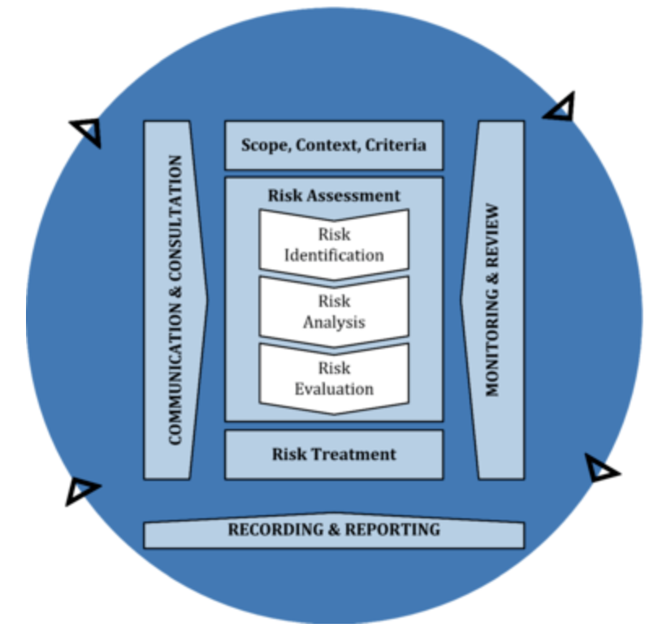

Source: ISO 31000 Risk Management – Guidelines

Every local government should consider developing a tailored risk management framework and make it an integral part of the organisation.

The following risk areas arise from the accountability and transparency requirements placed on local government and should be addressed through a risk management process:

- Waste - the misuse of resources.
- Financial prudence - being careful with money.
- Probity - the high standard of ethical behaviours expected of the staff, management, and governing bodies of public sector entities.
- Propriety - appropriateness to the purpose or circumstances.
- Compliance - adherence to applicable laws, regulations, and policy requirements.

Most local governments have a risk management framework in place. However, where a local government does not yet have a risk framework this should be a high priority. This will enable the local government to identify and manage organisational levels of risks, as well as operational risks.

The following table presents several typical financial risks areas for local governments and provides a useful basis for performing a risk assessment for financial management. The nature of financial risks is such that the list cannot be relied on as being exhaustive and does not substitute undertaking a formal risk assessment process by the local government.

Table 1 - Examples of Typical Financial Risk Areas
Financial Areas | Risk Areas
Strategic Financial Planning and Reporting | - Annual budget  - Annual Financial Report  - Statement of Financial Activity  - Long term financial plans  - Asset management plans  - Workforce plans  - Corporate business plans
Revenues | - Receipting  - Rates including interim and back rates  - Operating grants  - Subsidies and Contributions  - Financial contributions  - Non-financial contributions  - Fees and charges  - Service charges  - Investment/interest income  - Other revenue
Expenditure | - Purchasing and procurement and receiving of goods  - Utility Changes and Insurance  - Employee costs  - Credit cards  - Elected members expenses  - Employee reimbursements  - Other expenses
Assets | - Cash floats and petty cash bank accounts and banking  - Investments  - Rates receivables  - Trade receivables  - Property plant and equipment  - Infrastructure assets  - Prepayments  - Loans to clubs/community groups  - Inventory  - Depreciation  - Project costing
Liabilities | - Trade payables  - Other payables  - Borrowings  - Employee liabilities  - Accrued expenses  - Taxation
General Ledger | - Routine journals  - Cost reallocations  - Error corrections  - Period end processing  - Reconciliation  - Chart of accounts  - Sub ledger
External Services | - Contracting
Information Technology | - General IT risks  - Application IT risks i.e. Cyber Security

More information on developing a framework and embedding it into the organisation can be found by accessing ISO 31000 or through the DLGSC – Risk Management Resources found at:

https://www.dlgsc.wa.gov.au/docs/default-source/local-government/integrated-planning-and-reporting/integrated-planning-and-reporting---risk-management-fact-sheets.pdf?sfvrsn=f4e6adea_3
4.4.2 Internal Control Environment

Internal control environments may be viewed as 5 interrelated elements which impact on the financial reporting objectives of a local government. These 5 elements are represented in the following diagram.

Control Environment

Refers to the attitude, awareness and actions of Council and staff towards internal controls and good governance. The control environment has the broadest impact of any of the elements and is the most pervasive.

Risk Assessment

The purpose of an internal control is to mitigate business risks including error and fraud. As all controls carry a cost of implementation, no control should exist which does not mitigate risk. Therefore, the identification of risks is of paramount importance when establishing, implementing or reviewing controls.

Information Systems

Information systems usually combine manual operations and computerised activity. These systems should provide the appropriate records for maintaining accountability and allow the CEO to fulfil part of their obligations under the Act and FM Regs.

Control Activities

The day-to-day operational policies and procedures which assist to ensure management directives are carried out are referred to as control activities. These controls include performance review activities and physical controls over assets, as well as general and application controls over IT systems. Control activities exist for operational and financial processes with some control activities covering both processes.

Control activities for financial processes impact on the ability of the organisation to meet its financial reporting objectives. Policies and legislation inform the drafting of operational procedures and the segregation of duties, form the two primary elements of control activities over financial processes. This includes:

- authorisation and approval
- reconciliation, review and physical security.

This is due to their function as entity level controls and their impact on many applications process controls.

Monitoring of Controls

The ongoing assessment of the design and operating effectiveness of controls along with the corrective actions helps the Council and the CEO ensure appropriate controls exist and are being implemented.

4.4.3 Segregation of Duties
A fundamental application of internal control is the segregation of duties which relies on the premise that the risk of two or more officers making the same error or colluding to defraud the local government is less than an individual act.

The design and implementation of internal controls will vary widely between local governments due to variations in the size and the complexity of operations. It is recognised small local governments with less staff and limited resources have a reduced capacity to segregate duties.

In the absence of full segregation, the increased involvement of the CEO and other knowledgeable senior staff in checking transactions and controls takes on a greater significance in reducing the risk that material error will go undetected and uncorrected.

The primary internal control weakness in these situations is the comparative ease with which senior officers may override the internal controls. Management override may be mitigated by the establishment of well documented procedures and policies with systems to ensure these policies and procedures are followed and regularly reviewed.

A policy or procedure containing a requirement for the officer authorising a purchase order not to be permitted to also authorise the payment of the purchase, would help minimise the risk of fraud or error.

The existence of the written policy would empower the accounts payable officer to request authorisation for payment from a person (with the appropriate delegated authority), who was not involved in generating the purchase order. In the absence of a written policy or procedure this control may not be consistently applied particularly if the role is subject to high levels of staff turnover.

In larger and more complex local governments, well documented procedures and policies should exist requiring a high level of segregation of duties. This will limit the opportunities for material misstatement, whether due to fraud or error. Regardless of how well designed and implemented an internal control is, major limitations to their effectiveness will remain. These limitations include:

- the human judgements required in any control system and the simple human failures which may occur within any system (such as errors or mistakes)
- circumvention of internal control by the collusion of two or more people
- inappropriate override of internal control.

The inherent weaknesses in internal controls when combined with a reduced segregation of duties, such as in smaller local governments, results in a need for increased staff training, more direct staff supervision and greater monitoring. Timely monitoring of performance against budget by management and the Council is also an effective means of compensating for a lack of segregation of duties and the inherent weaknesses in internal controls.

4.4.4 Documented Procedures
Some people view internal controls as a bureaucratic hurdle to be overcome. This may be the case for poorly designed internal controls. However, well designed and documented controls can achieve the following:

- Compliance with policies, plans, procedures, laws and regulations.
- Efficient, economical and effective use of resources.
- Accomplishment of established objectives and goals for operations or programs.

Clarity and continuity in the operation of any internal control is achieved by documenting the controls appropriately. Appropriate control documentation has the effect of clarifying the control activity. It creates the appropriate control environment by improving the awareness and actions of staff.
Control documentation may take many forms, however, appropriate control documentation contains five elements to evidence how transactions are:

- initiated
- authorised
- recorded
- processed
- reported.

The responsible employee for each of the 5 elements of the procedure should be documented along with the frequency with which each element is to be performed (daily, weekly, monthly, annually or non-routine).

Documented procedures detailing the course of action, should a breach of internal controls occur, should exist to ensure breaches are recorded and appropriate corrective action is taken to avoid reoccurrence.

New or amended control documentation should follow a clearly defined process to ensure all relevant staff are aware of the new or amended control and have been appropriately trained in its application.

Retention of documents resulting from the operation of a control is essential to not only provide evidence of its existence and operation but also to provide a trail in the event of a breakdown of the control.

Documentation retention is required even when the control operates in an IT environment. This will often take the form of transaction logs or audit trails which should be verified to ensure the logs are recording sufficient appropriate detail of the operation of the control.

4.4.5 Experience and Qualification of Staff
Control activities require an element of judgement based on the experience and qualification of the staff implementing and monitoring the control irrespective of the size of the local government. The greater the risk treated by the control or the lower the level of documentation of the control, the higher level of experience and knowledge required.

Small local governments with little or no documented control procedures are heavily reliant on the competency of a relatively small number of staff in order to reduce risk through their ability to detect and correct material errors. Recruitment of inexperienced or unqualified staff into these environments may result in material errors remaining undetected and uncorrected resulting in a significant negative impact on the operations of the local government.

Large local governments with advanced risk management processes in place are far less exposed to the impact of inexperienced or unqualified staff as the risk they pose is addressed through the risk management process. The high level of documentation of control activities and extensive monitoring and review which exists in these organisations results in a reduced need for judgement.

Regardless of the size of the local government staff involved in the review and monitoring of controls require a higher level of experience and knowledge than those responsible for undertaking the control procedure. The higher level of judgement required will by its very nature require a far greater understanding of the wider context within which the control procedure is being applied.

Some smaller local governments find it difficult to engage experienced knowledgeable employees and need to resource training of any inexperienced employees to a level where they will be able to prevent, detect and appropriately report errors when they occur. Reliance on IT systems to provide a satisfactory level of control where experienced staff are not available is not a solution due to the risks associated with IT environments. Where resourcing, capability and capacity are a challenge, local governments should consider options such as, outsourcing, resource sharing and training and mentoring programs.

4.4.6 IT Controls
As with other controls there are 2 types of controls that exist within the IT environment:

- General IT Controls
These are controls over the wider IT environment of the local government; they include such items as virus protection, backups, system password and access controls.

- Application IT Controls
These are controls within the specific IT applications and include such items as application password and access controls, data field validations, processing restrictions and reporting restrictions.

The extensive use of IT to record, validate, collate and report financial transactions makes the IT control environment an excellent area to implement a number of financial process or application controls. However, these application controls may be significantly undermined by a lack of appropriate general controls.

Granting IT administrators administration rights to all applications, a lack of appropriate backups or the ability of someone to “hack” into the IT system are all examples of general IT control risks which will undermine the effectiveness of the best application controls.

Understanding and assessing the risks within an IT environment requires extensive IT knowledge and experience and may require the use of external parties in the case of small entities. As with other financial controls the review and assessment of these systems should be done by someone independent of the day-to-day management of the IT environment.

The OAG has completed local government information systems audits as part of their program. The results of these audits are published on the OAG’s website and provide key recommendations in managing IT-related risks and ensuring appropriate controls are in place. Better practice guides to assist the local governments perform efficiently and effectively are also available on the OAG website https://audit.wa.gov.au/reports-and-publications/reports/regulation-and-support-of-the-local-government-sector/ and include:

- cyber security
- fraud prevention
- procurement
- purchase cards.

4.4.7 Monitoring and Control Activities
Monitoring provides a level of assurance of the effectiveness of key financial controls. It is acknowledged that monitoring the effectiveness and operation of all controls at all times even in the largest local governments may be difficult. However, monitoring should be performed on a routine and timely basis for all medium to high-risk areas. In the case of low-risk areas, the intervals between monitoring may be extended based on an assessment of the risk(s).

Higher risk areas such as cash (electronic or physical) need to be monitored frequently and in some cases daily. Monitoring should be performed by someone independent of the preparation or processing of the relevant information. Signing and dating of reviews by the reviewer is an essential part of the process, as it provides evidence of the review and helps ensure the task is performed.

In line with a risk-based approach whenever system weakness is identified, management should take remedial action in a timely basis to minimise the risks.

The limited resources and number of staff in small local governments results in a reduced capacity to segregate tasks. However, regardless of the size of the local government it is important for certain key control activities to be undertaken due to the inherent high risks associated with various transactions.

The table below presents a number of key monitoring and control activities within local government finance. This list is not exhaustive but rather a minimum level of monitoring and control activities which should be conducted in addition to any legislative requirements and any additional activities identified by the risk management process.

Table 2 - Key Monitoring and Control Activities within Local Government Finance

Risk Area | Monitoring Activities | Control Activities
Annual Budget | - Monthly actuals are compared to budget and significant variances fully investigated and explained. | - Employees responsible for budget preparation are competent and adequately trained.  - Accounting software used contains application controls that prevent or detect an error from occurring.
Financial Reporting | - Through the presentation of the Monthly Statement of Financial Activity (SFA) to Council, actual results are compared to budget each month; management reviews, investigates and explains significant variances. | - Employees responsible for financial report preparation are competent and adequately trained.  - All journal entries require supporting documentation. Any non-routine entries require documented approval prior to being posted.  - Accounting software used contains application controls that prevent or detect an error from occurring.
Payroll | - Management reviews employee costs against budget on a monthly basis and investigates any outstanding items.  - Each departmental manager performs a regular review of reports detailing all employees listed on payroll master file; all unusual items are investigated.  - Salary and hourly payroll reports (including compensation and withholding information) are reviewed and approved by management before payments are approved.  - The payroll deduction table data is periodically reviewed by management for accuracy and ongoing pertinence.  - Management reviews a selection of salary sacrifice calculations for accuracy and compliance with statutory requirements; identified errors are promptly corrected.  - Each pay run is reviewed prior to authorisation for payment for consistency with prior pay runs and for abnormal items such as overtime. | - Payroll staff are competent in their assigned tasks, adequately trained and supervised.  - Person(s) processing payroll are independent of other payroll functions, such as hiring/firing of staff, timekeeping and EFT payment.  - Approval in writing is obtained before adding new employees to payroll.  - Signed and dated approval of each employee's pay rate is documented on employee file.  - Timesheets and totals of hours worked are approved before being processed for payment.  - Procedures exist to ensure terminated employees are immediately removed from payroll.  - Payroll register is reconciled to the general ledger and reviewed by a senior officer independent of payroll.  - Costs are compared to budget with variances investigated.
Revenue (including Rates and other sources) | - Management reviews rates ageing profile on a monthly basis and investigates any outstanding items.  - Actual rate revenue is compared to budget; management reviews, investigates and explains significant variances.  - Annual valuation update is balanced prior to the generation of rates; this is reconciled to the rate record and reviewed.  - Interim valuation updates are balanced prior to the generation of the interim rates; this is reconciled to the rate record and reviewed.  - Management regularly reviews all sources of income and monitors compliance with both the terms of the contract with the customer (i.e. grant agreement) and any relevant Council policies.  - Revenue is compared to budget; management reviews, investigates and explains significant variances. | - Rates/debtors officers are competent for their assigned tasks, adequately trained and supervised.  - Monthly statements are issued to trade debtors.  - Rates are raised in line with the approved budgeted rate in the dollar.  - The rate record is updated and reconciled monthly to the Valuer Generals Office (VGO) records.  - Documented procedures are in place to ensure the VGO is informed of any building works approved.  - The rates ledger is reconciled to the General Ledger.  - The approved schedule of Fees and Charges is used for invoice preparation. Exceptions require documentation and approval.  - Automatic or manual checks are performed on serial continuity of invoice documents.  - Credit note approvals are independent of accounts receivable.
Receivables, Receipting, Banking, Investments | - Receivables compared to budget monthly; management reviews, investigates and explains significant variances.  - Management reviews provision for doubtful debts on a regular basis.  - Management reviews debtors ageing profile on a monthly basis and investigates any outstanding items.  - Trade receivables aged reconciliation to the general ledger is reviewed at least monthly.  - Management reviews journal transactions to the bank account.  - Management reviews bank reconciliations monthly to confirm large outstanding items are adequately explained and subsequently resolved.  - Review the Council investment performance regularly.  - Actual investment income compared to budget on a regular basis; management reviews, investigates and explains significant variances.  - Investments register maintained in accordance with regulations and investment policy.  - Reconciliation of investment register to general ledger routinely prepared and reviewed.  - Income is compared to budget regularly in the SFA; management reviews, investigates and explains significant variances.  - Statements of accounts receivable are sent to customers enabling review. | - Staff handling cash receipts and managing receivables are competent for their assigned tasks, adequately trained and supervised.  - Bank reconciliation is prepared monthly (with statements from bank) and management approval documented. Councils with a high volume of transactions may reconcile the bank daily.  - Customers are informed (signs, etc.) that they should obtain receipts.  - Pre-numbered cash receipts are issued for every cash sale.  - Serial continuity is reviewed periodically and checked against cash deposits data.  - Staff required to take their leave entitlements annually.  - When opening mail, cheques are stamped “for deposit only” with the local government bank account number. Cheques received are listed, totalled and reviewed before deposit.  - All receipts cash/cheques are deposited on a regular and timely basis.  - Reconciliation of daily deposit total to receivable posting and cash sales is prepared and reviewed.  - A reconciliation of aged receivables to control accounts is prepared monthly and management approval documented.  - Procedures exist to ensure receipts are recorded in the correct period.  - Significant overdue customer accounts are investigated by management and actions taken documented.
Purchases, Payables, Payments | - Actual expenditure is compared to budget monthly; management reviews, investigates and explains significant variances.  - A list of all payments is prepared and presented monthly to the Council; management reviews, investigates and explains any unusual or large payments.  - Management reviews supporting documentation before approving payments.  - Management reviews trade payables ageing profile monthly and investigates any outstanding items.  - Trade payables aged reconciliation to the general ledger is reviewed at least monthly. | - Personnel responsible for the purchasing, shipping, receiving and payable functions are competent, adequately trained and supervised.  - Management reviews outstanding cheques on period-end bank reconciliation.  - Pre-numbered cheques are used, EFTs are allocated a sequential number for each creditor payment and details for every number is documented. Spoiled cheques are clearly marked "VOID" and cancelled.  - The purchasing policy clearly defines who can issue purchase requisitions/orders and to what dollar limit.  - Access to purchasing, receiving, accounts payable, and inventory records is restricted to authorised personnel.  - Spending limits are set by budget or individual levels of authority. These limits are monitored by the system or manually.  - A list of preferred suppliers is maintained and used where possible.  - Controls exist to ensure corporate buying cards/credit cards are only issued to authorised staff and personal purchases are not allowed.  - Pre-numbered purchase orders and receiving reports are used and exceptions are approved and documented.  - Period-end procedures exist to detect and account for unprocessed goods/service receipts.  - Personnel receiving goods do not perform any accounting functions.  - An aged accounts payable listing is reconciled to general ledger each month and exceptions investigated by management.  - Aged report of open orders is reviewed each month and old/unusual items are investigated.  - Unit prices on invoices received are checked against price lists, quotes or approved purchase orders. Invoices are checked for correct calculations, discounts, taxes and freight before payment.  - System has checks to prevent duplicate payments on same order.  - A list of accounts for payments is prepared in line with the legislation and authorised by Council or a person with delegated authority before cheques are signed or EFT is authorised.  - Signing officers examine supporting documentation to payments and document approval.  - All cheques must be made out to authorised vendors and cannot be made out to "cash".  - A reconciliation of the accounts payable sub ledger to the general journal is prepared monthly and approved by management.  - Suppliers’ statements are reconciled to accounts payable monthly and reviewed by management.  - Procedures exist to ensure payments are recorded in the correct period.  - Procedures exist to ensure all bank accounts and signatories are authorised by Council.  - The accounting policy for when goods should be capitalised is documented and clearly understood by accounting personnel.  - Management regularly compares actual purchases (costs and expenses) to budgeted purchases and investigates and documents variances.  - Management follows up creditor queries on a timely basis.  - Management addresses the reasons for debit balance creditor accounts on a timely basis.
Fixed Assets, Inventories and Portable and Attractive Items | - Management compare actual fixed asset balance to budget; management reviews, investigates and explains significant variances.  - Activity recorded in fixed asset register is reviewed by management, including comparison to the capital budget.  - Management regularly reviews valuation of fixed assets (i.e. methodology and useful lives of assets) to ensure that assets’ valuation is appropriate and in accordance with Australian Accounting Standards.  - Management reviews depreciation rates and methodology (at least annually) to ensure that rates and remaining useful lives are reasonable.  - Fixed asset register to the general ledger reconciliation is prepared and reviewed routinely. | - Appropriate approvals for additions and disposals are in place and documented in accordance with the requirement of the Act.  - Assets that are portable and attractive that are not considered Fixed Assets are maintained in a Portable and Attractive Register.  - At least annually a stocktake of physical assets, inventories and portable and attractive items is undertaken.
Borrowings | - Borrowings actual and interest charges are compared to budget monthly; management reviews, investigates and explains significant variances. | - Borrowings are carried out in accordance with the Act and appropriate approvals and delegations.  - A borrowings policy is implemented, and borrowings are conducted in accordance with the policy.  - The long-term impact of borrowings is considered prior to approval of borrowings.
General Journals | - All journals are independently reviewed (including check to ensure correct account allocation) and contain sufficient support information prior to processing. | - Personnel responsible for completing journals are competent, adequately trained and supervised.  - All journals are independently reviewed (including check to ensure correct account allocation) and contain sufficient support information prior to processing.  - Limited amount of personnel has authorisation and access to process a general journal.
IT Risks/General Computer Controls | - Regular IT audits performed focusing on data accuracy, retention, recovery and security. Results of these IT Audits reviewed by management and action plan promptly implemented. | - Management should ensure good security policies and practices are implemented and continuously monitored.  - Local governments should have an appropriate business continuity plan, disaster recovery plan and incident response plan to protect critical services and systems from disruptive events. These plans should be tested on a periodic basis to ensure unexpected events do not affect business operations.  - Implementation of a risk management framework around general computer controls, which is regularly reviewed and considered as part of core business activities.  - Appropriate policies and procedures are in place to manage incidents, IT risks, information security and business continuity.  - IT strategic plans and objectives support overall organisation strategies and objectives.  - Change control processes should be well developed and consistently followed when applying patches, updating or changing computer systems. All changes should be subject to thorough planning and impact assessment to minimise the occurrence of problems. Change control documentation should be current, and approved changes formally tracked.  - Physical and environmental control mechanisms to prevent unauthorised access or accidental or environmental damage to computing infrastructure and systems are in place and tested regularly.

4.4.8 Application of Controls to Different Sized Local Governments
While there is no one standard set of internal controls for different sized local governments, there are some variations which may be expected. These are illustrated in the table below.

Table 3 - Application of Controls to Different Sized Local Governments
Control Environment | Small | Medium | Large
Risk Management Approach | Limited risk management approach to all high-level plans. | Experienced and qualified staff required for all key roles. | Enhanced risk management with a risk management approach to all decision making.
Entity Level Controls | Entity level controls required by regulation as a minimum. Further entity level controls identified by risk assessment. | Entity level controls required by regulation as a minimum. Further entity level controls identified by risk assessment. | Entity level controls required by regulation as a minimum. Further entity level controls identified by risk assessment.
IT General Controls | IT General Controls administered by external service providers subject to routine monitoring. | IT General Controls administered by internal or external service providers routinely monitoring controls. | IT General Controls administered by internal IT staff routinely monitoring controls.
IT Applications Controls | IT application controls administered by external service providers subject to routine monitoring. | IT application controls administered by internal or external service providers routinely monitored. | IT application controls administered by internal or external service providers routinely monitored.
Documented Procedures | Documented procedures for all high-risk operational activities and processes. | Well documented procedures for all high and medium risk operational activities and processes. | Well documented procedures for all operational activities and processes. Timely exception reporting in place.
Segregation of Duties | Low level of segregation of duties. High level of review of overall results by Council. | Segregation of high-risk duties with timely documented reviews by officers independent of operations. | High level of segregation of duties with timely reviews by independent officers.
Experience and Qualifications of Staff | Experienced and qualified staff required for all key roles. | Experienced staff in key roles undertaking reviews with lower qualified staff in operational roles. | Experienced staff in senior roles with full range of experience and qualification of staff below.

4.4.9 Lines of Defence Model
The OAG provides for a ‘four lines of defence model’ in the delivery of quality public services for the community.

The lines of defence model is a visual representation of the different mechanisms (defences) which work together to manage risks and ensure that controls are implemented and effective, providing a coordinated approach to an organisation’s risks.

All organisations regardless of their size and complexity should establish a good understanding of their risks and four lines of defence.

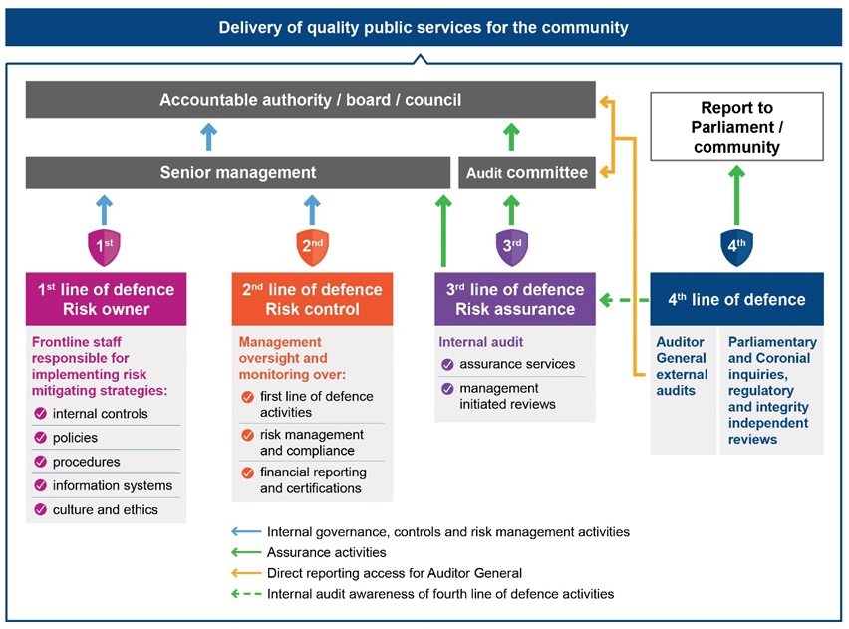
Source: audit.wa.gov.au/wp-content/uploads/2020/06/Report-26_Western-Australian-Public-Sector-Audit-Committees-–-Better-Practice-Guide.pdf

When applying the model, entities need to understand and assess business activities performed by each line of defence. This is often referred to as ‘assurance mapping’. This mapping helps the accountable authority (i.e., DLGSC or Council), audit committee and management to understand whether there are any gaps in assurance activities that manage key risks or whether there is duplication of effort.

This can help inform an internal audit program, improve efficiency and assist an audit committee/Council in their oversight responsibilities.

4.5 Policies, Procedures and Delegations

Many issues associated with financial performance can be addressed with the development of proper policies and procedures. These provide for the smooth running of the organisation, while providing for the stewardship function of the public money under the control of the local government.

The legislative requirements for establishing efficient systems and procedures are outlined in FM Reg 5, previously discussed. A local government’s accounting policies will need to be suitable for the size, scale and operations of their own affairs and consistent with AAS and other associated legislation.

Developing Policies and Procedures

Developing policy and procedures should be undertaken in consultation with relevant stakeholders within the local government. The process for developing these policies and procedures would be relevant to the size and complexity of the local governments but generally follow the steps set out below:

- Identify and document the issue and determine if a solution is achievable by the creation of, or amendment to, a policy or procedure. Determine if the solution is best achieved by the creation of a Council policy, a management policy or a management procedure.

- Plan and allocate the development task and resources. Plan the process timing and format of the policy/procedure. Determine the policy objectives and principles.

- Conduct basic research such as:
  - Gathering information on similar policies/procedures at other local governments.
  - Checking the legislative requirements to ensure there is no potential conflict.
  - Talking to other staff with experience in the area or experienced staff at other local governments.
  - Seeking professional advice if required.

- Prepare a draft policy which includes notes on the policy/procedure objectives and any limiting issues found in the research phase. Determine the likely commencement date of the policy/procedure.

- Undertake consultation within the organisation. Set the level of confidentiality relevant to the topic and circulate a draft policy/procedure to internal stakeholders. Ensure the draft status of the document is understood by the recipients and seek feedback on any potential unintended consequences of the policy/procedure. Seek opinion on the likelihood of the policy/procedure achieving its stated objectives.

- Prepare the final document from the revised draft policy/procedure based on the consultation and prepare an item for consideration by the Council or Management.

- Seek formal adoption of the policy/procedure and review any feedback from this process. This may be through Council for any Council level policies or internally for a management policy.

- After adoption, the policy/procedure should be communicated and distributed to the organisation with an effective implementation date.

- Set a date for review of the policy/procedure to ensure it maintains currency with any changes in legislation or circumstance. Noting that review timeframes for some policies are set within the associated legislation.

4.5.1 Policies
There are a number of accounting policies which are considered fundamental to the definition of a local government finance and accounting framework. While this is not an exhaustive list of the policies required or recommended, some of the common policies are further detailed below.

Significant Accounting Policy

Accounting policies are the specific principles, bases, conventions, rules and practices applied by an entity in preparing and presenting financial statements. (AASB 108.5)

AASB 101.117 requires an entity to disclose its significant accounting policies comprising:

(a) the measurement basis (or bases) used in preparing the financial statements
(b) the other accounting policies used that are relevant to an understanding of the financial statements.

It is important for an entity to inform users of the measurement basis or bases used in the financial statements (for example, historical cost, current cost, net realisable value, fair value or recoverable amount). This is because the basis on which an entity prepares the financial statements significantly affects users’ analysis.

When an entity uses more than one measurement basis in the financial statements, for example when particular classes of assets are revalued, it is sufficient to provide an indication of the categories of assets and liabilities to which each measurement basis is applied. (AASB 101.118)

In deciding whether a particular accounting policy should be disclosed, it should be considered as to whether disclosure would assist users in understanding how transactions, other events and conditions are reflected in reported financial performance and financial position. Each entity considers the nature of its operations and the policies that the users of its financial statements would expect to be disclosed for that type of entity. (AASB 101.119)

When it comes to significant accounting policies, some local governments choose to include the significant accounting policy as one of the policies in their policy document (either as one significant accounting policy or as a collection of policies that make up the significant accounting policies.

For example, a local government may include a separate policy for Accounting for Non-Current Assets, and a separate policy for Fair Value, whereas some may choose to rely upon the significant accounting policies resting solely in the Annual Financial Statements.

What is important is that the significant accounting policies adopted by a local government are reviewed each year.

Investment Policy

The Act provides that a local government has the power to invest funds that, for the time being, are not required by the local government.

6.14. Power to invest

(1) Money held in the municipal fund or the trust fund of a local government that is not, for the time being, required by the local government for any other purpose may be invested as trust funds may be invested under the Trustees Act 1962 Part III.

(2A) A local government is to comply with the regulations when investing money referred to in subsection (1).

(2) Regulations in relation to investments by local governments may —
(a) make provision in respect of the investment of money referred to in subsection (1); and

[(b) deleted]

(c) prescribe circumstances in which a local government is required to invest money held by it; and

(d) provide for the application of investment earnings; and

(e) generally provide for the management of those investments.

The FM Regulations also prescribe that local governments should establish and document internal control procedures in relation to the investment of surplus funds.

19. Investments, control procedures for

(1) A local government is to establish and document internal control procedures to be followed by employees to ensure control over investments.

(2) The control procedures are to enable the identification of —
(a) the nature and location of all investments; and

(b) the transactions related to each investment.

19C. Investment of money, restrictions on (Act s. 6.14(2)(a))

(1) In this regulation — authorised institution means —
(a) an authorised deposit-taking institution as defined in the Banking Act 1959 (Commonwealth) section 5; or

(b) the Western Australian Treasury Corporation established by the Western Australian Treasury Corporation Act 1986; foreign currency means a currency except the currency of Australia.

(2) When investing money under section 6.14(1), a local government may not do any of the following —
(a) deposit with an institution except an authorised institution;
(b) deposit for a fixed term of more than 3 years;
(c) invest in bonds that are not guaranteed by the Commonwealth Government, or a State or Territory government;
(d) invest in bonds with a term to maturity of more than 3 years;
(e) invest in a foreign currency.

Many local governments hold significant cash reserves and should develop a policy on investment to provide guidance to employees who have the role to invest surplus funds.

The decision to use a particular approach on how a local government structures its policy will depend on the particular circumstances of each local government.

This includes:

- an assessment of the scale of funds under management
- safeguards in place to manage the investment portfolio
- the level of risk aversion
- the capability of management
- systems capacity
- internal procedures
- controls to protect the investment and operational risk.

An investment policy may include provisions for a local government’s:

- risk profile
- safety and security of the investments
- liquidity requirement
- return of Investment target
- approved institutions (in accordance with the FM Regulations)
- authorised investments
- approval, reporting and recording requirements.

Purchasing Policy

A purchasing policy (sometime known as a procurement policy) is required to be implemented in a local government for the supply of goods or services where the consideration or value is expected to be $250,0000 or less, by Local Government (Functions and General) Regulations 1996 (F&G Reg) 11A.

11A. Purchasing policies for local governments

(1) A local government is to prepare or adopt, and is to implement, a purchasing policy in relation to contracts for other persons to supply goods or services where the consideration under the contract is, or is expected to be, $250 000 or less or worth $250 000 or less.

(2) A purchasing policy is to make provision for and in respect of the policy to be followed by the local government for, and in respect of, entering into contracts referred to in subregulation (1).

(3) A purchasing policy must make provision in respect of —

- the form of quotations acceptable; and

(ba) the minimum number of oral quotations and written quotations that must be obtained; and

(b) the recording and retention of written information, or documents, in respect of —

(i) all quotations received; and
(ii) all purchases made.

F&G Reg 11A sets out some minimum requirements of the policy, in that the policy must make provision for:

- the form of quotations acceptable
- the minimum number of oral quotations and written quotations that must be obtained
- the recording and retention of written information, or documents, in respect of
  - all quotations received
  - all purchases made.

Most local governments set out to achieve a range of objectives through their purchasing policy, some examples of this are as follows:

- To establish a framework of operational standards for contracts to purchase goods and services.
- To sets out the requirements for acceptable forms of quotation, and the recording of documents and information, for contracts to purchase goods and services.
- To ensure that the local government receives value for money as a result of its purchasing activities.
- To ensure compliance with all obligations under the Act and Regulations.
- To strengthen integrity and confidence in the local government procurement systems and processes.
- To encourage effective competition with the supply of goods and services from local businesses.
- To ensure that sustainable benefits, such as environmental, social and local economic factors are considered in the overall ‘value for money’ assessment.
- To mitigate probity risk by establishing consistent and demonstrated processes that promote transparency, probity and integrity, including the avoidance of bias and of perceived and actual conflicts of interest.
- To encourage consistent, efficient and accountable processes and decision-making in accordance with applicable policies and procedures.

To include all procurement within the one policy, most local governments will also include the policy requirements for purchases that exceed the $250,000 limit under F&G Reg 11A, that then fall under the regulations associated with conducting tenders.

Related Party Disclosures Policy

AASB 124 – Related Party Disclosures requires an annual financial report to contain the disclosures necessary to draw attention to the possibility that its financial position may have been affected by the existence of related parties and by transactions and outstanding balances, including commitments, with such parties. It is important to note that AASB 124 is not designed to detect and report fraud or misconduct. It is to enhance transparency and accountability of Council transactions.

Having a policy in regard to Related Party Disclosures assists those that may be impacted by having to provide information (being a related party of the local government) and those that require the information for reporting purposes.

A related party disclosure policy may include the provision of:

- key definitions - detailing what is considered:
  - a related party
  - key management personnel
  - close member of the family of a person
  - related party transactions
- what roles, organisations, parties have been identified as related parties of the local government
- identification of related party transactions and whether they are considered ordinary citizen transactions
- requirements to disclose/declare information by related parties
- how the information in the relevant disclosures will be kept confidential
- any assessment of materiality as applied to the related party disclosure requirements.

Corporate Credit Card Policy

Corporate credit cards can deliver significant benefits to local governments through improved administrative practices and more effective cash management. However, they can also expose a local government to significant risks if not properly controlled.
The risks associated with credit cards can be minimised by implementing policies to control their use.

The following issues should be considered when developing policies and procedures for controlling the use of credit cards:

- General

- Who/what roles are eligible for a corporate credit card and any limits associated with the role/card.
- Who/what role can approve the application of a corporate credit card.
- An agreement should be signed by the cardholder and the local government which sets out the cardholder's responsibilities and legal obligations when using the credit card.
- A register of all current cardholders should be kept which includes card number, expiry date of the credit card, credit limit and details of goods and services the cardholder has authority to purchase.
- All new and existing cardholders should be provided with a copy of the policies relating to the use of credit cards.
- What the cardholder should do in the event their employment ceases, an extended period of leave is taken, or they are moved to a position which does not require the use of a credit card.
- What the cardholder should do if they lose or misplace their credit card.
- Credit cards should not be transferred to other users.
- How reward schemes, such as Fly Buys, will be treated.
- The arrangements for destruction of all surrendered credit cards.
- What action is to be taken in the event that a cardholder fails to comply with the policies.

- Purchasing

- Credit cards should only be used for purchasing goods and services on behalf of the local government.
- Personal expenditure must be prohibited.
- A credit card should not be used for cash withdrawals.
- Maximum credit limits should be based on the cardholder's need.
- How purchases by facsimile, telephone or over the Internet are to be dealt with.

- Payments and reporting

- Timeframes for payment of accounts should be monitored to ensure that credit charges are minimised.
- Strict guidelines for expenditure on entertainment should be established.
- Cardholders cannot approve expenditure incurred on their corporate credit cards.
- Details of reports to be provided to management and Council for the oversight of use of corporate credit cards.

Borrowing Policy

Section 6.20 of the Act gives local governments the power to borrow to enable the local government to perform the functions and exercise the powers conferred upon it.

A borrowings policy provides direction to management in relation to the decision-making framework surrounding a decision to use borrowings to finance activities. Generally, the objectives of a borrowings policy are to:

- ensure the appropriate level of funds are available at the appropriate time to support its strategic objectives
- be financially responsible and prudent in financial matters ensuring all risks are considered in the decision-making process
- minimise the costs of borrowing
- ensure, where possible, the structure of the borrowing is appropriate for the nature of the assets/function being funded
- consider intergenerational issues as part of determining the most appropriate way to fund activities
- ensure funding activities are in accordance with its legislative responsibilities
- establish the process for monitoring the level of borrowings and to ensure decisions in relation to the use of borrowings are made within a long-term financial context.

The policy text may provide for a local governments approach to:

- types of expenditures that Council will consider loan borrowings for
- types of expenditures that Council will not consider loan borrowings for
- loan structures (i.e. fixed, variable, interest only, term)
- impact on long-term financial sustainability
- community loans (self-supporting loans)
- borrowing limits
- monitoring and reporting
- risk.

Revenue Policy (or Strategy)

A revenue policy (or strategy) is required by a local government to develop their longer-term revenue streams. It encompasses all revenue streams and provides a basis for ensuring local government rates and fees are being set in a consistent and clear manner. A revenue and rating strategy ideally comprises a number of components and may include information on:

- a Council’s rationale and objective discussion of its pricing policy and core components of its rating structure
- principles adopted for rating or fees and charges
- related research and background discussion on the local government and past practices
- comprehensive rates, fees and charges impact modelling
- explanatory material
- opportunity for public review/consultation.

This policy/strategy acts as one of the key informing documents to the Integrated Planning and Reporting framework, including the LTFP and Corporate Business Plan.

Other Financial Policies

Other financial policies that a local government may consider are:

- Rates and General Debtor Collection.
- Asset Management.
- Self-Supporting/Community Loans.
- Financial staff capability and training.

4.5.2 Procedures
Once accounting policies are in place, it is the important to have procedures to support them.

Procedures are clear and concise instructions on how to abide by a policy or to carry out a task or activity required to perform a role. They detail the sequence of activities needed to complete tasks.

Effective procedures will:

- be factual, succinct and simple to understand
- be in a format that supports the activity being conducted. For example, a procedure could be presented as written steps, a flow chart or a checklist
- be written in a step-by-step style that demonstrates how to follow the procedure from beginning to end
- include references or links to any related documents and forms that must be completed when following the procedure.

Procedures aid officers in maintaining consistency when performing tasks, understanding and adhering to required controls, adhering to policy and legislative requirements and mitigating against any knowledge lost, should a staff member leave a local government. Similar to policies, procedures must be reviewed regularly.

4.5.3 Delegations
The provisions of the Act, which provide for delegations by a local government, or its CEO are as follows:

- Section 5.16(1), states: ‘Under and subject to section 5.17, a local government may delegate to a committee any of its powers and duties other than this power of delegation.’

- Section 5.42(1), states: ‘A local government may delegate to the CEO the exercise of any of its powers or the discharge of any of its duties under this Act other than those referred to in section 5.43.’

- Section 5.44(1), states: ‘A CEO may delegate to any employee of the local government the exercise of any of the CEO’s powers or the discharge of any of the CEO’s duties under this Act other than this power of delegation.’
The Act has been framed in a way that determines whether powers and duties can be delegated or not. If the term ‘Council’ is used, then it is the Council itself which must carry out that function. If the term ‘local government’ is used then it may be possible to use delegation, subject to any other express powers against delegation or the desirability in using ‘acting through’ where it may be a better way of carrying out the power or duty.

More information on delegations can be found in the DLGSC Local Government Operational Guidelines Number 17 – Delegations. A link to this guideline has been provided in section 6.0 – Related Guidance of this document.

4.6 Local Government Accounting

Local governments are a reporting entity and are therefore required to prepare general-purpose financial reports in accordance with the Act, the FM Regulations and AAS. Local governments are required to prepare monthly Statements of Financial Activity and Annual Financial Statements. These financial statements must comply with all relevant legislation and the AAS.

Local governments are comprised of all entities controlled by the governing body of the local government. As such the general-purpose financial report of a local government is to encompass all business and non-business operations which the governing body controls, either directly or through the operations of the controlling entity. The underlying principles used in the preparation of local government financial statements include:

- fair presentation and compliance with AASs and legislation
- the use of full accrual accounting
- preparation of the financial statements using a consolidated approach of all municipal operations of a local government’s control
- going concern
- consistency of presentation
- materiality and aggregation
- comparative information
- offsetting.

4.6.1 Basic Accounting Concepts
Fund Accounting

The fund basis of accounting and reporting by local governments provides a separation of the various operating activities and financial segments for a local government’s financial operations normally by program of activity or by divisions of its municipal fund operations. Local governments may act as trustees whereby; the local government has legal custody of the resources without controlling them. That is, the local government is unable to deploy those resources to meet the objectives of its governing body. Trust funds are required to be held in a separate bank account, as these funds do not belong to the local government and are held in trust on behalf of other parties.

Consolidation

All municipal operations and activities of a local government shall be consolidated in preparation of the financial statements for each reporting period. Consolidation is the process by which the financial results of an organisation’s various entities and sub-entities are consolidated into one overall financial report.

The aim of consolidating the financial results is to reflect the ‘real’ impact of an organisation’s overall activities and control over its various entities. Consolidated financial statements shall be prepared by local government as required by and in accordance with AASB 10.

Consolidated Financial Statements.

Consolidated financial reporting enables users of financial information to understand the overall result of the operating activities and resources of a group of entities under the control of a parent entity – in this case, a local government.

Accrual Accounting

A local government shall prepare its financial report, except for the cash flow statement, using the accrual basis of accounting. Accrual accounting is the principle whereby, revenue and expenditure is brought to account, as it is earned or incurred and included in the accounts for the financial period to which they relate.

Accounting for Taxation

Local governments are non-taxable entities for income tax purposes. They are however, required to pay Goods and Services Tax (GST) and Fringe Benefits Tax (FBT).

Division 81 of the GST legislation provides that as a general rule, GST applies to all fees and charges levied by government agencies including local government, unless specifically excluded from GST via a determination by the Federal Treasurer. Australian taxes, including local government rates are GST-exempt unless a regulation has been made to treat certain taxes as being subject to GST. Currently, no regulations have been made to treat any Australian taxes as being subject to GST.

Local governments are subject to FBT on ‘fringe benefits’ provided to their staff under the income tax provisions.

4.6.2 Account Structures
When establishing and maintaining a chart of accounts a local government should consider the most appropriate account structure to permit the efficient production of general purpose financial and management reports. Section 6.6.(2) of the Act requires the municipal fund to be kept separate and distinct from the trust fund. Therefore, at its highest level a typical account structure will contain two separate funds, the trust fund and the municipal fund.

Trust Fund

The trust fund structure usually comprises four groups of accounts as follows:

Account Group | Purpose
Revenue | Accounts for recording revenue transactions relating to the trust fund.
Expenditure | Accounts for recording expenditure transactions relating to the trust fund.
Assets | Accounts for recording the Assets balance of the trust fund cash at bank or the value of other assets held in trust.
Liabilities | Accounts for recording the balance of the trust fund owing to external parties.

The value of all trust fund assets, liabilities, revenues and expenses accounts should sum to zero in the general ledger. As the trust fund holds the value of assets outside of the control of the local government, all the related transactions should be identified in the chart of accounts to enable them to be excluded from general-purpose financial reports. The trust fund is accounted for on a cash basis (recognition of receipts when received and payments when made) with a separate note included in general-purpose financial reports to disclose the opening balance, receipts, payments and closing balance for the relevant reporting period.

The OAG provided a position paper in relation to accounting for work bonds, building bonds and hire bonds previously commonly treated as Trust Funds by many local governments – and can be found at
https://audit.wa.gov.au/wp-content/uploads/2019/07/OAG-position-paper-Accounting-for-bonds.pdf.

The OAG’s position is that work bonds, building bonds and hire bonds should not, for accounting purposes, be regarded as Trust Fund money in terms of the Act. Consequently, this money should be held in the Municipal Fund, recognised on the statement of financial position in the annual financial report and interest, if any, would therefore not need to be paid to the person entitled to the money in accordance with section 6.9(3)(a) of the Act.

Municipal Fund

The municipal fund structure usually comprises 7 groups of accounts as follows:

Account Group | Purpose | Comments
Operating Revenue | Accounts for recording operating revenue transactions relating to the municipal fund. | The account structure of operating revenue and expenditure accounts is heavily influenced by the accounting application software in use. There is typically a master or natural account general ledger number with the account linked to a reporting code to permit sorting and extraction in accordance with the mandatory reporting programs and nature or type classifications. Although not mandatory, to assist with the management of financial resources it may also be desirable for operating accounts to be nominated with a responsible officer code according to the organisation’s corporate hierarchy.  This enables reports to be tailored to the needs of each officer and assists with budgetary control and error recognition. The balance of all operating revenue and expenditure accounts are cleared to nil at the end of the financial year with the sum transferred to a retained earnings account in the equity account group. Due to the volume of account codes in a typical local government chart of accounts this task is usually automated at year end as part of the roll over process.
Operating Expenditure | Accounts for recording operating expenditure transactions relating to the municipal fund.
Non-Operating (Capital) Revenue | Accounts for recording capital revenue transactions relating to the municipal fund. | Although there are variations according to the accounting application software used it is common practice for a local government chart of accounts to be structured with nominated capital revenue and expenditure accounts in addition to operating revenue and expenditure. These capital accounts are essentially temporary accounts and hold transactions of a capital nature prior to transfer to balance sheet accounts. The principal purpose of establishing this type of account structure is to permit detailed budget to actual reporting of capital transactions throughout the budget period. At the end of a financial year these temporary capital accounts are closed to the relevant balance sheet accounts (in a similar way to closing operating accounts). The task of transferring these balances is usually automated as part of an end of year roll-over process.
Non-Operating (Capital) Expenditure | Accounts for recording capital expenditure transactions relating to the municipal fund.
Assets | Accounts for recording the balance of all municipal fund assets.
Liabilities | Accounts for recording the balance of all municipal fund liabilities and provisions.
Equity | Accounts for recording retained earnings from past accounting periods, cash reserves and revaluation reserves.

No Ward Accounting

Regulation 7 of the FM Regulations does not permit a local government to structure its accounts for the purpose of separately tracking revenue and expenditure according to wards, if any. A local government is to consider the needs of the district in its entirety and cannot determine how much to spend in each ward based on the revenue generated by a ward. This restriction should be considered when developing an account structure, a chart of accounts and when preparing accounting reports.

Establishing a Chart of Accounts

A chart of accounts (COA) is a listing of a string of numerical and/or alphabetic account codes used by a local government to aggregate and provide structure and consistency to the recording and reporting of transactions or events held in an accounting information system.

Each account string in a COA is assigned a unique identifier to allow for retrieval and reporting of data.

Establishing the logic and structure of a COA is extremely important to the overall performance of an accounting system. Once established it is essential to maintain the structural integrity of the chart when accounts are added, deleted or modified. Making changes without an understanding of the underlying logic can undermine the system’s reliability and result in inconsistent reporting.

In recognition of the importance of maintaining a high level of consistency in the structure of the COA it is recommended that operating policies and procedures are developed to limit access to edit the COA and senior staff conversant with the importance of the COA structure should monitor and approve any changes.

Many computerised accounting systems place constraints on the structure of the COA as part of their configuration to ensure consistent reporting. When establishing a COA, it is important to consider the requirements of your accounting software by reference to a manual or by contacting the supplier or support and ensure the structure is consistent with the logic imbedded in the software.

When establishing and maintaining an effective local government COA it is vital to ensure transactions are coded to accounts that support the extraction of information in these two mandatory formats. Some computerised accounting systems permit ledger accounts in the COA to be linked to a corporate hierarchy. This permits reporting in accordance with staff responsibility, service or business unit management. Linking accounts to a corporate hierarchy also permits budget to actual comparative reporting for individual officers which supports greater budgetary control.

4.6.3 Classification of Financial Transactions
In establishing the nature or type classifications which a local government will use to best describe the information in its budgets and financial statements the requirements of both the legislation and the AAS need to be addressed.

AASB 101.99 requires a reporting entity to:

“Present an analysis of expenses recognised in profit or loss using a classification based on either their nature or their function within the entity, whichever provides information that is reliable and more relevant.”

According to AASB 101.105:

“The choice of classification between nature and function will depend on historical and industry factors and the nature of the entity. The entity should choose the classification that provides the most relevant and reliable information about its financial performance.”

Classification of revenues and expenses according to their nature or type may be made to enable users to identify such matters as:

- the major financial characteristics of the local government's operations for the reporting period, for example the costs of services provided by employees, the interest expense, and the repairs and maintenance expense, for the reporting period
- the variability of revenues and expenses
- the dependence of the local government on particular types of revenues, such as grants and rates, to enable it to provide goods and services to constituents.

In 2022, amendments made to the Act and FM Regulations required local governments to present operating expenses and revenue in ‘nature or type’ format in their annual budget, monthly statement of financial activity and annual financial report, from 1 July 2022.
The amendments mean that local governments must adopt a Rate Setting Statement in ‘nature or type’ format as part of their 2022-23 annual budget.
Formally local governments were required to report by 'program’ however with changes made as part of the amendments this is no longer required for the purposes of the annual budget, monthly statement of financial activity and annual financial report. It is however, still required under the Local Government Grants Act 1978, as the Local Government Grants Commission will continue to require financial information to be provided by ‘program’ for the time being.
Therefore, local governments should continue to record relevant transactions by ‘program’ and ‘nature or type’ in their financial systems.
When presenting the monthly statement of financial activity to Council, some local governments’ preference may still be to present the report by program. Historically, this is how Councils reported, as it provided information closer to that of the services provided. If this is still a preference of a local government, to meet the requirements of the FM Regulations, they must ensure that they are reporting by both nature and type and program when presenting the monthly statement of financial activity.

Nature or Type Classifications
Part 2 of Schedule 1 of the FM Regulations list the nature or type classifications as follows:

Table 4 - Minimum Nature or Type Classifications
Revenue/Income | Expenditure
Rates | Employee Costs
Operating Grants, Subsidies and Contributions | Materials and Contracts
Non-Operating Grants, Subsidies and Contributions | Utility Charges (Electricity, Gas, Water, etc.)
Profit on Asset Disposals | Loss on Asset Disposals
Fees and Charges | Interest Expenses
Service Charges | Insurance Expenses
Interest Earnings | Other Expenditure
Other Revenue/Income

The definitions for each of the nature or type classifications can be found at Appendix 2.

Program Classifications

Part 1 of Schedule 2 provides a list of program titles used in classification by program.

In classifying expenditures, the first process is to identify the program which causes the outlays to be incurred. A number of outlays represent a program in their own right, for example, parking is a sub-program under Transport. However, most parking outlays are in support of a sub-program or facility such as a recreation ground or a child-care centre. In these cases, the outlays on parking are to be allocated to the program the facility supports. Other expenditures of an administrative nature need to be allocated to the program using those services. It is important that allocations are made to identify the true cost of services and facilities and not as an accounting convenience. Any clearing accounts such as those under ‘Other Property and Services’ must be allocated to programs to ensure true costs are recorded.

A list of the Programs, Sub-Programs and the associated definitions can be found at Appendix 3.

Project/Job Costing

To track expenditure on projects in greater detail, it is common practice to establish a separate works costing sub-ledger below the general ledger. This involves the application of various codes at the time of data input to permit greater analysis of costs on these projects or jobs. This analysis may involve the use of expenditure and/or revenue codes to track various components or identify locations of expense. As a minimum it is expected such a system would identify the following cost types:

- Wages.
- Labour Overheads.
- Plant Operation Costs.
- Plant Depreciation.
- Materials and Stores.
- Contractors.
- Other Costs.

It is also desirable for the account structure to permit the tracking of costs according to the source of funding such as the grant provider and individual grants.

4.6.4 Activity Based Costing (ABC)
Activity-based costing (ABC) is a methodology for more precisely allocating overhead costs by assigning them to activities. In the local government context, it is the process of allocating overhead costs (usually corporate overheads, public works overheads or plant operating overheads/costs) to the various services, programs or business units that consume the overheads. This enables management, Council and the community to better understand the true cost of each service that is provided. For example, among other things the library service requires elements of information technology support and infrastructure to loan books, access the internet and provide online resources; and assistance from the finance team to pay their bills, collect any revenue, pay their staff and support management in budgeting and reporting. Without these ‘corporate overheads’ they would not be able to operate a fully functioning service or would have to provide for the activities required directly.

Developing an ABC system involves a two-step process whereby:

- overhead costs are assigned to activity cost pools
- overhead costs are allocated from each activity cost pool to the product or service by using a cost driver.

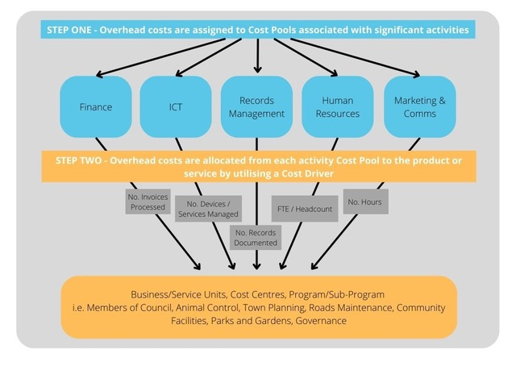

Activity Cost Pools

An activity cost pool is a grouping of costs, typically by business unit or service. Costs are then allocated from the cost pool to the business unit, service, program, etc. that uses the service.

Cost Driver

A cost driver is a characteristic or element that influences the cost of an operation or service. There may be several cost drivers associated with a cost pool. When selecting the most appropriate cost driver consideration must be given to the degree of correlation/causal relationship, the cost to measure the driver, and the impact it may have on behavioural effects/decision making.

Some examples of cost drivers are:

- Number of supplier invoices processed/paid.
- Number of customer invoices issued.
- Square metres used.
- Number of labour hours.
- Number of employees (headcount or FTE).
- Number of computers/laptops/devices.
- Number of plant machine hours.
- Number of work orders.
- Number of customer service calls.

In local government there are 3 broad categories by which overhead costs are categorised, being:

- Corporate overheads – this may include activity cost pools such as information technology, finance, human resources, records management, marketing, customer service, etc.
- Public Works Overheads – this activity cost pool captures management and supervisory costs, in-direct labour costs such as superannuation, annual leave, sick leave, etc, specific to the public works teams.
- Plant Operating Costs – this activity pool captures costs associated with operating plant. For example, parts and repairs, fuels and oils, tyres and tubes, licences and registrations, etc.

When developing a local government’s activity-based costing system, consideration must be given to the cost to collate the required data (cost pool/cost driver information), and the materiality and the impact on true costing of services and operations. A service that is being allocated too many costs may be subject to being considered for review or ceasing of a service. One where costs are being under-allocated may indicate to management and Council that the cost benefit of a service is worthwhile to the community. If the costs were more accurately allocated and they understood the true cost, they may feel otherwise.

Tools such as interviews, data collection, storyboarding and team diversity can be used when developing the system. It can take a considerable amount of time to develop an ABC system in the first instance, however once it is setup up, periodic reviews and the right tools should enable a fairly straight forward allocation of costs.

An example of an ABC system, as part of the tools and templates at Template 3. However, this should be used as an example, as the individual circumstances of each local government need to be taken into consideration when developing an appropriate system.

4.6.5 Balance Day Adjustments
Accounting periods are commonly separated into months and financial years. A balance day adjustment is a term used to describe the process of identifying the most appropriate accounting period to recognise revenue and expenditure within the accounting system.

Ensuring the value of transactions are reflected in the appropriate accounting period is essential for ensuring accounting reports contain information relevant to the user.

The majority of balance day adjustments occur at the end of a financial year to support the preparation of general-purpose financial reports.

However, it is appropriate to undertake selected balance day adjustments at the end of each month. The extent and frequency of undertaking various balance day adjustments is dependent on the potential for the adjustment to have a material impact on decision making.

Some of the more common balance day adjustments are:

- Interest Receivable.
- Pre-Paid Expenses.
- Salaries and Wages Payable.
- Annual Leave.
- Long Service Leave.
- Loans Receivable.
- Self-Supporting Loans.
- Revenue recognition and Contract Liabilities.
- Loans Payable.

4.7 Procurement to Payment

A procurement to payment process outlines how an organisation purchases the raw materials/goods and services they need to do business, receives and manages those purchases, processes vendor invoices, and finally authorises payments. The process spans procurement, operations, and accounts payable.
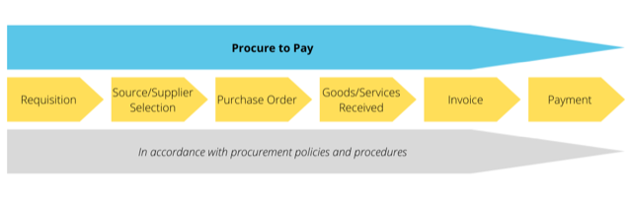
Specific to local government, Part 4 — Provision of goods and services and Part 4A — Regional price preference of the F&G Regulations details specific requirements when it comes to:

- purchasing policies
- tenders for providing goods or services
- panels of pre-qualified suppliers
- regional price preference.

Whereas FM Regulations 11, 12 and 13 deals with requirements in regard to payments.

4.7.1 Purchasing
Purchasing is the process whereby a local government acquires goods or services to conduct its operations. F&G Regulations 11A require local governments to have in place a purchasing policy for the supply of goods or services where the consideration is or is worth less than $250,000. Where the value exceeds this amount, the regulations in respect to tender’s takeover.

Details of what is to be included in a local government’s purchasing policy is provided in section 4.5.1 – Policies.

4.7.2 Tenders
The general provisions for calling for and accepting tenders under the legislation are summarised below:

- Section 3.57.(1) of the Act states that:

“A local government is required to invite tenders before it enters into a contract of a prescribed kind under which another person is to supply goods or services.”

- Section 5.43.(b) of the Act states that:

“A local government cannot delegate to a CEO any of the following powers or duties –

(b) accepting a tender which exceeds an amount determined by the local government for the purpose of this paragraph”

- Part 4 of the F&G Regulations regulates and provides the procedures for local government tenders for providing goods or services.

- Regulation 11(1) of the F&G Regulations requires tenders to be publicly invited before a local government enters into a contract for another person to supply goods or services if the consideration under the contract is worth more than $250,000 and unless subregulation (2) states otherwise.

Meeting the required obligations and developing the frameworks that are needed to have a compliant and effective local government procurement system can be complex and resource intense. Further assistance with and resources for procurement and tendering can also be obtained through a Western Australian Local Government Association (WALGA) procurement subscription. Contact WALGA for more information.

Additionally, ensuring that the finance system in place is keeping up with technological advancements will also assist with maintaining an effective and compliant procurement system. An effective finance system or ERP will have automated workflows for approvals, checks and processing (Procure to Pay System). If the system at your local government does not have this in place, you may want to discuss the options with your system provider initially or consider as part of a system review.

4.7.3 Payment of Accounts
Local governments are required under legislation to develop proper procedures and processes for payment of accounts. The FM Regulations set out requirements for:

- procedures for making payments
- Restrictions on Payment from Municipal or Trust Funds
- reporting.

Procedures for making payments

Regulation 11 of the FM Regulations provides the minimum requirements for a local government to have procedures in regard to making payments. Minimum requirements have been used here as the making of payments is probably one of the biggest financial risk areas to a local government. The making of a payment is the final point in the process whereby, sufficient controls, checks and balances need to be in place prior to any cash leaving a local government’s bank account/control.

The FM Regulations provide that a local government is to develop procedures for the authorisation and the payment of accounts to ensure that there is effective security for and properly authorised use of:

- cheques
- credit cards
- computer encryption devices and passwords
- purchasing cards and any other devices or methods by which goods, services, money or other benefits may be obtained
- petty cash systems.

Additionally, FM Reg 11(2) states that procedures also need to be in place to ensure the proper authorisation was obtained to incur the debt prior to making the payment. Meaning, the relevant authorising officer has signed off on the purchase order, there is a three-way match between the purchase order, goods/service being received, and the invoice, and where there is a variation, the right authorisation of the variation has been approved prior to the payment. In essence, the procurement to payment policies and procedures have been adhered to.

11. Payments, procedures for making etc.

(1) A local government is to develop procedures for the authorisation of, and the payment of, accounts to ensure that there is effective security for, and properly authorised use of —

(a) cheques, credit cards, computer encryption devices and passwords, purchasing cards and any other devices or methods by which goods, services, money or other benefits may be obtained; and

(b) petty cash systems.

(2) A local government is to develop procedures for the approval of accounts to ensure that before payment of an account a determination is made that the relevant debt was incurred by a person who was properly authorised to do so.

(3) Payments made by a local government —

(a) subject to subregulation (4), are not to be made in cash; and

(b) are to be made in a manner which allows identification of —

(i) the method of payment; and
(ii) the authority for the payment; and
(iii) the identity of the person who authorised the payment.

(4) Nothing in subregulation (3)(a) prevents a local government from making payments in cash from a petty cash system.

Restrictions on Payment from Municipal or Trust Funds

A local government is not to make payments from its municipal or trust fund:

- unless it has delegated to the CEO to exercise of its power to make payment from those funds
- where it has not delegated to the CEO, unless a list of payment/s to be made has been authorised in advance by resolution of the Council. The details required in this list is set out in FM Regulations 13(2).

In practice, Councils have usually put in place a delegation to the CEO, the exercise of its power to make payment. This enables a more efficient system by which a local government is able to make to its creditors.

12. Payments from municipal fund or trust fund, restrictions on making

(1) A payment may only be made from the municipal fund or the trust fund —

(a) if the local government has delegated to the CEO the exercise of its power to make payments from those funds — by the CEO; or

(b) otherwise, if the payment is authorised in advance by a resolution of the council.

(2) The council must not authorise a payment from those funds until a list prepared under regulation 13(2) containing details of the accounts to be paid has been presented to the council.

Reporting – List of Accounts Paid

A key tool for a Council to have oversight of the payments made by a local government in carrying out its business is the ‘list of accounts paid’. The FM Regulations 13 require a local government to prepare each month a list of accounts paid (and present to Council) detailing:

(a) the payee’s name

(b) the amount of the payment

(c) the date of the payment

(d) sufficient information to identify the transaction.

‘Sufficient information to identify the transaction’ is considered to include the cheque number, or voucher number or EFT number together with a brief description of the goods or services for which the payment is made.

It is important to keep in mind that like all the data, information and reports produced by the finance team, this report forms part of information that is available to the public. Specifically, this report is to be presented to Council and professionalism, transparency and accuracy is key. Educating staff at the point of data entry that builds the basis for this report will have real time saving efficiencies when it comes time to produce this report for Council. The last thing that the report producer or reviewer should be having to do is spend surplus amounts of time fixing spelling errors and adjusting descriptions to be report-friendly.

Monthly credit card payments should not be listed as a single line entry but should list details of every credit card transaction made during the month to ensure full disclosure and openness and transparency in the use of cards.

13. Payments from municipal fund or trust fund by CEO, CEO’s duties as to etc.

(1) If the local government has delegated to the CEO the exercise of its power to make payments from the municipal fund or the trust fund, a list of accounts paid by the CEO is to be prepared each month showing for each account paid since the last such list was prepared —

(a) the payee’s name; and
(b) the amount of the payment; and
(c) the date of the payment; and
(d) sufficient information to identify the transaction.

(2) A list of accounts for approval to be paid is to be prepared each month showing —

(a) for each account which requires council authorisation in that month —

(i) the payee’s name; and
(ii) the amount of the payment; and
(iii) sufficient information to identify the transaction; and

(b) the date of the meeting of the council to which the list is to be presented.

(3) A list prepared under subregulation (1) or (2) is to be —

(a) presented to the council at the next ordinary meeting of the council after the list is prepared; and

(b) recorded in the minutes of that meeting.

4.7.4 Credit Cards
Corporate credit cards form part of most modern purchasing systems. They can offer significant benefits such as reduced costs and streamlined business processes. In local government they are commonly used for purchases including subscriptions, computing and other equipment, general consumables, hospitality and travel. While local governments generally use credit cards for a small proportion of their payments, it is important they are effectively managed to reduce the risk of improper or unauthorised use.

Local government employees and CEOs use corporate credit cards. However, the elected members that make up a local government Council cannot use these cards as the Act does not allow them to incur debts. Instead, local governments pay allowances or reimburse expenses to an elected member.

Strong controls assist in the early identification of erroneous, inappropriate or unauthorised transactions. Local governments should:

- ensure policies specify requirements for all key credit card processes
- keep adequate records of all card transactions, including information that describes the nature/purpose of the expenditure and evidence of review and approval
- cancel redundant cards in a timely manner to avoid loss and/or misuse of cards
- regularly monitor outstanding transactions to identify and follow up on long outstanding unacquitted transactions
- ensure senior management periodically reviews credit card use, to confirm compliance with policies and to identify any abnormal trends. The results of these reviews should be documented and retained.

The payment made for a credit card is to be included in the accounts for payment report to Council, required under FM Reg 13. For transparency local governments are providing an addendum to the payments report detailing the transactions of each credit card.

Further information on the use of corporate credit cards can be found in the DLGSC Local Government Operational Guidelines Number 11 – Use of Corporate Credit Cards. A link to this guideline has been provided in section 6.0 – Related Guidance of this document.

4.7.5 Identifying and Minimising Risk in Procurement
Good procurement practices centred around the principles of probity, accountability and transparency are key to managing procurement risks and the delivery of good outcomes for ratepayers. Local governments expose themselves to the risk of fraud and misconduct and reputational damage when procurement processes are not followed or are seen not to be acting in the best interests of their communities.

Having policies and controls that are appropriate, and monitoring their effectiveness is essential if local governments, and the ratepayers that they serve, are to have confidence in local government procurement activities. Procurement practices that focus solely on minimum compliance with legislation are unlikely to provide local governments with the oversight and control they need to address risks and ensure value for money in their procurement. Therefore, it is essential local governments enhance their “procurement capability to give staff the knowledge and skills to effectively carry out their jobs”.

In October 2018, the OAG conducted a performance audit into local government procurement. The resulting audit report outlined what the OAG would expect to see regarding each focus area within local government procurement – see below table. Completing a regular self-assessment against these items will assist your local government in maintaining an effective procurement framework.

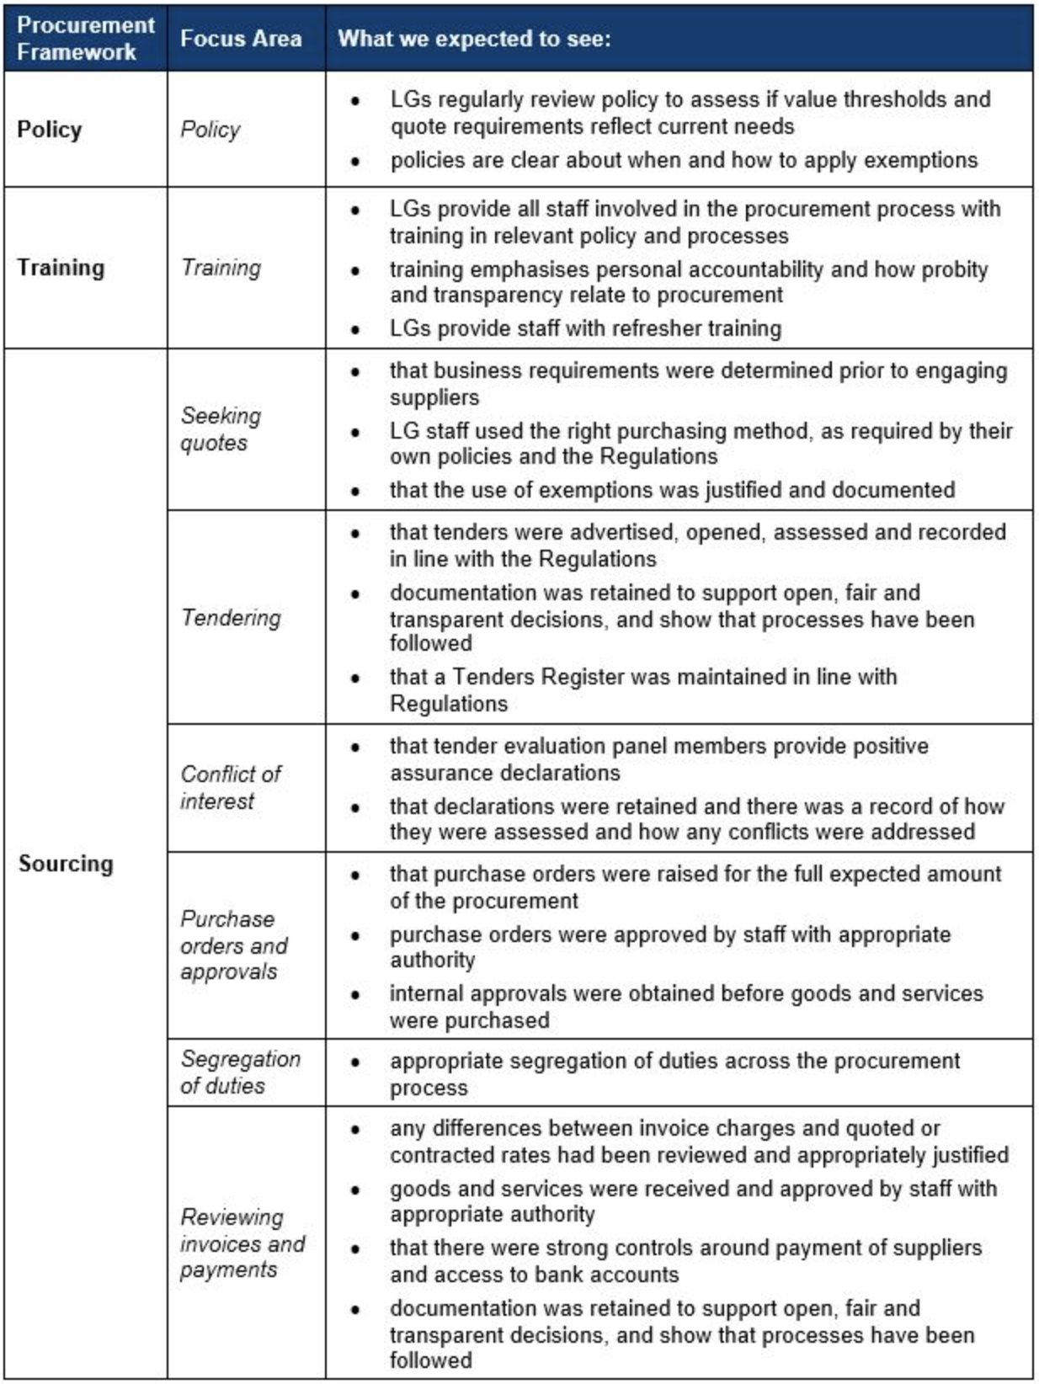
Source: https://audit.wa.gov.au/reports-and-publications/reports/local-government-procurement/appendix-1-audit-focus-areas/

4.8 Audits and Reviews

Local governments are subject to a number of audits or reviews. Some are prescribed, while others are recommended or used as a tool within a local governments risk management and internal control framework.

In preparation for any audit or review, a local government can put themselves in a position to be ready by:

- reviewing their prior year audit findings and ensure they have been addressed (where applicable)
- reviewing what went well and what could be improved from past audit experiences
- preparing financial statements applying best practice principles for financial statement audits.

Duties of a local government with respect to audits

Section 7.12A. of the Act details the duties of local government with respect to audits as follows.

A local government must:

- do everything in its power to:

(a) assist the auditor of the local government to conduct an audit and carry out the auditor’s other duties under this Act in respect of the local government; and

(b) ensure that audits are conducted successfully and expeditiously.

- meet with the auditor of the local government at least once in every year.

- examine an audit report received by the local government; and

(a) determine if any matters raised by the audit report, require action to be taken by the local government; and

(b) ensure that appropriate action is taken in respect of those matters.

- prepare a report addressing any matters identified as significant by the auditor in the audit report, stating what action the local government has taken or intends to take with respect to each of those matters; and give a copy of that report to the Minister within 3 months after the audit report is received by the local government. Within 14 days after a local government gives a report to the Minister the CEO must publish a copy of the report on the local government’s website.

- Of note, section 7.12A(4) the Act requires the local government to report to the Minister any significant adverse trends identified within the Auditor’s Report. However, this does not apply to significant adverse trends noted within the management letter.

4.8.1 Annual Financial Report Audit
The Act requires that the annual financial report of a local government is to be audited by 31 December following the financial year to which the accounts and report relate (s.7.9. of the Act). The responsibility for the audit of local governments sits with OAG under section 7.10 Powers of auditor of the Act. Either staff of the OAG will conduct the audit of a local government or where the OAG appoints an approved contractor to conduct the audit on their behalf however, the OAG is still the auditor that ultimately signs off on the audit.

The Local Government Reform Agenda is delivering Model Financial Statement, with a reduced version for smaller local governments, and implementation is planned for the 2002-23 financial year reports.

In most instances the audit of the annual financial report will be conducted across two audit periods:

- an interim audit – usually prior to the year-end being audited
- the final audit – post year end and finalisation of the accounts and annual financial report.

A key date in the calendar for finance officers of a local government is 30 September of each year. This is the prescribed date (s.6.4. of the Act), unless the Minister has provided for an extension to the time, that a local government is to submit to its auditor:

- the accounts of the local government, balanced up to the last day of the preceding financial year

(b) the annual financial report of the local government for the preceding financial year.

As mentioned previously, preparation is the key to a successful audit. It can be a busy time of the year, with finalisation of annual budgets, new year accounts and reporting starting, and rates being raised. It is important to be organised and where resources are limited, plan early for assistance in meeting these deadlines. The best preparation is to ensure that procedures are in place, daily tasks, reports and controls are completed satisfactorily, and each month-end, the month procedures and reconciliations are being conducted in a timely manner. Local governments should not sit on an unreconciled balance and queries. At the end of the day, year-end reporting is a slightly bigger version of the month-end reporting cycle.

4.8.2 Financial Management Regulation Review (FM Reg 5.)
In accordance with FM Reg 5, part of a CEO’s duties regarding financial management is to undertake a review of the appropriateness and effectiveness of the financial management systems and procedures of a local government regularly. This should take place not less than every 3 financial years with the findings reported to the local government.

5. CEO’s duties as to financial management

…
(2) The CEO is to —

- ensure that the resources of the local government are effectively and efficiently managed; and

- assist the council to undertake reviews of fees and charges regularly (and not less than once in every financial year); and

(c) undertake reviews of the appropriateness and effectiveness of the financial management systems and procedures of the local government regularly (and not less than once in every 3 financial years) and report to the local government the results of those reviews.

The Regulations do not prescribe how the CEO must carry out this review and it may be conducted in different forms across each local government. Such forms may include:

- appointment of external auditors/consultants to carry out a review
- internal appointment of a review officer/team
- a comprehensive internal audit program (carried out by either an external provider or internal audit team)
- a combination of all or some of the above.

What is important is that the CEO undertakes a review regularly and the officer/consultants charged with the responsibility of the review are experienced in the required areas of financial management and review processes.

The Audit Regulations (Reg 17) also requires a review to be completed. It may be beneficial to align both the FM Reg 5 and Audit Reg 17 reviews to enable any economies of scale in both dollars and time to be realised.

4.8.3 Audit Regulation Review (Audit Reg 17)
Further to the review required under FM Reg 5, Audit Reg 17 requires a local government’s CEO to undertake a review of the appropriateness and effectiveness of a local government’s systems and procedures in relation to risk management, internal control and legislative compliance, not less than every 3 financial years. The findings are to be reported to the local government’s audit committee.

While this review is not solely focussed on areas to do with financial management, but more broadly across the organisation, due to the level of risk, the finance systems and procedures as they relate to risk management, internal control and legislative compliance are usually reviewed more regularly than other areas within the local government.

17. CEO to review certain systems and procedures

(1) The CEO is to review the appropriateness and effectiveness of a local government’s systems and procedures in relation to —

- risk management; and

- internal control; and

(c) legislative compliance.

(2) The review may relate to any or all of the matters referred to in subregulation (1)(a), (b) and (c), but each of those matters is to be the subject of a review not less than once in every 3 financial years.

(3) The CEO is to report to the audit committee the results of that review.

Similarly, the FM Reg 5 review and the Audit Regulations do not prescribe how the CEO must carry out this review and it may be conducted in different forms across each local government. Such forms were previously referenced within section 4.8.2.

While combining the FM Regulations and Audit Regulations reviews may assist in achieving economies of scale in regards to time, cost and effectiveness, another avenue is to implement a regular internal audit program covering all of the required review components, plus any risk appropriate or value add areas.

4.8.4 Internal Audit
An internal audit is an appraisal activity, which may be established within a local government and would usually function under the oversight of the audit committee. It is a tool that forms part of the local government’s internal control structure. The internal audit function examines if internal controls, systems, procedures, governance arrangements, risk management and operations are adequate and effective.

While it is currently not prescribed that a local government is required to have an internal audit program/function, the Lines of Defence Model referred to earlier in section 4.4.9 recommends internal audit as forming part of the 3rd line of defence.

For local governments that have internal audit functions in place or are looking to commence a program, the role and extent of internal audit may vary across local governments. Internal audit typically provides management and the Audit Committee with objective and independent assessments of controls, risk management, and governance processes. In so doing, internal audit assists in achieving desired outcomes, and to know when objectives and goals are not being achieved.

Importantly, while the legislation does not currently prescribe a formal internal audit program, FM Reg 6 does prohibit an employee to whom responsibility for the day-to-day accounting or financial management operations of a local government is delegated, to also be delegated the responsibility for:

- conducting an internal audit
- reviewing the discharge of duties by that employee or
- managing, directing or supervising a person who carries out any of those functions.

The internal auditor should report functionally to the audit committee and administratively to the CEO. In accordance with section 5.41 of the Act, the CEO undertakes the day-to-day management of Council activities inclusive of staff direction and implicitly the internal audit function.

6. Audits and performance review of accounting staff etc., who may conduct

A local government is to ensure that an employee to whom is delegated responsibility for the day to day accounting or financial management operations of a local government is not also delegated the responsibility for —

(a) conducting an internal audit; or

(b) reviewing the discharge of duties by that employee,

or for managing, directing or supervising a person who carries out a function referred to in paragraph (a) or (b).

Internal audit is an area where local governments may consider resource sharing or collaborative engagement of services. As a stand-alone this function may not be viewed as cost effective. When considering if an internal audit is cost effective, the local government’s risk management and continuous improvement needs to be considered, as usually this will outweigh any cost of an internal audit program.

4.8.5 Other Audits

A local government may be included in other audits that have not specifically been detailed in the above sections. Sections 7.12AF – 7.12AL outline that a local government may be subject to:

- a supplementary audit
- a performance audit
- other audits of accounts of related entities and certain subsidiary bodies.

All audits are an opportunity for improvement and the key to succeeding in these audits is no different to that of the other types of audits outlined – preparation, and effective participation in the process.

4.9 Appendices and Templates

Appendix 1 - Finance Reporting and Compliance Checklist - (the Act and Regulations)
ITEM | RELEVANT LEGISLATION | DUE DATE | DETAILS / NOTES
Plan for the Future | The Act s.5.56  The Act s.6.2(2)  Admin Regs r.19C  Admin Regs r.19DA | SCP – review every 4 years  CBP – review annually | - A local government is to plan for the future of the district.  - In the preparation of the annual budget the local government is to have regard to the contents of the plan for the future  - A local government is to review the current strategic community plan for its district at least once every 4 years.  - A local government is to review the current corporate business plan for its district every year.  - A corporate business plan for a district is to develop and integrate matters relating to resources, including asset management, workforce planning and long-term financial planning.
Annual Budget – Preparation and Adoption | The Act s.6.2(1) | 31 August | - Between 1 June and 31 August, a local government is to prepare and adopt an Annual Budget. Unless the Minister has approved an extension.
Annual Budget – Lodgement with DLGSC | FM Regs r.33 | 30 days from Council adoption | - A copy of the annual budget of a local government is to be submitted to the DLGSC CEO within 30 days of its adoption by the local government.
Monthly Statement of Activity | The Act s.6.4(1)  FM Regs r.34(1)  FM Regs r.34(4) | Not later than 2 months from end of month of report | - A local government is to prepare an annual financial report for the preceding financial year and such other financial reports as are prescribed.  - A local government is to prepare each month a statement of financial activity.  - The Statement is be presented at an ordinary meeting of the Council within 2 months after the end of the month to which the statement relates and recorded in the minutes of the meeting at which it is presented.
Mid-Year Budget Review – Preparation and Adoption | FM Regs r. 33A(1)  FM Regs 33A(2A) | 31 March | - Between 1 January and 31 March in each financial year a local government is to carry out a review of its annual budget for that year.  - The review must consider the local government’s financial performance in the period beginning on 1 July and ending no earlier than 31 December in that financial year
Mid-Year Budget Review – Lodgement with DLGSC | FM Regs r. 33A(4) | 30 days from Council adoption | - Within 30 days after a Council has made a determination, a copy of the review and determination is to be provided to the DLGSC.
Annual Financial Report – due to Auditor | The Act 6.4(3) | 30 September | - By 30 September following each financial year or such extended time as the Minister allows, [the extension request must be made before 30 September] a local government is to submit to its auditor:  (a) the accounts of the local government, balanced up to the last day of the preceding financial year; and  (b) the annual financial report of the local government for the preceding financial year.
Annual Financial Report - Lodgement with DLGSC | FM Regs r.51(2) | 30 days from receipt of auditor’s report | - A copy of the annual financial report of a local government is to be submitted to the DLGSC CEO within 30 days of the receipt by the local government’s CEO of the auditor’s report on that financial report.
Audit and Audit Report | The Act s.7.9(1)  Audit Regs r.10. | 31 December and 30 days from completion of Audit Report | - An auditor is required to complete the audit of the Annual Financial Report by the 31 December following the financial year to which report relates  - Auditors are to prepare an audit report and forward a copy of that report to —  (a) the mayor or president; and  (b) the CEO of the local government; and  (c) the Minister,  within 30 days of completing the report
Annual Report | The Act s.5.53  The Act s.5.54 | 31 December or not later than 2 months after the auditor’s report becomes available | - A local government is to prepare an Annual Report for each financial year.  - The annual report for a financial year is to be accepted by the local government (by absolute majority) no later than 31 December after that financial year  - If the auditor’s report of the Annual Financial report is not available by 31 December, the Annual Report is to be accepted no later than 2 months after the auditor’s report becomes available
Review of Financial Management Systems and Procedures | FM Regs r.5.(2)(c) | Not less than every 3 years | - A local government’s CEO is to undertake reviews of the appropriateness and effectiveness of the financial management systems and procedures of the local government regularly (and not less than once in every 3 financial years) and report to the local government the results of those reviews.
Review of Systems and Procedures | Audit Regs r.17. | Not less than every 3 years | A local government’s CEO, not less than once every 3 years, is to review the appropriateness and effectiveness of a local government’s systems and procedures in relation to —  (a) risk management; and  (b) internal control; and  (c) legislative compliance,  and report to the audit committee the results of that review.

Appendix 2 - Nature and Type Classifications
REVENUE | EXPENDITURE
RATES  All rates levied under the Local Government Act 1995. Includes general, differential, specific area rates, minimum rates, interim rates, back rates, ex-gratia rates, less discounts offered.  Exclude administration fees, interest on instalments, interest on arrears, service charges and sewerage rates. | EMPLOYEE COSTS  All costs associate with the employment of a person such as salaries, wages, allowances, benefits such as vehicle and housing, superannuation, employment expenses, removal expenses, relocation expenses, worker’s compensation insurance, training costs, conferences, safety expenses, medical examinations, fringe benefit tax, etc.
SERVICE CHARGES  Service charges imposed under Division 6 of Part 6 of the Local Government Act 1995. Regulation 54 of the Local Government (Financial Management) Regulations 1996 identifies the charges which can be raised. These are television and radio broadcasting, underground electricity and neighbourhood surveillance services.  Excludes rubbish removal charges. Interest and other items of a similar nature received from bank and investment accounts, interest on rate instalments, interest on rate arrears and interest on debtors. | MATERIALS AND CONTRACTS  All expenditures on materials, supplies and contracts not classified under other headings. These include supply of goods and materials, legal expenses, consultancy, maintenance agreements, communication expenses (such as telephone and internet charges), advertising expenses, membership, periodicals, publications, hire expenses, rental, leases, postage and freight etc.  Local governments may wish to disclose more detail such as contract services, consultancy, information technology, rental or lease expenditures.
OPERATING GRANTS, SUBSIDIES AND CONTRIBUTIONS  All amounts received as grants, subsidies and contributions that are not non-operating grants. | UTILITY CHARGES  Expenditures made to the respective agencies for the provision of power, gas or water. Excludes expenditure incurred for the reinstatement of roadworks on behalf of those agencies.
NON-OPERATING GRANTS, SUBSIDIES AND CONTRIBUTIONS  Amounts received specifically for acquisition, new construction or upgrading of non-current assets paid to a local government, irrespective of whether received as capital grants, subsidies, contributions or donations. | DEPRECIATION ON NON-CURRENT ASSETS  Depreciation and amortisation expenses raised on all classes of assets.
FEES AND CHARGES  Revenues (other than service charges) from the use of facilities and charges made for local government services, sewerage rates, rentals, hire charges, fee for service, photocopying charges, licences, sale of goods or information, fines, penalties and administration fees.  Local governments may wish to disclose more detail such as rubbish collection fees, rental of property, fines and penalties, other fees and charges. | INSURANCE EXPENSES  All insurance other than worker’s compensation and health benefit insurance included as a cost of employment.
INTEREST EARNINGS  Interest and other items of a similar nature received from bank and investment accounts, interest on rate instalments, interest on rate arrears and interest on debtors. | INTEREST EXPENSES  Interest and other costs of finance paid, including costs of finance for loan debentures, overdraft accommodation and refinancing expenses.
PROFIT ON ASSET DISPOSALS  Gain on asset disposal including disposal of long-term investments.  Losses are disclosed under expenditure. | LOSS ON ASSET DISPOSAL  Loss on the disposal of fixed assets.
OTHER REVENUE  Other revenue, which cannot be classified under the above headings, includes dividends, discounts, rebates etc. | OTHER EXPENDITURE  Statutory fees, taxes, provision for bad debts, member’s fees or levies including FESA levy and State taxes. Donations and subsidies made to community groups.

Appendix 3 - Program Classifications
Governance | Members of Council | Administration and operation of facilities and services to members of Council. Includes fees, expenses and allowances paid to elected and committee members, election costs, insurance, subscriptions, conference expenses, Council chamber expenses, members’ entertainment, support staff (orderly, secretarial, receptionists etc.), printing, telephones, faxes, delivery expenses.  Also includes the allocation of administration expenses for the Chief Executive Officer and staff in preparation, administration and attendance at meetings and assisting elected members and other committees of Council.
 | Other Governance | Other costs that relate to the tasks of assisting elected members and ratepayers on matters which do not concern specific Council services. Including civic receptions, refreshments (receptions), naturalisation (citizenship) ceremonies, polls, referendums, public relations (newsletters, sister city relationships etc.), Freedom of Information requests and preparation for State visits.  Research, development and preparation of policy documents, development of local laws, strategic planning, principal activity plans, annual budgets, annual financial reports, audit fees and the annual report.  The allocation of expenses made to this program, such as meetings, public relations or staff should not include those identified with specific programs or business units.
General Purpose Funding | Rates | Rates levied under Division 6 of Part 6 of the Local Government Act 1995. Revenue from a general rate, differential rates, minimum rates, interest and fees on instalment arrangements, interest on arrears, government subsidy for rates deferred by entitled pensioners, less discounts and/or concessions relating to rates levied.  Expenditures incurred in administration and maintaining rate records, rating valuations, servicing notices, postage, stationery, advertising, doubtful debt expense, debt collection, printing, indirect administration costs etc.  Specified area rates, service charges, sewerage rates and water rates are to be allocated to the service program for which the charge is being levied.
 | Other General-Purpose Funding | Amounts receivable from the Western Australian Grants Commission and any other Government Grant of a general-purpose nature and generally referred to as untied grants. The funds allocated by the Grants Commission and referred to as general purpose funding and local roads funding are considered untied grants. Grants for special projects from the Commission are considered tied grants and should be disclosed under the appropriate program i.e. Transport.  Interest earnings from deposits and investments, including reserve accounts. General overdraft expenses on the Municipal Fund. Where overdraft arrangements are made for specific purposes, the cost incurred with that purpose is to be allocated to the appropriate program.  Interest expenses on borrowing are to be allocated to the program for which purposes the loans were raised. Repayments of interest by community groups or self-supporting loans are to be treated as revenue in the corresponding program
Law, Order & Public Safety | Fire Prevention | Administration and operations on fire prevention services, including volunteer fire brigades, FESA levy, outlays on roadside clearing operations (slashing, clearing, mowing verges, standpipes, insurance) and other protective burning. Revenues include the sale of local laws, maps, materials relating to fire prevention, fines and penalties imposed under relevant Acts and fines, fees or charges for clearing fire breaks.
 | Animal Control | Administration, enforcement and operations relating to the control of animals. Include costs of impounding, destroying and disposal of stray animals. Revenues include dog registration fees, fines and penalties relating to straying dogs, cats, cattle and other livestock and impounding and destruction fees.
 | Other Law, Order, and Public Safety | Administration, promotion, support and operation of services relating to public order and safety that cannot be assigned to one of the two preceding sub-programs.  Includes outlays on beach inspectors, lifesaving (including clubhouses) and beach patrols, contributions to State and Voluntary emergency services (civil defence, civil emergency, cyclone preparation, emergency services), the control of off-road vehicles, traffic control by rangers, enforcement of Council local laws and impounding vehicles.  Where the cost of enforcement of Council local laws cannot be assigned to a specific program those costs should be included under this program.  The removal of derelict/abandoned vehicles and dead animals are assigned to the Protection of the Environment.
Health | Maternal and Infant Health | Administration and operation of centres concerned with the provision of pre-natal and post-natal care and counselling to mothers and their children, including mother craft nursing services, pre-school dental clinics and infant health centres.
 | Preventative Services – Immunisation | Administration, implementation and operation of immunisation and inoculation programs. Includes contract services, donations, subsidies to programs and accommodation costs.
 | Preventative Services – Meat Inspection | Carrying out meat inspection services under the Health Act 1911.
 | Preventative Services – Administration and inspection | Administration, inspection and operations of programs concerned with the general health of the community.  Includes the costs and revenues derived from the inspection of eating houses, alfresco dining, lodging and boarding houses, itinerant food vendors, stall holders, offensive trade etc.  Also includes providing the services of a Medical Officer of Health, group and regional health schemes and any other outlays concerned with the general health inspection and administration services provided by the Council.
 | Preventative Services – Pest Control | Administration and operations for programs concerned with the eradication of noxious insects and vermin such as mosquitoes, flies, rodent etc.
 | Preventative Services – Other | Operation of preventive services that cannot be assigned to one of the four preceding sub-programs.  Includes outlays for the supply of fluoride tablets, analytical fees, school health programs (dental, head lice, etc.).
 | Other Health | Administration and operation of medical and dental clinics including contributions, subsidies, donations etc. provision of medical services such as doctors, dentists nursing services, Royal Flying Doctors Service, ambulance services, and hospitals.  Subsidies and donations to the Silver Chain, Red Cross, various research appeals such as Huntington’s Disease, Heart, Cancer and Arthritis Foundations, etc.
Education & Welfare | Pre-School | Providing and maintaining pre-school centres having a qualified teacher which are primarily educational institutions (e.g. pre-schools, 4 year old program, kindergartens).  Excludes outlays on play centres, crèches etc. which do not have as a main function the role to prepare children for subsequent schooling (see Care of Families and Children).
 | Other Education | Outlays on other than pre-primary school institutions and services. Including improvements to school grounds, school bus services, student hostels, awards, prizes, scholarships, adult education programs, migrant education services, junior Council training, tele-centres, education support programs and associations linked to education such as parents and citizens associations.
 | Care of Families & Children | Administration, inspection, support and operation of programs concerned with providing facilities to serve dependent parents and young children, parent and baby centres, childcare centres, crèches and play centres at which little or no schooling is provided.  Also, emergency housekeeping services, out of school child care centres and associations, the operation of home help services for families and children and donations, subsidies, contributions etc. made to centres and associations of welfare services for families and children.
 | Aged & Disabled – Senior Citizens Centres | Administration, support and operation of welfare services for the elderly and senior citizens' centres.  Includes the provision and maintenance of senior citizen centres and the related services such as the provision of meals, hairdressing, podiatry, entertainment and social activities.
 | Aged & Disabled – Meals on Wheels | Administration, preparation, support and operation of meals on wheels service.  Revenues include fees, donations, grants and contributions from other local governments and organisations.
 | Aged & Disabled – Other | Administration and operations of welfare services that cannot be assigned to one of the preceding two subgroups.  Includes home help services provided for senior citizens and disabled persons, subsidies, contributions, donations etc.  Housing for the frail aged is to be included in ‘Other Housing’.
 | Other Welfare | Administration, support and operation of other welfare services concerned with family support schemes, refuge centres, drop-in centres for the unemployed or youth, services for migrants, social workers and contributions, subsidies, donations to welfare groups.
Housing | Staff Housing | Administration and operation of residential housing for Council staff.  The net costs of these facilities should be assigned to the program for which the employee is engaged e.g. environmental health officer’s residence to Health.
 | Other Housing | Administration, provision and operation of housing programs other than those for the benefit of Council staff.  These include housing for aged persons, unemployed youth, aboriginal housing schemes, Homeswest schemes, government and semi government employees.
Community Amenities | Sanitation – Household | Administration and operation of general refuse collection and disposal services.  These include the collection of general, recyclable and green waste, the delivery to a disposal site or transfer station, provision and maintenance of rubbish disposal sites, regional schemes, recycling depots and transfer stations.
 | Sanitation – Other | Operation of sanitary services other than for general refuse collection and disposal services.  Includes trade and industrial waste disposal, offal and pig swill disposal, industrial waste disposal sites, cleaning of street gutters, verges and public litter bins, special rubbish clean ups, litter enforcement and control.  Contributions, subsidies, donations etc. (e.g. to Keep Australia Beautiful Council, Tidy Towns competition).
 | Sewerage | The operation of services and facilities for the collection, treatment and disposal of sewerage.  Includes the maintenance of deep mains, reticulation, pumps etc., effluent and sullage drainage disposal systems, water treatment systems, septic tank cleaning and inspection and night soil disposal (pan removal).  Revenues include sewerage rates, inspection fees, septic tank installation and cleaning fees.
 | Urban Stormwater Drainage | Administration, inspection and operation of urban stormwater drainage systems including the lining or barrelling of creeks and the provision of open or deep drainage systems and other assistance for the development, expansion or operation of such systems.  Excludes the construction of drains associated with roadworks (Transport) and flood mitigation works (Protection of the Environment or Rural Services).
 | Protection of Environment | Administration, inspection and operation of flood mitigation works, beach and river bank restoration, foreshore protection, removal of dead animals, derelict and abandoned vehicles.  Includes the development, monitoring and operation of pollution and noise control, soil erosion, contributions etc., to the Swan River Conservation Board and other waterway management authorities.  Exclude the cost of destroying animals and the cost of impounding vehicles (Law, Order and Public Safety).  Cleaning and maintenance of beaches and foreshore areas is to be shown under ‘Recreation and Culture’.
 | Town Planning & Regional Development | Administration, inspection and operation of town planning and regional development services. These include planning control, the preparation of town planning development schemes, zoning and rezoning.  Includes costs associated with the purchase and resumption of land for public open space, community facilities etc. for the expansion or development of this program.  Excludes outlays on town planning development schemes wherein the owners of land within the particular schemes are responsible on a contributory basis for the land development costs incurred by Council in the scheme area.
 | Other Community Amenities | The provision, supervision and operation of community amenities that cannot be assigned to one of the preceding groups.  Includes outlays on public conveniences, statues, pedestrian shopping malls, drinking fountains, cemeteries, crematoriums, rest centres, bus shelters, street seats and other street furniture.  Where these facilities are provided in association with another program, e.g. public toilets on recreation grounds, they should be classified under ‘Recreation and Culture’.
Recreation and Culture | Public Halls, Civic Centres | Administration, provision and operation of multipurpose venues such as public halls, town halls, function rooms, civic and community centres, including scout halls, Masonic lodges, CWA halls etc.  Exclude municipal offices, indoor sporting complexes, art galleries, nurseries, pre-school centres, senior citizen centres.
 | Swimming Areas and Beaches | Administration and operation of public swimming pools and other recreational swimming areas, including beaches, lakes and foreshore areas.  Exclude lifesaving, beach patrols and beach inspectors, which are classified under ‘Law, Order and Public Safety’.
 | Other Recreation & Sport | Administration, provision and maintenance of other recreational facilities and services.  Including indoor and outdoor sporting complexes and facilities such as football and cricket grounds, tennis courts, basketball and netball courts, bowling greens, golf links, squash courts and other recreational areas such as parks and gardens, ovals, playgrounds, barbecue areas, cycleways, dual use paths, showgrounds, race-courses, stables etc.  Include boat ramps, jetties, wharves, ferries, marinas predominantly used for recreational purposes.  Also include recreation programs, recreation officers, donations, subsidies, contributions etc. to swimming clubs, Scout and Girl Guides Associations, Youth Organisations whose activities are predominantly of a sport and recreational nature.
 | Television and Radio Re-Broadcasting | Administration, support, provision and operation of facilities to receive and re-broadcast radio and television signals in a district or a defined portion of a district.
 | Libraries | Administration, provision and operation of regional and local libraries, lending and reference libraries open to the public and the operation of mobile libraries.  Includes books, tapes, records, audio-visual aids, internet and other facilities and services in delivering library services.
 | Heritage | Administration and operations relating to heritage issues such as developing and maintaining a heritage inventory, museums, preservation of the national estates, historical projects, local history books and the operation of heritage buildings not associated with other programs.
 | Other Culture | The administration, provision and operation of cultural activities including facilities and services for the creative and performing arts like theatres, auditoriums, the staging of concerts, stage productions and orchestral recitals.  Other Culture also includes art and craft centres, art galleries, zoological and botanical gardens, presentation of festivals, anniversary, centenary and Christmas celebrations, exhibition pavilions, etc.
Transport | Streets, Roads, Bridges, Depots | Administration, regulation and operation relating to the provision of streets, roads and bridges under the control of the local government and the Commissioner of Main Roads.  Includes roads and bridges as well as corresponding drainage works, kerbing, road verges, roundabouts, median strips, footpaths, private streets, crossovers and approaches, overpasses, underpasses, road signs and names, street crossings, line marking, street lighting, street trees and street cleaning.
 | Road Plant Purchases | Purchase of plant used predominantly for the construction and maintenance of streets, roads, bridges, etc.
 | Parking Facilities | Administration, regulation, control and operation of both on and off-street parking areas, multipurpose and fee paying car parks including those adjacent to sport and recreation facilities such as beach parking, football ground parking, etc.  Where parking is provided in conjunction with specific facilities such as libraries or recreation centres those costs should be allocated to the ‘Recreation and Culture’ program.
 | Traffic Control (Vehicle Licensing) | Operations relating to the licensing or regulating of traffic under the control of the local government. Includes vehicle registration (plates, discs, stickers), vehicle examination expenses and examination facilities.  Commissions received for the issue of licences should be assigned to Private Works under ‘Other Property and Services’.
 | Aerodromes | Administration, provision and operation of airports, runways, terminals and other facilities associated with the provision of aerodromes.
 | Water Transport Facilities | Administration and operation of water transport facilities such as wharves, ferries, jetties, marinas and boat ramps predominantly used for commercial activities.
Economic Services | Rural Services | Agricultural drainage schemes, flood mitigation and the eradication of fruit fly, noxious weeds, (pest plants) and vermin control in rural areas. Include veterinary schemes, clinics and subsidies in providing these services.
 | Tourism and Area Promotion | The development, promotion, support, research, operation, etc. of tourism and area promotion to attract tourists, promotion to attract tourist development such as brochures, contributions to tourist promotion schemes.  Include tourist bureaus, information offices, information bays, roadside bays, scenic lookouts, caravan parks, chalets and camping areas.
 | Building Control | Administration, inspection and operations concerned with application of the building standards.  Includes examination, processing and inspection services, swimming pool inspections, etc.
 | Saleyards and Markets | Administration, regulation, inspection and operation of saleyards and markets where sales of rural produce, livestock and other goods are conducted.
 | Plant Nursery | The provision and operation of a plant nursery used to raise plants for sale or use in the community and the local government’s operations.  All stock issues should reflect the cost of propagation and be allocated to the program in which they have been used.
 | Economic Development | The development, promotion, support and research of economic development issues within the community.  Include contributions to business centres and incentives provided for local economic development.
 | Public Utility Services | Revenues, charges and outlays associated with the development of electricity, gas and water supply including electricity extension, water supply (standpipes, reticulated schemes, etc.), reticulation systems and undergrounding power.
 | Other Economic Services | The provision, supervision and operation of economic services that cannot be assigned to one of the preceding sub-programs.  Includes public weighbridges, quarries and gravel pits, Hot-mix plants and community bus services.
Other Property & Services | Private Works | Administration, inspection, and operation of work carried out on property or services not under the care, control and management of the local government.  These include road works on private property, commissions for agencies and fees or service.  Where revenues are received from the provision of professional services incidental to the program responsibilities of the local government, then those revenues should be matched with expenses of that program and not private works.
 | Administration Overheads | All administration overheads are to be assigned to the programs. The amount allocated to other programs should be shown in the sub-program as a reduction of the expenditure on general administration.  For the purpose of grouping, allocating and classifying assets this sub-program should be used for administration assets that cannot be readily assigned to another program.
 | Public Works Overheads | Overhead expenditure necessarily incurred as the result of the use of direct labour shall be apportioned to the cost of the appropriate works and services.  As far as practicable the calculated proportion of ‘overhead’ or ‘on-cost’ expenditure should be such as to absorb the total expenditure.  The amount allocated to works and services should be shown in the sub-program as a reduction of the expenditure on ‘Public Works Overheads’.
 | Plant Operation | Expenditure necessarily incurred in the maintenance and operation of plant includes fuel, oil, tyres, insurance and registration, repairs, replacement parts and tools, direct labour of mechanics and plant operators.  The hire rates fixed by Council should, as far as practicable, absorb the total expenditure of plant running costs and usage.
 | Salaries and Wages | The total of salaries and wages incurred during the year is recorded under this sub program and allocated over the various works and services to which it relates.
 | Business Unit Operations | The administration and operation of business units established by the local government.  Recovery of costs to the local government is to be disclosed as a reduction of expenditures in the sub-program.  Revenue received from other activities outside the local government is to be shown as revenue rather than offset expenditure.
 | Unclassified | Outlays that cannot be assigned to one of the preceding programs and sub-programs.  These will include sale of miscellaneous land, assistance to victims of droughts, floods and bushfires and programs such as unemployment schemes, apprenticeship and training which cannot be assigned to another program.
 | Town Planning Schemes | Administration, planning, support, operation etc, relating to the betterment of land within a defined scheme area, whereby the sum total of scheme costs is payable by the owners of the existing lots within the scheme area on a contributory basis.  Betterment of land shall include the creation of new lots, roads, pedestrian access ways, public open space, drainage, lighting, water, sewerage and other costs associated with work in the scheme area.

Appendix 4 - Alphabetical List of Transactions – Program Classification
ITEM | PROGRAM | SUB-PROGRAM
Abandoned vehicle | Community amenities | Protection of environment
Abattoirs | Economic services | Other economic services
Aboriginal community development | Education and welfare | Other welfare
Aboriginal housing schemes | Housing | Other housing
Accounting services | Classified by purpose | Costing technique used to assign costs
Administration - overheads | Other property & services | Administration overheads
Administration - recovery | Classified by purpose | Allocated direct to cost centres
Administration - staff | Classified by purpose | Costing technique used to assign costs
Administration staff - meetings | Governance | Members of Council
Adult education | Education and welfare | Other education
Advertising - public notice | Governance | Other governance
Advertising, printing, stationery | Classified by purpose | Allocated direct to cost centres
Aerodromes | Transport | Aerodromes
After school care | Education and welfare | Care of families and children
Aged care study | Education and welfare | Aged & disabled - other
Aged persons centres | Education and welfare | Aged & disabled - senior citizens centres
Aged persons homes | Housing | Other housing
Agricultural protection boards | Economic services | Rural services
Airport landing fees | Transport | Aerodromes
Airport terminal | Transport | Aerodromes
Allowances - elected members | Governance | Members of Council
Ambulance services | Health | Other health
Analytical expenses | Health | Preventive services - other
Animals - dead removal | Community amenities | Protection of environment
Animals - destruction & disposal | Law, order & public safety | Animal control
Anniversary celebrations | Recreation & culture | Other culture
Annual report | Governance | Other governance
Apprenticeship schemes | Classified by purpose | Allocated direct to cost centres
Aquatic centre | Recreation & culture | Swimming areas and beaches
Art & Craft centres | Recreation & culture | Other culture
Art Galleries | Recreation & culture | Other culture
Audio visual aids | Classified by purpose | Allocated direct to cost centres
Audit fees | Governance | Other governance
Audit fees - specific activities | Classified by purpose | Allocated direct to cost centres
Auditorium | Recreation & culture | Other culture
Australian Country Information Service | Education and welfare | Other welfare
Autumn centres | Education and welfare | Aged & disabled - senior citizens centres
Bank charges | Classified by purpose | Costing technique used to assign costs
Basketball courts | Recreation & culture | Other recreation and sport
BCITF commission | Economic services | Building control
Beach cleaning | Recreation & culture | Swimming areas and beaches
Beach patrol/Inspection | Law, order & public safety | Other law, order, public safety
Beach restoration | Community amenities | Protection of environment
Beaches | Recreation & culture | Swimming areas and beaches
Betterment Levies/penalties | Community amenities | Town planning & regional development
Bicycle paths, racks | Recreation & culture | Other recreation and sport
Bins - household waste | Community amenities | Sanitation - household
Bins - public litter | Community amenities | Sanitation - other
Boarding house registration | Health | Preventive services - admin/inspection
Boat ramp/mooring fees | Transport | Water transport facilities
Books - libraries | Recreation & culture | Libraries
Bores - water supply recreation | Recreation & culture | Other recreation and sport
Botanical gardens | Recreation & culture | Other culture
Boundary adjustment | Governance | Other governance
Bowling clubs | Recreation & culture | Other recreation and sport
Branding fees | Health | Preventive services - meat inspection
Bridges & culverts | Transport | Streets, roads, bridges, depots
Builder rubbish removal | Community amenities | Sanitation - other
Building permits | Economic services | Building control
Building supervision | Economic services | Building control
Bulk bins | Community amenities | Sanitation - other
Burial fees | Community amenities | Other community amenities
Bus shelters | Community amenities | Other community amenities
Bush fire control | Law, order & public safety | Fire prevention
Bush fire insurance | Law, order & public safety | Fire prevention
Bush fire radios | Law, order & public safety | Fire prevention
Business centre | Economic services | Economic development
Business plans | Classified by purpose | Allocated direct to cost centres
Business Unit loss/profit | Other property & services | Business operations
Business Unit overheads | Other property & services | Business operations
By-law (see local laws) | Classified by purpose | Allocated direct to cost centres
Camping areas | Economic services | Tourism and area promotion
Car park on recreation reserve | Recreation & culture | Other recreation and sport
Caravan parks | Economic services | Tourism and area promotion
Cash in lieu of POS | Community amenities | Town planning & regional development
Cattle pounds | Law, order & public safety | Animal control
Cattle slaughtering fees | Health | Preventive services - meat inspection
Cemeteries | Community amenities | Other community amenities
Centenary celebrations | Recreation & culture | Other culture
Chalets | Economic services | Tourism and area promotion
Change rooms | Recreation & culture | Other recreation and sport
Child care centres | Education and welfare | Care of families and children
Child minding centres | Education and welfare | Care of families and children
Children playgrounds | Recreation & culture | Other recreation and sport
Christmas decorations | Recreation & culture | Other culture
Citizenship ceremonies | Governance | Other governance
Civic centres | Recreation & culture | Public halls, civic centre
Civic receptions | Governance | Other governance
Civil defence | Law, order & public safety | Other law, order, public safety
Civil emergency | Law, order & public safety | Other law, order, public safety
Clinics - Health/Dental | Health | Other health
Commons | Recreation & culture | Other recreation and sport
Community centres | Recreation & culture | Public halls, civic centre
Community health services | Health | Preventive services - immunisation
Community needs study | Governance | Other governance
Community policing program | Law, order & public safety | Other law, order, public safety
Community training & development | Education and welfare | Other education
Community youth support scheme | Education and welfare | Other welfare
Computer software - acquisition | Non current assets | According to asset class
Computer software - maintenance | Classified by purpose | Costing technique used to assign costs
Computers - operating | Classified by purpose | Costing technique used to assign costs
Concert halls | Recreation & culture | Other culture
Conference expenses | Classified by purpose | Allocated direct to cost centres
Consultancy fees | Classified by purpose | Allocated direct to cost centres
Consultative committees | Governance | Members of Council
Contribution in lieu of parking | Transport | Parking facilities
Contributory Bitumen Scheme | Transport | Streets, roads, bridges, depots
Corporate plan | Governance | Other governance
Council chamber expenses | Governance | Members of Council
Council house expenses | Classified by purpose | Costing technique used to assign costs
Council offices | Classified by purpose | Costing technique used to assign costs
Country Club | Recreation & culture | Other recreation and sport
Country Shire Councils' Association | Governance | Members of Council
Crèche | Education and welfare | Care of families and children
Crèche - supporting activities | Classified by purpose | Allocated direct to cost centres
Crematoriums | Community amenities | Other community amenities
Crossovers | Transport | Streets, roads, bridges, depots
Cul-de-sacs | Transport | Streets, roads, bridges, depots
Cycleway | Recreation & culture | Other recreation and sport
Cyclone preparation | Law, order & public safety | Other law, order, public safety
Data processing | Classified by purpose | Costing technique used to assign costs
Day care centre | Education and welfare | Care of families and children
Debt collection - rates | General purpose funding | Rates
Deferred rates - interest grant | General purpose funding | Rates
Demolition fees | Economic services | Building control
Dental program at schools | Health | Preventive services - other
Dentist surgery | Health | Other health
Depot - other | Other property & services | Unclassified
Depot - roads | Transport | Streets, roads, bridges, depots
Depot - sanitation | Community amenities | Sanitation - household
Depreciation expense | Classified by purpose | Allocated direct to cost centres
Derelict vehicles | Community amenities | Protection of environment
Destruction - animals | Law, order & public safety | Animal control
Destruction - noxious weeds | Economic services | Rural services
Destruction - vermin | Economic services | Rural services
Dishonoured cheque | Classified by purpose | Allocated direct to cost centres
District history | Recreation & culture | Other culture
District Nurse | Health | Other health
Doctor - housing | Health | Other health
Doctor - surgery | Health | Other health
Dog Catcher | Law, order & public safety | Animal control
Dog containment and control | Law, order & public safety | Animal control
Dog registrations | Law, order & public safety | Animal control
Domestic recycling program | Community amenities | Sanitation - household
Doubtful debt expense | Classified by purpose | Allocated direct to cost centres
Doubtful debt expense - rates | General purpose funding | Rates
Drainage - roadways | Transport | Streets, roads, bridges, depots
Drainage - stormwater | Community amenities | Urban stormwater drainage
Drinking fountains | Community amenities | Other community amenities
Drive-in theatres | Recreation & culture | Other recreation and sport
Drop-in centre for unemployed | Education and welfare | Other welfare
Drought relief | Other property & services | Unclassified
Drug & Alcohol program | Health | Other health
Dual use paths | Recreation & culture | Other recreation and sport
Dust abatement | Community amenities | Protection of environment
Eating house registration | Health | Preventive services - admin/inspection
Economic development program | Economic services | Economic development
Effluent drainage/disposal | Community amenities | Sewerage
Election expenses | Governance | Members of Council
Electoral officers | Governance | Members of Council
Electoral rolls - sale of | Governance | Members of Council
Emergency housekeeping service | Education and welfare | Care of families and children
Emergency services | Law, order & public safety | Other law, order, public safety
Emergency Services Levy | Law, order & public safety | Fire prevention
Employee housing | Classified by purpose | Allocated direct to cost centres
Employment grants | Classified by purpose | Allocated direct to cost centres
Engineering - salaries | Other property & services | Public works overheads
Engineering - supervision | Other property & services | Public works overheads
Environmental health officer | Health | Preventive services - admin/inspection
Environmental protection | Community amenities | Protection of environment
Equipment | Non current assets | According to asset class
Estuary foreshore protection | Community amenities | Protection of environment
Ex gratia rates | General purpose funding | Rates
Exhibition pavilions | Recreation & culture | Other culture
Extractive industry licences | Economic services | Other economic services
Family support scheme | Education and welfare | Care of families and children
Federal/State employment schemes | Classified by purpose | Allocated direct to cost centres
Fees - child minding | Education and welfare | Care of families and children
Fees - clearing fire breaks | Law, order & public safety | Fire prevention
Fees - elected members | Governance | Members of Council
Fees - meals on wheels | Education and welfare | Aged & disabled - meals on wheels
Fees - meat inspection | Health | Preventive services - meat inspection
Ferries | Transport | Water transport facilities
Ferries | Recreation & culture | Other recreation and sport
Festivals | Recreation & culture | Other culture
Financial counselling | Education and welfare | Other welfare
Fines - fire hazards | Law, order & public safety | Fire prevention
Fire control & protection | Law, order & public safety | Fire prevention
Fitness centre | Recreation & culture | Other recreation and sport
Flood - relief to victims | Other property & services | Unclassified
Flood prevention - rural | Economic services | Rural services
Flood prevention - urban | Community amenities | Protection of environment
Fluoride tablets | Health | Preventive services - other
Fly & mosquito control | Health | Preventive services - pest control
Flying doctor services | Health | Other health
Food sampling | Health | Preventive services - admin/inspection
Food vendors licences | Health | Preventive services - admin/inspection
Footpaths | Transport | Streets, roads, bridges, depots
Foreshore amenities | Recreation & culture | Swimming areas and beaches
Foreshore restoration | Community amenities | Protection of environment
Frail aged assistance | Education and welfare | Aged & disabled - other
Frail aged housing | Housing | Other housing
Fringe benefit tax | Classified by purpose | Allocated direct to cost centres
Fruit fly eradication - rural | Economic services | Rural services
Fruit fly eradication - urban | Health | Preventive services - pest control
Fuel & oils | Other property & services | Plant operations
Furniture & equipment | Non-current assets | According to asset class
Garbage services | Community amenities | Sanitation - household
Gardens - public | Recreation & culture | Other recreation and sport
General purpose funding grant | General purpose funding | Other general-purpose funding
Geographic information systems | Classified by purpose | Allocated direct to cost centres
Golf course/clubs | Recreation & culture | Other recreation and sport
Government guaranteed loans | Classified by purpose | Allocated direct to cost centres
Grant - general purpose funding | General purpose funding | Other general-purpose funding
Grant - local road funding | General purpose funding | Other general-purpose funding
Grant - special projects | Classified by purpose | Allocated direct to cost centres
Gratuities | Classified by purpose | Allocated direct to cost centres
Gravel pits | Economic services | Other economic services
Group health schemes | Health | Preventive services - admin/inspection
Group meat inspection scheme | Health | Preventive services - meat inspection
Group traffic scheme | Transport | Traffic control
HACC - meals on wheels grant | Education and welfare | Aged & disabled - meals on wheels
HACC program grants | Classified by purpose | Allocated direct to cost centres
Halls | Recreation & culture | Public halls, civic centre
Handicapped persons | Education and welfare | Other welfare
Hawkers & licences | Health | Preventive services - admin/inspection
Headstone fees - cemetery | Community amenities | Other community amenities
Health inspection | Health | Preventive services - admin/inspection
Heritage Act expenses | Recreation & culture | Heritage
Heritage inventory | Recreation & culture | Heritage
Hire bulk bins | Community amenities | Sanitation - other
Hire of plant | Classified by purpose | Allocated direct to cost centres
Historical sites | Recreation & culture | Heritage
History - shire | Recreation & culture | Heritage
Holiday pay | Classified by purpose | Allocated direct to cost centres
Holiday pay - wages | Other property & services | Public works overheads
Home and community care program | Classified by purpose | Allocated direct to cost centres
Home help - aged & disabled | Education and welfare | Aged & disabled - other
Home help services | Education and welfare | Care of families and children
Home nursing | Health | Other health
Homeless youth housing | Housing | Other housing
Hospitals | Health | Other health
Hostels - school | Education and welfare | Other education
House numbering | Law, order & public safety | Other law, order, public safety
House rentals | Classified by purpose | Allocated direct to cost centres
Household rubbish removal | Community amenities | Sanitation - household
Immunisation | Health | Preventive services - immunisation
Impounded vehicles | Law, order & public safety | Other law, order, public safety
Impounding fees - animals | Law, order & public safety | Animal control
Impounding livestock | Law, order & public safety | Animal control
Improvement to school grounds | Education and welfare | Other education
Industrial/commercial waste | Community amenities | Sanitation - other
Infant health | Health | Maternal and infant health
Information bays | Economic services | Tourism and area promotion
Inoculation programs | Health | Preventive services - immunisation
Insecticides | Health | Preventive services - pest control
Instalment fee - rates | General purpose funding | Rates
Insurance | Classified by purpose | Allocated direct to cost centres
Insurance - works overheads | Other property & services | Public works overheads
Interest - earnings | General purpose funding | Other general-purpose funding
Interest - earnings reserve accounts | General purpose funding | Other general-purpose funding
Interest - expense | Classified by purpose | Allocated direct to cost centres
Interest - on rate arrears | General purpose funding | Rates
Interest - on rate instalments | General purpose funding | Rates
Interest - payments | Current liabilities | Accrued interest payable
Interest - rates | General purpose funding | Rates
Internal audit | Classified by purpose | Allocated direct to cost centres
Internment fees | Community amenities | Other community amenities
Itinerant food vendors | Health | Preventive services - admin/inspection
Jetties | Transport | Water transport facilities
Jetties | Recreation & culture | Other recreation and sport
Kennel licences | Law, order & public safety | Animal control
Kennels | Law, order & public safety | Animal control
Kindergartens | Education and welfare | Pre-school
Kiosk (swimming pool) | Recreation & culture | Swimming areas and beaches
Land - sale of miscellaneous | Classified by purpose | According to the program the asset is held
Land - sale of miscellaneous | Other property & services | Unclassified
Land Care program | Community amenities | Protection of environment
Land development | Other property & services | Town planning schemes
Lawn mowers | Recreation & culture | Other recreation and sport
Legal aid | Education and welfare | Other welfare
Legal expenses | Classified by purpose | Allocated direct to cost centres
Libraries | Recreation & culture | Libraries
Library books & expenses | Recreation & culture | Libraries
Licences - building | Economic services | Building control
Licences - dog | Law, order & public safety | Animal control
Licences - extractive industry | Economic services | Other economic services
Life saving | Law, order & public safety | Other law, order, public safety
Lighting of streets | Transport | Streets, roads, bridges, depots
Litter control | Community amenities | Sanitation - other
Loan repayments | Current liabilities | Loan borrowing
Local enterprise centre | Economic services | Economic development
Local history | Recreation & culture | Heritage
Local laws | Classified by purpose | Allocated direct to cost centres
Local laws - sale of | Classified by purpose | Allocated direct to cost centres
Local public notice | Governance | Other governance
Local road funding grant | General purpose funding | Other general-purpose funding
Lodging house registration | Health | Preventive services - admin/inspection
Long service leave | Classified by purpose | Allocated direct to cost centres
Long service leave expense | Classified by purpose | Allocated direct to cost centres
Long service leave overheads | Other property & services | Public works overheads
Long service leave payment | Current liabilities | Provision for employee entitlements
Loose tools purchase | Classified by purpose | Allocated direct to cost centres
Loose tools purchase | Other property & services | Public works overheads
Malls | Community amenities | Other community amenities
Markets | Economic services | Saleyards and markets
Masonic lodge | Recreation & culture | Public halls, civic centre
Material purchase - stock | Current assets | Stock on hand
Materials | Classified by purpose | Allocated direct to cost centres
Mayor or president allowance | Governance | Members of Council
Meals on wheels | Education and welfare | Aged & disabled - meals on wheels
Meat inspection | Health | Preventive services - meat inspection
Median strips | Transport | Streets, roads, bridges, depots
Medical centres | Health | Other health
Medical officer of health | Health | Preventive services - admin/inspection
Members fees/expenses | Governance | Members of Council
Migrant education services | Education and welfare | Other education
Migrant services | Education and welfare | Other welfare
Minimum rates | General purpose funding | Rates
Mosquito & fly control | Health | Preventive services - pest control
Mothercraft nursing services | Health | Maternal and infant health
Motor vehicle purchase | Non-current assets | According to asset class
Motor vehicles abandoned | Community amenities | Protection of environment
Motor vehicles insurance | Other property & services | Plant operations
MRD lighting grant | Transport | Streets, roads, bridges, depots
MRD recoup & special grants | Transport | Streets, roads, bridges, depots
Museums | Recreation & culture | Heritage
National employment training | Classified by purpose | Allocated direct to cost centres
National estate | Recreation & culture | Heritage
National Transmission Agency | Recreation & culture | Television and radio re-broadcasting
Needle disposal services | Health | Other health
Neighbourhood surveillance service | Law, order & public safety | Other law, order, public safety
Neighbourhood Watch | Law, order & public safety | Other law, order, public safety
Netball courts | Recreation & culture | Other recreation and sport
Nightsoil removal | Community amenities | Sewerage
Noise control | Community amenities | Protection of environment
Nomination deposits forfeited | Governance | Members of Council
Noxious weeds | Economic services | Rural services
Number plates & discs | Transport | Traffic control
Nurseries - plants | Economic services | Plant nursery
Nursing services | Health | Other health
Nutrition program | Health | Other health
Off road vehicle licences | Law, order & public safety | Other law, order, public safety
Off street/on street parking | Transport | Parking facilities
Offal disposal | Community amenities | Sanitation - other
Offensive trade registration | Health | Preventive services - admin/inspection
Office accommodation | Classified by purpose | Allocated direct to cost centres
Office expenses | Classified by purpose | Allocated direct to cost centres
Old peoples centres | Education and welfare | Aged & disabled - senior citizens centres
Open space purchase of | Community amenities | Town planning & regional development
Operation costs plant | Other property & services | Plant operations
Orchestras | Recreation & culture | Other culture
Out of school child care | Education and welfare | Care of families and children
Ovals | Recreation & culture | Other recreation and sport
Ovals and grounds | Recreation & culture | Other recreation and sport
Overdraft interest | General purpose funding | Other general-purpose funding
Pans | Community amenities | Sewerage
Parents & citizens association | Education and welfare | Other education
Parking | Classified by purpose | Allocated to the program using the facility
Parks, gardens, reserves | Recreation & culture | Other recreation and sport
Pavilions | Recreation & culture | Other recreation and sport
Pedestal charges | Community amenities | Sewerage
Pensioners rates subsidy | General purpose funding | Rates
Pest control | Health | Preventive services - pest control
Pest plants | Economic services | Rural services
Pesticides | Health | Preventive services - pest control
Petrol pump licences | Economic services | Building control
Petty cash advance | Current assets | Cash on hand/advances
Photocopying | Classified by purpose | Allocated direct to cost centres
Photocopying Library | Recreation & culture | Libraries
Pig swill | Community amenities | Sanitation - other
Planning scheme expenses | Community amenities | Town planning & regional development
Plant & equipment | Non-current assets | According to asset class
Plant hire | Classified by purpose | Allocated direct to cost centres
Plant operation costs | Other property & services | Plant operations
Plant repairs - wages | Other property & services | Plant operations
Plant/equipment - sale of | Classified by purpose | According to the program the asset is held
Plates (traffic) | Transport | Traffic control
Play groups | Education and welfare | Care of families and children
Playgrounds | Recreation & culture | Other recreation and sport
Podiatry services | Education and welfare | Aged & disabled - other
Poisons - sale & purchase of | Health | Preventive services - pest control
Post-natal care | Health | Maternal and infant health
Post office | Economic services | Other economic services
Pounds | Law, order & public safety | Animal control
Pre-natal care | Health | Maternal and infant health
Pre-school dental clinic | Health | Maternal and infant health
Preschool centres | Education and welfare | Pre-school
President or mayor allowance | Governance | Members of Council
Prevention fires | Law, order & public safety | Fire prevention
Principal activity plan | Governance | Other governance
Principal repayments | Current liabilities | Loan borrowing
Printing & stationery | Classified by purpose | Allocated direct to cost centres
Private works | Other property & services | Private works
Promotion of area for tourism | Economic services | Tourism and area promotion
Property valuation - rating | General purpose funding | Rates
Protective burning | Law, order & public safety | Fire prevention
Protective clothing | Classified by purpose | Allocated direct to cost centres
Public car park | Transport | Parking facilities
Public conveniences | Community amenities | Other community amenities
Public litter bins | Community amenities | Sanitation - other
Public open space purchase | Community amenities | Town planning & regional development
Public utility reinstatement | Transport | Streets, roads, bridges, depots
Public weighbridges | Economic services | Other economic services
Public works overheads | Other property & services | Public works overheads
Purchase materials | Current assets | Stock on hand
Quarries | Economic services | Other economic services
Racecourses | Recreation & culture | Other recreation and sport
Radio re-broadcasting | Recreation & culture | Television and radio re-broadcasting
Ranger - Council local laws | Law, order & public safety | Other law, order, public safety
Ranger - dog control | Law, order & public safety | Animal control
Rates - arrears | General purpose funding | Rates
Rates - differential | General purpose funding | Rates
Rates - Ex Gratia | General purpose funding | Rates
Rates - general | General purpose funding | Rates
Rates - instalment fee | General purpose funding | Rates
Rates - instalment interest | General purpose funding | Rates
Rates - levied | General purpose funding | Rates
Rates - notices | General purpose funding | Rates
Rates - Officer/Clerk | General purpose funding | Rates
Rates - receipts | Current assets | Accounts receivable
Rebate insurance | Classified by purpose | Allocated direct to cost centres
Records management | Classified by purpose | Costing technique used to assign costs
Recreation grounds | Recreation & culture | Other recreation and sport
Recreation officer | Recreation & culture | Other recreation and sport
Recycling depot | Community amenities | Sanitation - household
Referendum expenses | Governance | Other governance
Refreshments & receptions | Governance | Other governance
Refuge centres | Education and welfare | Other welfare
Refuse disposal | Community amenities | Sanitation - household
Refuse site operations | Community amenities | Sanitation - household
Regional Council - meeting expenses | Governance | Members of Council
Regional Council contributions | Non current assets | Investment in regional Council
Regional Council operating costs | Classified by purpose | Allocated direct to cost centres
Regional development officer | Economic services | Economic development
Regional health scheme | Health | Other health
Regional sanitation scheme | Community amenities | Sanitation - household
Regional traffic scheme | Transport | Traffic control
Registration plates etc | Transport | Traffic control
Reinstatement works | Transport | Streets, roads, bridges, depots
Removal expenses | Classified by purpose | Allocated direct to cost centres
Removal expenses overheads | Other property & services | Public works overheads
Rent subsidies | Classified by purpose | Allocated direct to cost centres
Rentals - property | Classified by purpose | According to the program the asset is held
Reserve account interest | General purpose funding | Other general-purpose funding
Reserve account transfer | Equity | Transfer to reserves
Reserves | Recreation & culture | Other recreation and sport
Respite centres | Education and welfare | Other welfare
Rest centres | Community amenities | Other community amenities
Resumption land road works | Transport | Streets, roads, bridges, depots
Reticulation | Recreation & culture | Other recreation and sport
Returning officer | Governance | Members of Council
Rezoning fees | Community amenities | Town planning & regional development
River bank restoration | Community amenities | Protection of environment
Road depot | Transport | Streets, roads, bridges, depots
Road grant | Transport | Streets, roads, bridges, depots
Road maintenance | Transport | Streets, roads, bridges, depots
Roadside clearing - fire prevention | Law, order & public safety | Fire prevention
Rodent eradication program | Health | Preventive services - pest control
Roundabouts | Transport | Streets, roads, bridges, depots
Royal flying doctor | Health | Other health
RPT services - air | Transport | Aerodromes
Rubbish depots | Community amenities | Sanitation - household
Rubbish removal | Community amenities | Sanitation - household
Rural air services | Economic services | Other economic services
Rural bus service | Economic services | Other economic services
Rural counselling service | Economic services | Rural services
Rural watch program | Law, order & public safety | Other law, order, public safety
Safety house program | Law, order & public safety | Other law, order, public safety
Safety management | Classified by purpose | Allocated direct to cost centres
Salaries | Classified by purpose | Allocated direct to cost centres
Sale - abandon vehicles | Community amenities | Protection of environment
Sale - electoral rolls | Governance | Members of Council
Sale - fluoride tablets | Health | Preventive services - other
Sale - grader blades, scrap | Other property & services | Plant operations
Sale - history books | Recreation & culture | Heritage
Sale - impounded cattle | Law, order & public safety | Animal control
Sale - miscellaneous land | Other property & services | Unclassified
Sale - miscellaneous land | Classified by purpose | According to the program the asset is held
Sale - plant/equipment | Classified by purpose | According to the program the asset is held
Sale - poisons | Health | Preventive services - pest control
Sale - recycled materials | Community amenities | Sanitation - household
Saleyards | Economic services | Saleyards and markets
Sanitation | Community amenities | Sanitation - household
Scenic lookouts | Economic services | Tourism and area promotion
School bus service | Education and welfare | Other education
School health programs | Health | Preventive services - other
School prizes, scholarships | Education and welfare | Other education
Schools | Education and welfare | Other education
Scout halls | Recreation & culture | Public halls, civic centre
Search fees | General purpose funding | Rates
Self supporting loans | Current assets | Loan borrowing - community groups
Senior citizen - entertainment | Education and welfare | Aged & disabled - senior citizens centres
Senior citizens centres | Education and welfare | Aged & disabled - senior citizens centres
Septic tank cleaning & fees | Community amenities | Sewerage
Service chg - neighbourhood surveillance | Law, order & public safety | Other law, order, public safety
Service chg - rebroadcasting | Recreation & culture | Television and radio re-broadcasting
Service chg - underground electricity | Economic services | Public utility services
Service chg - volunteer bush fire brigade | Law, order & public safety | Fire prevention
Sewerage | Community amenities | Sewerage
Sewerage rates | Community amenities | Sewerage
Sewerage scheme subsidy | Community amenities | Sewerage
Shire halls | Recreation & culture | Public halls, civic centre
Shire history | Recreation & culture | Heritage
Shire office | Classified by purpose | Costing technique used to assign costs
Shopping malls | Community amenities | Other community amenities
Show grounds | Recreation & culture | Other recreation and sport
Sick & holiday pay | Classified by purpose | Allocated direct to cost centres
Sick & holiday pay - overheads | Other property & services | Public works overheads
Signs - traffic streets | Transport | Streets, roads, bridges, depots
Signs, hoardings | Economic services | Building control
Silver chain nursing | Health | Other health
Sister city program | Governance | Other governance
Social welfare worker | Education and welfare | Other welfare
Soil erosion | Community amenities | Protection of environment
Special housing assistance | Housing | Other housing
Special projects - grants | Classified by purpose | Allocated direct to cost centres
Sporting clubs | Recreation & culture | Other recreation and sport
Sporting clubs loan repayments | Recreation & culture | Other recreation and sport
Sporting complexes | Recreation & culture | Other recreation and sport
Stables | Recreation & culture | Other recreation and sport
Staff housing | Classified by purpose | Allocated direct to cost centres
Stand pipes - water supply | Economic services | Public utility services
State Emergency Service | Law, order & public safety | Other law, order, public safety
State-wide public notice | Governance | Other governance
Statues | Community amenities | Other community amenities
Stock issues | Current assets | Stock on hand
Stock purchases | Current assets | Stock on hand
Storeman - wages | Other property & services | Public works overheads
Stormwater drainage | Community amenities | Urban stormwater drainage
Strata title - fees | Community amenities | Town planning & regional development
Strategic plan | Governance | Other governance
Street - bins | Community amenities | Sanitation - other
Street - cleaning | Transport | Streets, roads, bridges, depots
Street - construction | Transport | Streets, roads, bridges, depots
Street - furniture | Community amenities | Other community amenities
Street - lighting | Transport | Streets, roads, bridges, depots
Street - lighting equipment | Transport | Streets, roads, bridges, depots
Street - maintenance | Transport | Streets, roads, bridges, depots
Street - seats | Community amenities | Other community amenities
Street - stalls | Health | Preventive services - admin/inspection
Street - trees | Transport | Streets, roads, bridges, depots
Street - watering | Transport | Streets, roads, bridges, depots
Student hostels | Education and welfare | Other education
Subdivisions | Other property & services | Town planning schemes
Subdivisions - fees | Community amenities | Town planning & regional development
Subdivisions - general | Community amenities | Town planning & regional development
Subscriptions | Classified by purpose | Allocated direct to cost centres
Subsidies - dentist | Health | Other health
Subsidies - doctor | Health | Other health
Subsidies - other | Other property & services | Unclassified
Subsidies - veterinary | Economic services | Rural services
Sullage scheme | Community amenities | Sewerage
Sundry creditors | Current liabilities | Trade creditors
Sundry debtors | Current assets | Accounts receivable
Superannuation | Classified by purpose | Allocated direct to cost centres
Superannuation - overheads | Other property & services | Public works overheads
Surgery | Health | Other health
Swan river conservation board | Community amenities | Protection of environment
Swill removal | Community amenities | Sanitation - other
Swimming pool - reg. fees | Economic services | Building control
Swimming pool - public | Recreation & culture | Swimming areas and beaches
Swimming pool - inspections | Economic services | Building control
Telecentre | Education and welfare | Other education
Telephone | Classified by purpose | Allocated direct to cost centres
Television re-broadcasting | Recreation & culture | Television and radio re-broadcasting
Tennis clubs & courts | Recreation & culture | Other recreation and sport
Terminal - airport | Transport | Aerodromes
Theatres | Recreation & culture | Other culture
Tidy town competition | Community amenities | Sanitation - other
Tips - rubbish | Community amenities | Sanitation - household
Toilets | Community amenities | Other community amenities
Toilets on reserves | Recreation & culture | Other recreation and sport
Tool purchases | Classified by purpose | Allocated direct to cost centres
Tool purchases | Other property & services | Public works overheads
Tourism generally | Economic services | Tourism and area promotion
Tourist associations | Economic services | Tourism and area promotion
Tourist bureau | Economic services | Tourism and area promotion
Town planning | Community amenities | Town planning & regional development
Trade-in - plant/equipment | Classified by purpose | According to the program the asset is held
Traffic | Transport | Traffic control
Traffic study | Transport | Traffic control
Traffic surveys | Transport | Traffic control
Training costs | Classified by purpose | Allocated direct to cost centres
Transfer station | Community amenities | Sanitation - household
Travelling expenses | Classified by purpose | Allocated direct to cost centres
Travelling expenses | Other property & services | Public works overheads
Trees - on reserves | Recreation & culture | Other recreation and sport
Trees - street | Transport | Streets, roads, bridges, depots
Two-way radios - fire | Non-current assets | According to asset class
Two-way radios - other | Non-current assets | According to asset class
Tyres | Other property & services | Plant operations
Underground power | Economic services | Public utility services
Unemployment centre | Education and welfare | Other welfare
Unemployment relief | Other property & services | Unclassified
Untied grants | General purpose funding | Other general purpose funding
Urban farmland rates | General purpose funding | Rates
Urban stormwater drains | Community amenities | Urban stormwater drainage
Valuation expenses - rates | General purpose funding | Rates
Vehicle examination | Transport | Traffic control
Vehicles crossovers | Transport | Streets, roads, bridges, depots
Vermin control | Health | Preventive services - pest control
Vermin control - rural | Economic services | Rural services
Veterinary clinic | Economic services | Rural services
Veterinary residence | Economic services | Rural services
Veterinary scheme | Economic services | Rural services
Veterinary subsidy | Economic services | Rural services
Voluntary fire brigades | Law, order & public safety | Fire prevention
WA Municipal Association | Governance | Members of Council
Wages | Other property & services | Public works overheads
Wages | Classified by purpose | Allocated direct to cost centres
Waste water treatment plant | Community amenities | Sewerage
Water supply (stand Pipe) | Economic services | Public utility services
Water treatment plant | Economic services | Public utility services
Weed control | Economic services | Rural services
Weighbridge | Economic services | Other economic services
Welfare centre | Education and welfare | Other welfare
Wharves & jetties | Transport | Water transport facilities
Wharves & jetties | Recreation & culture | Other recreation and sport
Wildlife reserve | Recreation & culture | Other culture
Women's rest centre | Community amenities | Other community amenities
Workers compensation | Classified by purpose | Allocated direct to cost centres
Workers compensation | Other property & services | Public works overheads
Workshops & depots | Classified by purpose | According to the program the asset is held
Write off rates | Current assets | Provision for doubtful debts
Youth centres | Education and welfare | Other welfare
Zoo & Botanical gardens | Recreation & culture | Other culture

Template 1 - Example Budget Plan
Refer to the excel version of this template for an Overview of the Budget Process, Template Budget Plan and Checklist.

Extracts shown below:

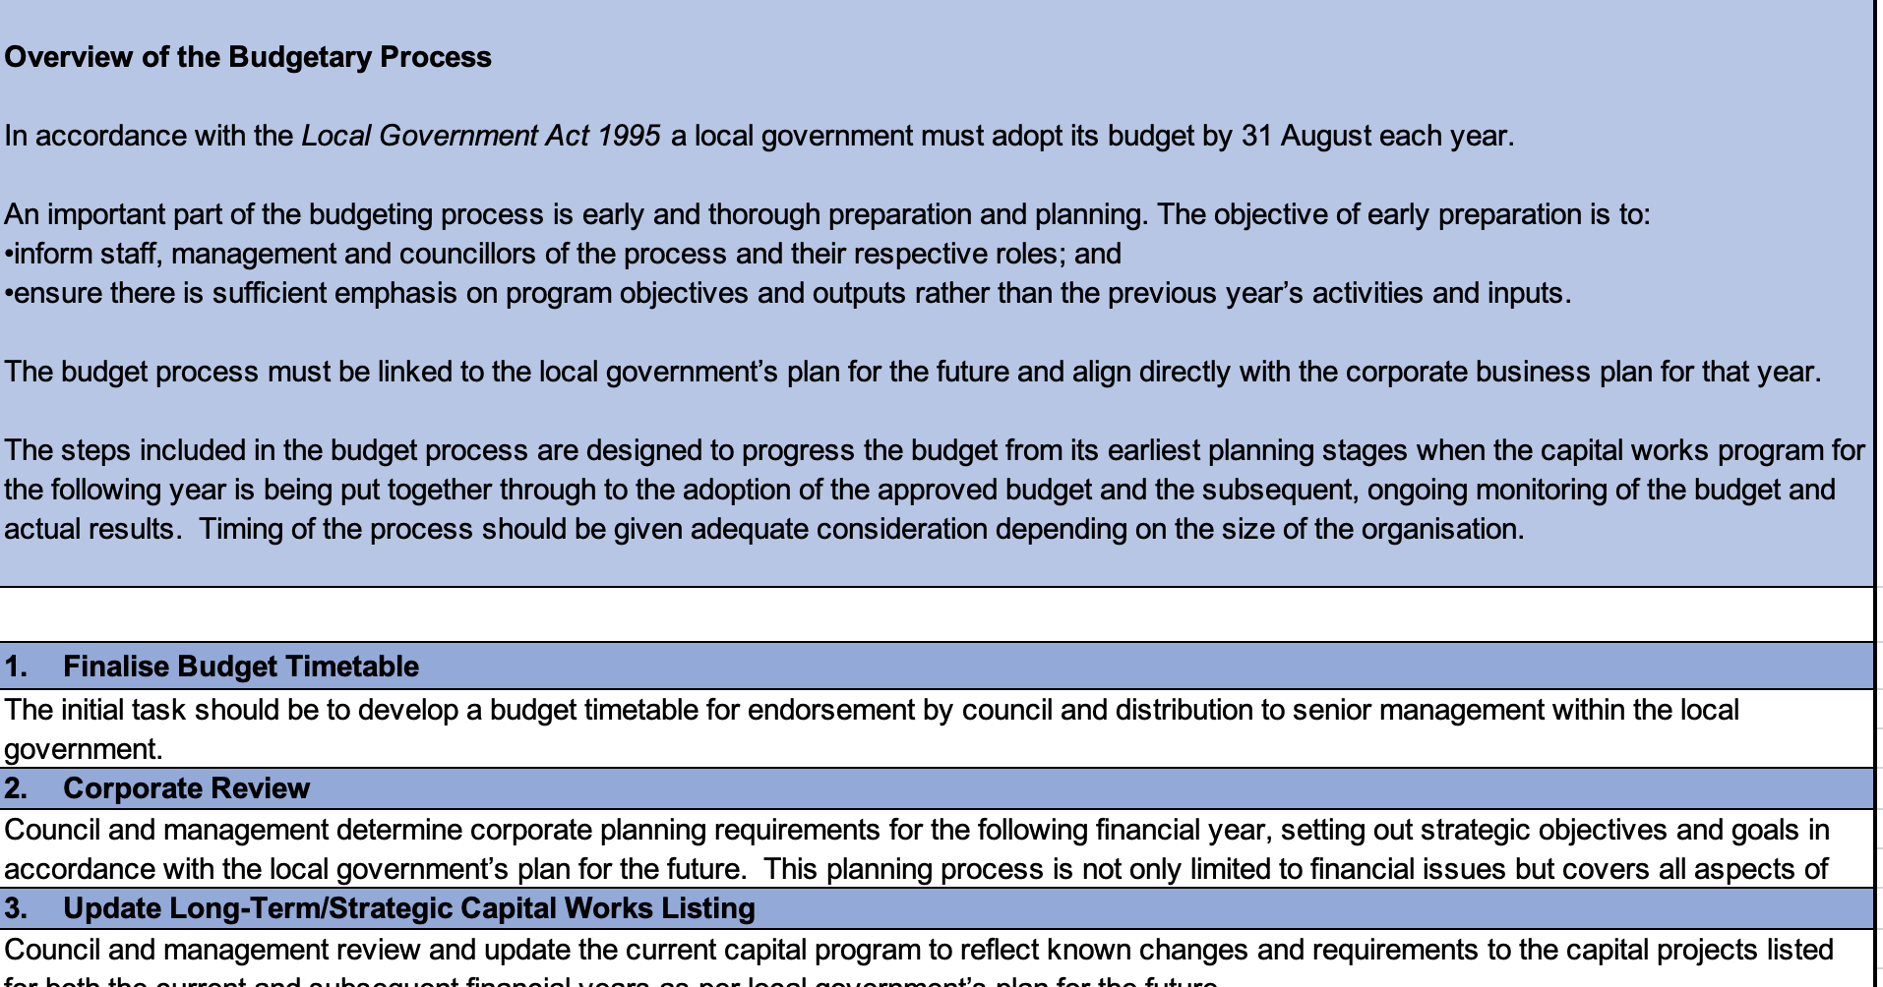

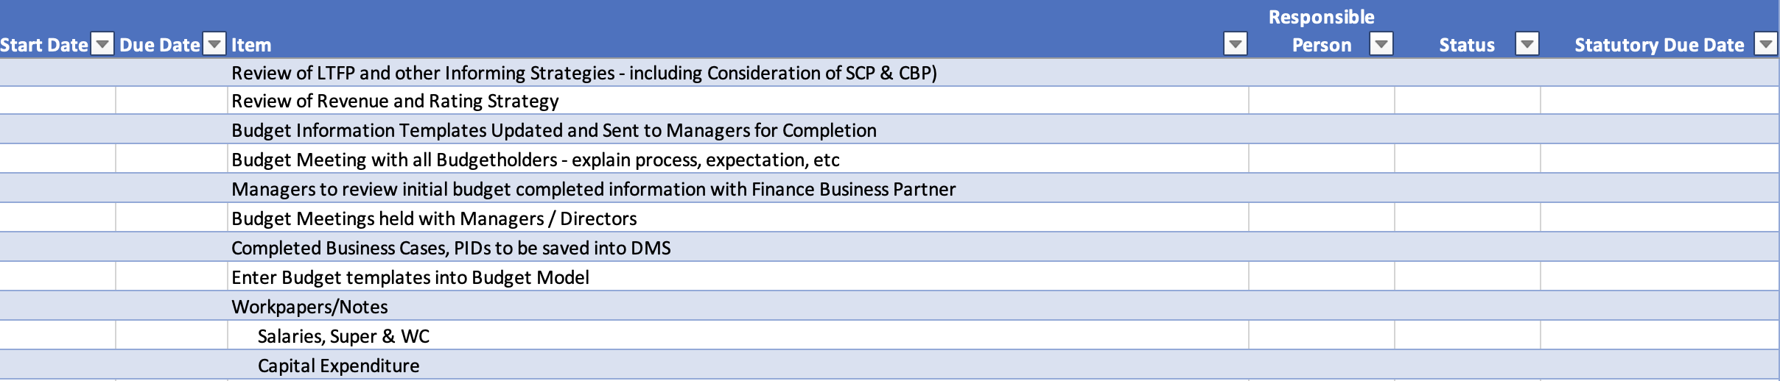

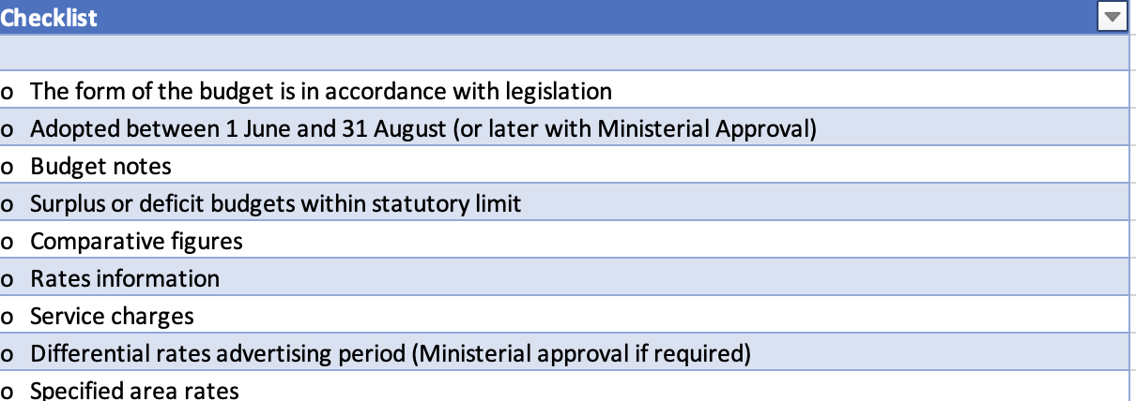

Template 2 - Example Month End Checklist
Refer to the excel version of this template for an example end of month checklist.

Extracts shown below:
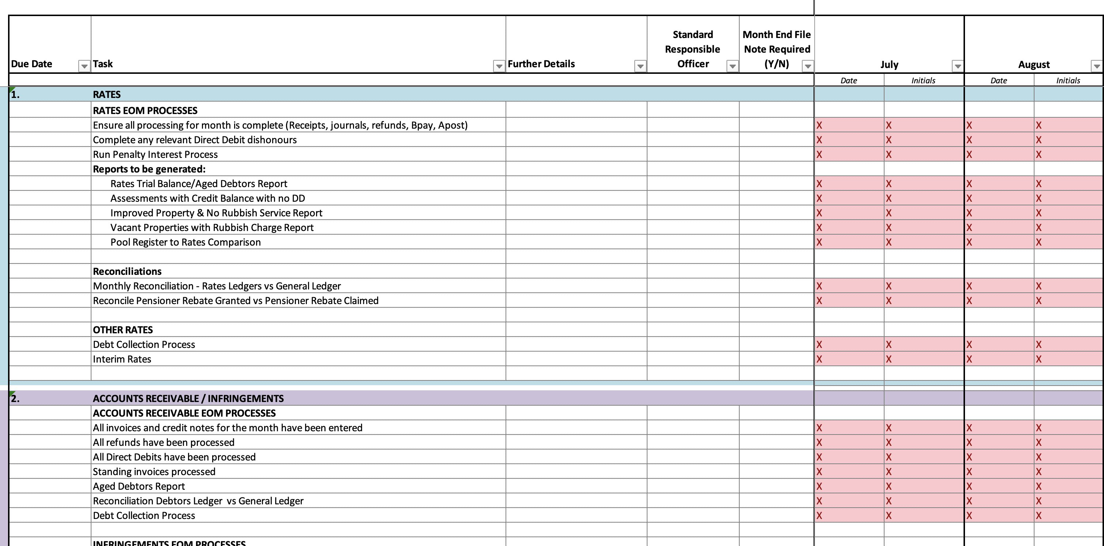

Template 3 - Example Activity Based Costing Worksheet
The excel version of this example can be found on the DLGSC website
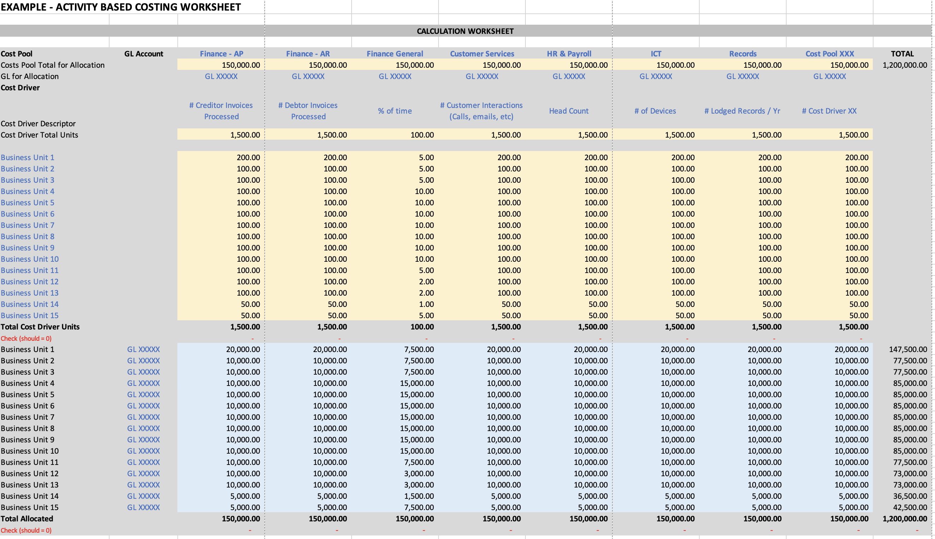

5.0 Further Resources and Training
A finance officer needs to ensure that they are regularly seeking opportunities to review, maintain and build their skills and knowledge. Working within the finance area involves a significant amount of responsibility to safeguard public funds. Among other topics, regular training should be sought in the following areas:

- Changes to Accounting Standards and legislation.
- Industry updates.
- Risk management, fraud detection and cyber-security.
- Process improvement and innovation.
- Ethics and integrity.

There are enormous amounts of resources available and training providers that are not only specific to the needs of a finance officer, but also specific to the local government industry.

You may like to commence your due diligence into training and resources by contacting the following organisations or reviewing the information on their websites:

- DLGSC, including contacting their Local Government Advisory Hotline 1300 762 511 (for local governments only)
- WALGA on 9213 2000 or email info@walga.asn.au
- LG Professionals WA on 9271 1136 or email admin@lgprofessionalswa.org.au
- WATC on 9235 9100 or email watc@watc.wa.gov.au
- Software Providers and User Groups
- Industry Consultants

Further resources and links to relevant information is provided in the Related Guidance section below.

6.0 Related Guidance
Australian Accounting Standards Board (AASB) | https://aasb.gov.au/
DLGSC – Integrated Planning and Reporting | https://www.dlgsc.wa.gov.au/local-government/strengthening-local-government/integrated-planning-and-reporting
DLGSC - Local Government Operational Guidelines | - No 2 - Changing Methods of Valuation of Land  https://www.dlgsc.wa.gov.au/department/publications/publication/changing-methods-of-valuation-of-land  - No 8 – Net Current Assets used in the Annual Budget  https://www.dlgsc.wa.gov.au/department/publications/publication/net-current-assets-used-in-the-annual-budget  - No 9 - Audit in Local Government  https://www.dlgsc.wa.gov.au/department/publications/publication/the-appointment-function-and-responsibilities-of-audit-committees  - No 11 – Use of Corporate Credit Cards  https://www.dlgsc.wa.gov.au/department/publications/publication/use-of-corporate-credit-cards  - No 17 - Delegations  https://www.dlgsc.wa.gov.au/docs/default-source/local-government/operational-guidelines/operational-guideline-17-delegations.pdf?sfvrsn=5bf158bf_1  - No 18 - Financial Ratios  https://www.dlgsc.wa.gov.au/department/publications/publication/financial-ratios
Note that all Local Government Operational Guidelines (including non- financial guidelines) can be accessed on the DLGSCs Website | https://www.dlgsc.wa.gov.au/local-government/local-governments/support-and-advice/local-government-operational-guidelines
DLGSC – Long Term Financial Planning Framework and Guidelines | https://www.dlgsc.wa.gov.au/docs/default-source/local-government/integrated-planning-and-reporting/integrated-planning-and-reporting-financial-planning-guidelines.pdf?sfvrsn=671ece6b_2#:~:text=The%20Long%20Term%20Financial%20Plan,strategic%20objectives%20can%20be%20developed
DLGSC – Risk Management Resources | https://www.dlgsc.wa.gov.au/docs/default-source/local-government/integrated-planning-and-reporting/integrated-planning-and-reporting---risk-management-fact-sheets.pdf?sfvrsn=f4e6adea_3
Local Government Act 1995 and Associated Regulations | https://www.legislation.wa.gov.au/legislation/statutes.nsf/main_mrtitle_551_homepage.html
OAG - Better Practice Guidance – all documents | https://audit.wa.gov.au/reports-and-publications/better-practice-guidance/
OAG - Better Practice Guide – Western Australian Public Sector Financial Statements | https://audit.wa.gov.au/reports-and-publications/reports/better-practice-guide-public-sector-financial-statements/

7.0 Disclaimer
Although every care has been taken in the production of these documents, neither the Crown in the right of the State of Western Australia nor any servant or agent of the Crown accepts responsibility for any loss or damage suffered at any time by any person as a result of any error, omission or inaccuracy in the publication whether or not the error, omission or inaccuracy has resulted from negligence or any other cause.

8.0 Version Control

Doc  No | Version No | Primary Author(s) | Description of Version | Date Completed
001 | 0.1 | Scoutta Pty Ltd t/a Business Beanies | Initial Draft | Oct 2022
002 | 0.2 | Suleila Felton & Anton Prinsloo | Final Version | Nov 2022
003 | 0.3 | Tim Fraser | Endorsed | Dec 2022
004 | 0.4 | Lanie Chopping | Approved | January 2023
005 | 0.5 |  | Next Review Date | Dec 2024

Disclaimer: Should any legislative amendments relevant to this document take effect prior to the next review date that the Introduction to Local Government Accounting Guidelines be immediately reviewed.

Western Australian Auditor General’s Report – Controls Over Corporate Credit Cards – Report 7: May 2018, Page 5
Ibid
Western Australian Auditor General’s Report – Local Government Procurement – Report 5: October 2018-19, Page 4
Local Government Operational Guidelines – Number 09 – Revised September 2013, Page 13

