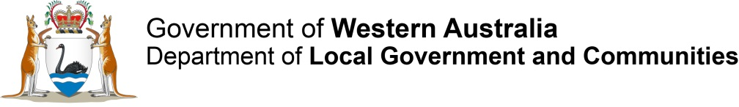
Local Government Advisory Board (LGAB)
  - Assessment of the proposal to amend the district boundary between the Shire of Kalamunda and the City of Gosnells
April 2016
LOCAL GOVERNMENT ADVISORY BOARD (LGAB)
Assessment of the proposal to amend the district boundary between the Shire of Kalamunda and the City of Gosnells

April 2016

Prepared by:
Local Government Advisory Board
Gordon Stephenson House
140 William Street
PERTH WA 6000
Tel: (08) 6552 1500
Fax: (08) 6552 1555
Freecall: 1800 620 511 (Country Only)
Email: advisory.board@dlg.wa.gov.au
Web: www.dlg.wa.gov.au/AdvisoryBoard
Translating and Interpreting Service (TIS) - Tel: 13 14 50
All or part of this document may be copied. Due recognition of the source would be appreciated.

Contents
1. Introduction 5
1.2 Key Statistical and Demographic Data 6
2. Local Government Advisory Board 7
2.1 The Proposal 7
2.2 Membership of the Board 8
3. Conducting the Inquiry 9
3.1 Community of Interests 12
3.2 Physical and Topographic Features 12
3.3 Demographic Trends 13
3.4 Economic Factors 13
3.5 History of the Area 13
3.6 Transport and Communication 13
3.7 Matters Affecting the Viability of Local Governments 14
3.8 The Effective Delivery of Local Government Services 14
4. Consultation 14
4.1 Meetings with Affected Local Governments 14
4.2 Public Hearings 18
4.3 Analysis of Public Submissions 19
5. Assessment of the Proposal – Matters Considered by the Board 21
5.1 Community of Interests 21
5.2 Physical and Topographic Features 24
5.3 Demographic Trends 26
5.4 Economic Factors 31
5.5. History of the Area 33
5.6 Transport and Communications 34
5.7 Matters Affecting the Viability of Local Governments 35
5.8 The Effective Delivery of Local Government Services 38
5.9 Other Matters 39
6. Conclusion 44
7. Recommendation 45

Introduction
A group of Wattle Grove electors submitted a proposal to the Local Government Advisory Board (the Board) dated 10 November 2015 to amend the district boundary of the Shire of Kalamunda by transferring part of the suburb of Wattle Grove currently located in the Shire of Kalamunda to the City of Gosnells.
Clause 2 (1) of Schedule 2.1 of the Local Government Act 1995 (the Act) states a proposal may be made to the Advisory Board by -
- affected electors who –
    - are at least 250 in number; or
    - are at least 10% of the total number of affected electors.
Based on Electoral Commission data, there are an estimated 485 electors in the affected area (at 9 March 2015). A petition signed by 120 petitioners accompanied the proposal; 98 of the 120 signatories were verified via the Western Australian Electoral Commission (WAEC), which equates to 20% of the estimated 485 electors. This then exceeds the 10% minimum requirement as specified by the Act.
The proposal met the requirements of clause 2(2) of Schedule 2.1 of the Act which states:
A proposal is to –
- set out clearly the nature of the proposal, the reasons for making the proposal and the effects of the proposal on local governments;
- be accompanied by a plan illustrating any proposed changes to the boundaries of a district; and
- comply with any regulations about proposals.
The Proposal therefore met all of the above requirements.
1.1 The Proposal
The Board has received a proposal from a group of Wattle Grove electors to amend the district boundary of the Shire of Kalamunda by transferring part of the suburb of Wattle Grove currently located in the Shire of Kalamunda to the City of Gosnells. A map illustrating the proposed boundary is included as Attachment 1 of this report. The area is bounded by Tonkin Highway to the west, Welshpool Road to the north, the Wattle Grove locality boundary to the east and the existing municipal boundary between the Shire of Kalamunda and the City of Gosnells to the south.
The Wattle Grove area was not specifically subject to any proposed boundary change during the Board’s Metropolitan Local Government Districts Inquiry (MLGDI) in 2014, other than those proposals and the Board’s recommendation for a boundary adjustment to the City of Belmont to incorporate the entire Shire of Kalamunda.
The Board met on 9 December 2015 and while it noted the proponent’s request that the Board assess the proposal informally, it resolved to conduct a formal inquiry into the proposal.

1.2 Key Statistical and Demographic Data
The following data is indicative of the geographic and demographic makeup of the two local governments.
Under the Australian Classification of Local Governments the City of Gosnells is classified as Urban Fringe Large and the Shire of Kalamunda is classified as Urban Fringe Medium.
Table 1 Key Statistical Data
 | City of Gosnells | Shire of Kalamunda
Area (sq km) | 127.29 | 324.36
Population | 123,993 | 60,743
Number of Electors* | 65,463 | 38,030
Number of Councillors | 11 | 12
Number of Employees | 642 | 273
Number of Dwellings | 42,454 | 22,415
*At 30 June 2015
This proposal would see the Shire of Kalamunda and City of Gosnells continue as local government entities, with the Shire of Kalamunda population being reduced by about 571 (0.9%) and the City of Gosnells population increased by 0.5% to approximately 124,564. The affected area of Wattle Grove has an estimated 244 rateable properties.

Table 2 Impact of boundary proposal
 | Proposal area* | Existing Shire of Kalamunda | Shire of Kalamunda after adjustment | Existing City of Gosnells | City of Gosnells after adjustment
Area (sq.km) | 3.75 | 324.36 | 320.6 | 127.29 | 131.0
Population (2014) | 571 | 60,743 | 60,172 | 123,993 | 124,564
Electors (2015) | 485 | 38,030 | 37,545 | 65,463 | 65,948
* Estimate based on ABS SA1 5113827 and 80% SA1 5113828

2. Local Government Advisory Board

2.1 The Proposal
The Board is a statutory body established under section 2.44 of the Act. Its role is to provide advice to the Minister on amalgamations, district and ward boundary amendments and councillor representation.
The Board’s major function is to assess proposals to change local government boundaries and their system of representation and make recommendations to the Minister about these proposals.
Clause 12 of Schedule 2.5 of the Act sets out the Board’s powers of inquiry and they are as follows:

Powers of Inquiry
- For the purposes of carrying out an inquiry under this Act, the Advisory Board may –
- by summons signed on behalf of the Advisory Board by its executive officer, require –
    - the attendance before the Advisory Board of any person;
    - the production before the Advisory Board of any document;
- inspect any document produced before it, and retain it for such reasonable period as it thinks fit, and make copies of the document or any of its contents;
- require any person to swear to truly answer all questions relating to a matter being inquired into by the Advisory Board that are put by or before the Advisory Board (and for that purpose a member of the Advisory Board or its executive officer may administer any oath or affirmation):
- require any person appearing before the Advisory Board to answer any relevant question.
(2) A person is not excused from complying with a requirement under subclause (1) on the ground that the answer to a question or the production of a document might be incriminating or render the person liable to a penalty, but an answer given by a person that was required under subclause (1) to be given is not admissible in evidence against the person in any civil or criminal proceedings other than proceedings for perjury or for an offence against this Act arising out of the false or misleading nature of the answer.

2.2 Membership of the Board
Clause 2 of Schedule 2.5 of the Act makes provision for the membership of the Board and reads as follows:

Membership of Advisory Board
The Advisory Board consists of 5 members appointed by the Governor of whom-
(a) one person is nominated by the Minister;
- 2 persons are to be persons having experience as a member of a council appointed from a list submitted to the Minister by WALGA under clause 4(1);
- one person is to be a person having experience as the chief executive officer of a local government appointed from a list submitted to the Minister by the Local Government Managers Australia WA Division under clause 4(2); and
- one person is to be an officer of the Department nominated by the Minister.

The current membership of the Board is included in Table 3 below:

Table 3 Board Members
Chair | Mr Melvyn Congerton JP
Members
WALGA Nominees | Ms Helen Dullard AM (Member)  Cr Karen Chappel (Member)  Mr Richard Smith (Deputy)  Mayor Gary Brennan (Deputy)
LGMA Nominees | Dr Shayne Silcox (Member)  Mr Mark Chester (Deputy)
Department of Local Government | Ms Mary Adam (Deputy Chair)  Mr Tim Fowler (Deputy)

As an elector of the Shire of Kalamunda, Dr Shayne Silcox did not participate in this Inquiry, including all relevant discussions of the Board.

Conducting the Inquiry
A proposal for amending local government district boundaries may be made by electors, local governments or the Minister.
Clause 2(2) of Schedule 2.1 of the Act sets out the requirements for proposals for amalgamations and boundary amendments and reads as follows:

Making a proposal
(1) A proposal may be made to the Advisory Board by —
(a) the Minister;
(b) an affected local government;
(c) 2 or more affected local governments, jointly; or
(d) affected electors who —
(i) are at least 250 in number; or
(ii) are at least 10% of the total number of affected electors.
(2) A proposal is to —
(a) set out clearly the nature of the proposal, the reasons for making the proposal and the effects of the proposal on local governments;
(b) be accompanied by a plan illustrating any proposed changes to the boundaries of a district; and
(c) comply with any regulations about proposals.

Provisions for dealing with proposals are set out in clause 3 of Schedule 2.1 of the Act and reads as follows:

Dealing with proposals
(1) The Advisory Board is to consider any proposal.
(2) The Advisory Board may, in a written report to the Minister, recommend* that the Minister reject a proposal if, in the Board’s opinion —
(a) the proposal is substantially similar in effect to a proposal on which the Board has made a recommendation to the Minister within the period of 2 years immediately before the proposal is made;
(aa) where the proposal was made by affected electors under clause 2(1)(d), that the majority of those electors no longer support the proposal; or
(b) the proposal is frivolous or otherwise not in the interests of good government.
* Absolute majority required.
(3) If, in the Advisory Board’s opinion, the proposal is —
(a) one of a minor nature; and
(b) not one about which public submissions need be invited, the Board may, in a written report to the Minister, recommend* that the Minister reject the proposal or that an order be made in accordance with the proposal.
* Absolute majority required.
(4) Unless it makes a recommendation under subclause (2) or (3), the Advisory Board is to formally inquire into the proposal.

On 8 October 2015, the Board determined that the Proposal should not be dealt with under the provisions of clause 2 and 3 above, and as such, the provisions of clause 4 would apply and the Board would conduct a formal inquiry into the Proposal. Both local governments were informed of the Board’s decision on 13 October 2015.
Clause 4 of Schedule 2.1 of the Act contains provisions relating to a Notice of Inquiry and reads as follows:

Notice of inquiry
(1) Where a formal inquiry is required the Advisory Board is to give —
(a) notice to affected local governments, affected electors and the other electors of districts directly affected by the proposal; and
(b) a report to the Minister.
(2) The notice and report under subclause (1) are to —
(a) advise that there will be a formal inquiry into the proposal;
(b) set out details of the inquiry and its proposed scope; and
(c) advise that submissions may be made to the Board not later than 6 weeks after the date the notice is first given about —
(i) the proposal; or
(ii) the scope of the inquiry.
(3) If, after considering submissions made under subclause (2)(c), the Advisory Board decides* that the scope of the formal inquiry is to be significantly different from that set out in the notice and report under subclause (1), it is to give —
(a) another notice to affected local governments, affected electors and the other electors of districts directly affected by the proposal; and
(b) another report to the Minister.
(4) The notice and report under subclause (3) are to —
(a) set out the revised scope of the inquiry; and
(b) advise that further submissions about the proposal, or submissions about matters relevant to the revised scope of the inquiry, may be made to the Board within the time set out in the notice.
* Absolute majority required
The Notice of Inquiry appeared in The West Australian on 23 January 2016 and the Midland Kalamunda Reporter and Comment News on 26 January 2016. A copy of the Notice is included at Attachment 2.
A six week public submission period closed at 4.00 pm on 3 March 2016. The Board met with representatives of the two local governments to discuss the proposal on 23 February 2016. The Board also held a public hearing in the evening of 23 February 2016 at the Woodlupine Community Centre, Forrestfield, in the Shire of Kalamunda.
In carrying out a formal inquiry the Board is required to consider submissions made to it under clause 4(2)(c) of Schedule 2.1 of the Act and have regard, where applicable, to:
- Community of interests
- Physical and topographic features
- Demographic trends
- Economic factors
- The history of the area
- Transport and communication
- Matters affecting the viability of local governments, and
- The effective delivery of local government services.

The Board may also take into account any other matter it considers relevant as part of its inquiry.
The Board has developed the following guiding principles for each of the above factors:

3.1 Community of Interests
Community of interests includes part of a district that share common interests, values, characteristics and issues giving rise to a separate sense of identity or community. Factors contributing to a sense of identity or community include shared interests and shared use of community facilities. For example sporting, leisure, religious and library facilities create a focus for the community.
The use of shopping areas and the location of schools also act to draw people together with similar interests. This can also give indications about the direction that people travel to access services and facilities. The external boundaries of a local government need to reflect distinct communities of interest wherever possible.
Neighbourhoods, suburbs and towns are important units in the physical, historical and social infrastructure and often generate a feeling of community and belonging. The Board believes that wherever possible, it is inappropriate to divide these units between local governments.

3.2 Physical and Topographic Features
Physical and topographic features may be natural or manmade and will vary from area to area. They may include:
Water features (such as rivers)
Catchment boundaries
Coastal plains and foothills
Parks and reserves, and
Manmade features (such as railway lines or freeways).
These features can form identifiable boundaries and can also act as barriers to movement between adjoining areas. In many cases physical and topographic features are appropriate district and ward boundaries. The Board supports local government structures and boundaries that facilitate the integration of human activity and land use.

3.3 Demographic Trends
Local governments should consider the following characteristics when determining the demographics within its locality:
Population size
Population trends
Distribution by age
Gender, and
Occupation.
Current and projected population factors will be relevant as well as similarities and differences between areas within the local government.

3.4 Economic Factors
Economic factors can include any factor that reflects the character of economic activities and resources in the area including:
Industries within the local area
Distribution of community assets, and
Infrastructure.

3.5 History of the Area
The history of an area can be a relevant consideration, although the Board believes that in the majority of cases this will not be a primary justification for changing or retaining local governments and local government boundaries. The nature of historical ties between communities is important to understand, irrespective of where the local government boundaries lie.
A community within a local government may have a strong historical identity; alternatively there may be strong historical links between two or more communities in adjacent local governments. It is important to note that historical identity is not lessened if an area does not have its own local government.

3.6 Transport and Communication
The transport and communication linkages between towns and other areas may be a significant barrier to movement and therefore an appropriate boundary between local governments.
Consideration of the following factors is important in any assessment of local government boundaries:
Port access
Neighbouring towns
Railways, and
Major roads.

3.7 Matters Affecting the Viability of Local Governments
Local governments should have a significant resource base:
To be able to efficiently and effectively exercise its proper functions and delegated powers and operate facilities and services
To be flexible and responsive in the exercise of its functions and powers and operation of its facilities and services
To employ appropriate professional expertise and skills, and
To be capable of embracing micro-economic reform.
Each local government should have a diverse and sufficient rate base to ensure that general purpose grants do not represent the major revenue source.

3.8 The Effective Delivery of Local Government Services
A broad range of factors can be relevant to the effective delivery of local government services and these are often directly relevant to those that also affect the viability of local governments. They include:
The size and geographical spread of the population
Management effectiveness and efficiency
The availability of staff expertise
Appropriate infrastructure and equipment, and
Customer satisfaction and feedback.

4. Consultation

4.1 Meetings with Affected Local Governments

Meeting with the City of Gosnells
The Board met with councillors and staff of the City of Gosnells to answer questions about the inquiry process and to also give them the opportunity to raise any concerns or issues about the boundary amendment proposal.
The CEO indicated that the City of Gosnells was generally ambivalent to the Wattle Grove elector’s proposal. Given that the City already had a population of around 125,000 the additional area is comparatively small and would have no particular impact. City representatives had liaised with the proponents but were not championing the proposal. The City indicated that the proposal made sense as Welshpool Road east is a major regional road (10,000 vehicles per day) and the current boundary, which it described as a saw tooth through bush blocks, is not ideal.
The City has a particular interest in an adjacent area of Wattle Grove, south of Welshpool Road and west of Tonkin Highway, which is part of the Maddington Kenwick Strategic Employment Area (MKSEA). This area is likely to be developed as an industrial area. A Metropolitan Region Scheme (MRS) amendment is being progressed and the city is currently undertaking traffic and transport studies. Developer contributions would fund the cost of developing the roads. The subject area is 95% in the City of Gosnells and 5% in the Shire of Kalamunda; it would potentially be the only developer contributions area spanning two local governments. The cooperation of the Shire of Kalamunda would be required. The City believes it would make sense to incorporate this area into the City as an extension to the current proposal before the Board. This additional land is 73 hectares with 38 properties. The City believes most residents in the area are aware of the MKSEA developments and support it as their property values would be increased.
The City would be keen to straighten the current boundary. For example, there is a situation at present with Valcan Road where City refuse trucks have to drive through the Shire of Kalamunda to service properties located in the City of Gosnells.
The Mayor indicated that while the City’s foothills strategy had been held up by quarry related issues, the City was generally supportive of property east of Tonkin Highway remaining rural. There was a small commercial area on Kelvin Road, otherwise the remainder is hobby farm type development.
It was suggested to the Board that the people of Wattle Grove would use the Karinya Equestrian Park developed by the City in nearby Orange Grove, as well as pony trails through the area. Kelvin Road has an old tip site which has the potential to be developed as future playing fields, and it is expected that this would be used by Wattle Grove residents. Many residents would be likely to use Cannington or Belmont for retail services rather than Kalamunda.
The City had not made a financial assessment of the impact of the transfer of the area, as it was likely to be insignificant in terms of the City budget.
The City stressed its priority is with the MKSEA area in which it had invested $750,000 to facilitate its conversion to industrial. This is also a State priority. The City believes that an amendment to the current proposal to include this area could be considered by the Board, as a minor matter. Alternatively, depending on the outcome of the current inquiry, there was the potential for the City to submit a separate boundary proposal in respect of this area.
Figure 1 City of Gosnells boundary showing effect of additional Wattle Grove areas (A and B)
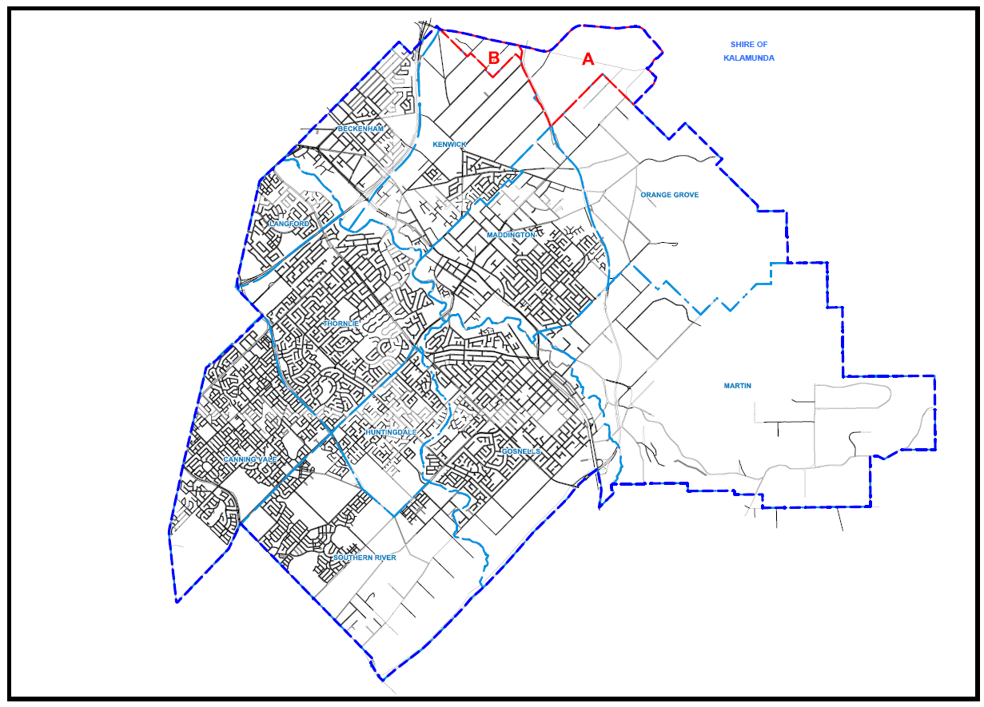

Figure 2 Maddington Kenwick Strategic Employment Area (MKSEA)
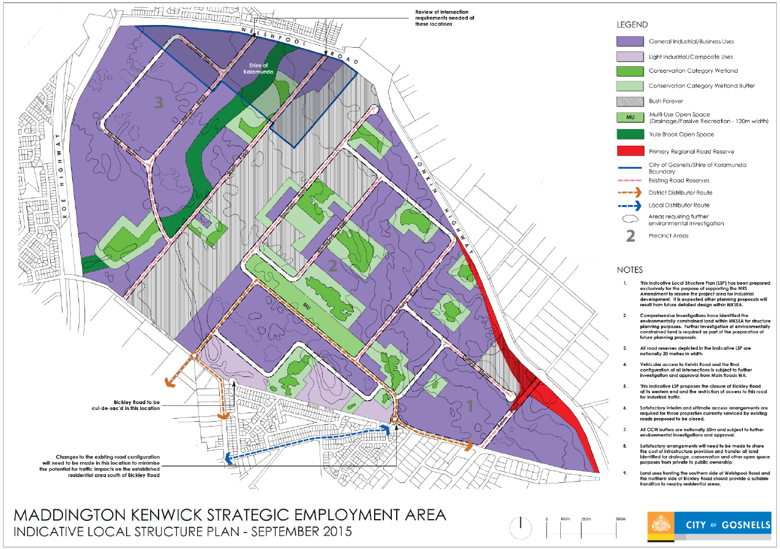
Source; http://www.gosnells.wa.gov.au/files/sharedassets/public/pdfs/plannning_and_development/mksea/mksea_indicative_local_structure_plan_9a_september_2015.pdf

Meeting with the Shire of Kalamunda
The Board met with councillors and staff of the Shire of Kalamunda to answer questions about the inquiry process and to also give them the opportunity to raise any concerns or issues about the boundary amendment proposal.

The Shire President advised that the Shire of Kalamunda were very strongly opposed to the proposal. The Shire could see no advantage in the proposal or any argument in support of it. A neutral letter had been sent to affected residents to advise them of the proposal. A council meeting on 22 February 2016 was attended by many residents opposed to the proposal. The Shire estimated that the loss of revenue would translate to a 2.5% rate increase for the remaining ratepayers in the Shire. The residents in the affected area would be faced with a 7% rate increase under the City of Gosnells’ current rating regime.
A proposal for an aged persons village had been opposed by the Wattle Grove Action Group, and this would remain an issue even if the area was part of the City of Gosnells. The group had also been critical of the Shire of Kalamunda. Wattle Grove has historical and cultural associations with the Kalamunda area.
The Shire noted that the elector’s proposal appeared to be from a minority of residents indicating that they represented the majority.
A local ward councillor noted that Wattle Grove residents used Kalamunda schools, libraries and recreation facilities. The Shire had many semi-rural areas and worked with them on issues such as minimising bushfire risk. Many residents were shocked that the proposal had been made. The proposal was divisive to the local community.
The CEO reiterated that the Shire saw little merit in the proposal. No cost-benefit analysis had been undertaken to support the proposal. There would be a financial implication for the Shire to recoup the lost rate base, making the Shire less sustainable, yet the residents would still be using Shire facilities. As such there would be no advantage to the Shire to give up this land. Maintaining services in the affected area is not a huge cost burden. The Chairman asked for a ‘net rates’ figure and the CEO undertook to provide this.
Kalamunda was said to have a prestigious reputation and there was concern that devaluation of properties would occur; being part of the City of Gosnells could therefore present a significant financial disadvantage.
The Chair was asked about the criteria that would be used to assess the proposal. In response, he indicated that the matters specified in the legislation such as community of interests, history, and demography would be taken into account. He suggested that the Shire’s submission also address these points.
The Board was advised that the Western Australian Planning Commission (WAPC) had already flagged that Wattle Grove will in future be urban. In terms of the proposed boundary, Tonkin Highway is as good a boundary as Welshpool Road. Welshpool Road is not a divider that affects service provision. There had been no particular service improvements demanded by the community. People are connected across the area.
In conclusion, the Shire President reiterated that the Shire was not prepared to let the area go, there would be no benefit to the rest of the community, and the proposal would satisfy only a small group. He also noted that the Shire would be willing to engage with open discussions with the City of Gosnells to further discuss local boundaries.

4.2 Public Hearings
The Board conducted public hearings in accordance with clause 4 of Schedule 2.1 of the Act.
The Act requires that any hearing for the purpose of an inquiry is to be conducted in a way that makes it as easy as possible for interested parties to participate fully in the process. The Board held a public hearing on the evening of 23 February 2016 at the Woodlupine Community Centre, Forrestfield, in the Shire of Kalamunda.
The venue and time for the public hearing was organised to ensure that affected residents were able to attend a hearing within close proximity to their place of residence. The hearing was also held in the evening to ensure maximum participation and minimal conflict with people’s work commitments.
The venue, date and attendance numbers for the hearing are detailed in the following table:
Table 4 Public Hearing
VENUE | Date | Attendance
Woodlupine Community Centre, Forrestfield | 23 February 2016 | Approx 160

4.3 Analysis of Public Submissions
The consultation period commenced on 21 January 2016 and concluded on 3 March 2016. The Board received 205 submissions in total. Of these, 21 (or 10%) supported the proposal and 184 (or 90%) opposed the proposal.
The following table provides a breakdown of the submission forwarded to the Board.
Table 5 Submissions
TOTAL  205 | Support | Oppose
 | 21 | 184

Respondents who were in favour of the proposal commonly cited the following reasons:
- They are neither considered by, nor respected by the Shire of Kalamunda
- An example provided as evidence of this claim is that the council approved amendment 18 (rezoning of Lot 500 Gavour Road) nine months after it was rejected by Minister for Planning
- They want to retain their rural lifestyle and don’t believe that this will be guaranteed by the Shire of Kalamunda
- They therefore believe that the City of Gosnells will better represent their desire to maintain their rural lifestyle
- Property values, crime rate, insurance rates, access to libraries, access to schools etc will not change simply because of a change to a local government boundary line on a map – therefore those are not valid reasons on which to base a rejection of the proposal.

There was also a view expressed that Kalamunda / Gosnells boundary is frustratingly dis-jointed, and this causes issues of council services and postal delivery. Whether boundaries are changed so that the areas of Wattle Grove and Orange Grove both become Kalamunda or both become Gosnells is irrelevant, what is relevant is the boundaries are redefined so that they are logical; ie: bounded by Tonkin Highway and Welshpool Road
Some of the common reasons cited by those who were against the proposal include:
- The petition provided as part of the original proposal only includes approximately 25% of residents in the affected area of Wattle Grove. Therefore the remaining 75% believe that they’ve been wrongly included as part of the group of concerned residents, and also maintain that democracy has not been followed. ”Democracy works best when the voters (or residents/electors) are fully informed” as quoted by one of the residents against the proposal
- Associated concern that there’s been little or no consultation with 75% of affected residents who were not included in the petition provided with the original proposal
- It is considered that the proponent group has made their submission due to a long term feud with the Shire of Kalamunda, rather than because of any genuine community or economically-based reasons
- There is no real evidence in the proponents proposal to support the claim that there will be a benefit to moving to City of Gosnells and therefore it does not demonstrate any valid and justifiable reason for the change to be made
- They are satisfied with the services currently provided by the Shire of Kalamunda
- There is some concern (which may or may not be justified) that a move to the City of Gosnells will adversely affect their current property values
- Most services – such as schools, shopping, local library, sporting grounds used by those residents in the affected area are currently located within the Shire of Kalamunda
- Residents believe that council rates would increase by up to 7% with a move to City of Gosnells
- Residents identify as being part of the hills community and therefore wish to stay with the Shire of Kalamunda which they believe appropriately represents the hills area
- There is no benefit to splitting the suburb of Wattle Grove between two local government authorities – and this in itself may potentially cause further problems
- Some residents are concerned about the higher crime rate associated with the City of Gosnells and wonder if it would therefore affect their properties should they be moved from the Shire of Kalamunda
- An understanding that “nothing is permanent” – ie a change to the City of Gosnells would not guarantee a permanent rural lifestyle either
- Acknowledgment therefore that urban sprawl is inevitable, so when the State Planning Commission moves to rezone an area, the issue can be addressed then. But until this occurs, they’d prefer to stay within the happy peaceful Kalamunda Shire they currently enjoy
- The belief that the City of Gosnells is “pro-industry” and therefore may not act in the best interests of residential property owners.
An underlying theme of many submissions was the view that a move to another municipality will not protect Wattle Grove or its residents from any future planning decisions at a state government level.
The City of Gosnells submission did not directly comment on the proposal before the Board, but expressed the view that if the Board should decide to recommend that the Minister accept the proposal, a further small adjustment should be made to the boundary between the Shire of Kalamunda and the City of Gosnells, in the locality of the Maddington Kenwick Strategic Employment Area. The City’s current northern boundary, in following the southern edge of the suburb of Wattle Grove, follows a zigzag pattern around land holdings, ‘rather than presenting as a strategic division of municipalities. Welshpool road is a logical municipal boundary as it is an identifiable primary regional road.
The Shire of Kalamunda submission rejected the City of Gosnells amendment to the original proposal, expressing disappointment that the City included this amendment without prior discussion with the Shire Council. The Shire suggested the City of Gosnells seeks to expand the area under consideration without providing affected residents an opportunity to properly respond to the expanded proposal.

5. Assessment of the Proposal –
Matters Considered by the Board

5.1 Community of Interests
The issue of community of interests is generally considered by the Board to be a minor consideration in the Board’s deliberations on boundary change proposals. However, the Board notes the proponent’s claim that there are community of interest linkages between those residents of the semi-rural portion of Wattle Grove living in the Shire of Kalamunda and those residents of adjacent semi-rural areas in the City of Gosnells.
The locality of Wattle Grove is approximately three quarters semi-rural in nature, and one quarter developed urban. The current proposal would see the urban area stay in the Shire of Kalamunda, and most of the semi-rural area transferred to the City of Gosnells, which has similar semi-rural areas in Orange Grove and Martin.
The proponent suggested the rural area of Wattle Grove shares more in common with the neighbouring suburbs of Orange Grove and Martin than it does with any of the surrounding suburbs in the Shire of Kalamunda. Lifestyle and larger blocks are cited as being in common. The proponent also makes reference to there being ‘a united community divided by a local government boundary’.
According to many inquiry respondents, the area has stronger community of interest linkages with other residents of Kalamunda. The Shire of Kalamunda submitted that the proposal area is located in close proximity to the Shire’s largest recreation complex at Hartfield Park and also the commercial activity centre at Forrestfield Forum. According to the Shire, the proximity of these facilities strengthens the community of interest ties with this local government area.
The Board understands there are many influences on community of interest including where people send their children to school and where they access retail services. The closest centres for major supermarkets are Forrestfield
(6 km, 8 minutes) or Maddington (8.6km, 11 minutes). Many residents would be likely to use Cannington or Belmont for other retail services as well as Kalamunda. Patterns of access and use are not likely to change because a local government boundary changes.

Figure 3 Satellite image, semi-rural Wattle Grove and adjacent areas
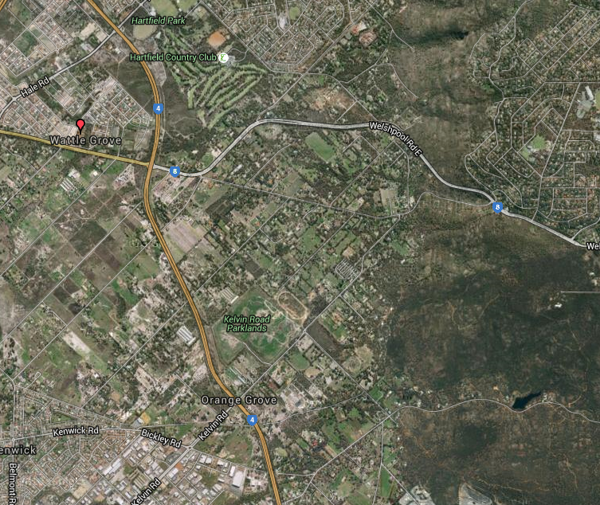
Source: https://www.google.com/maps/@32.0220559,116.0195394,2603m/data=!3m1!1e3?hl=en

Primary schools closest to the area subject to this proposal include:
- Wattle Grove Primary School (approximately 1.9 km distance)
- Forrestfield Primary School (2.4 km)
- Orange Grove Primary School (2.6 km)
Most of the affected area is within the catchment of the Wattle Grove Primary School located on St John Road. This school opened to students in 2011 replacing an older school which had been located on Welshpool Road west of Tonkin Highway, having been established in 1915. The School was awarded the "Primary School of the Year" in the WA Education Awards 2014.
High schools closest to the area include:
- Lesmurdie Senior High School (3.7 km)
- Darling Range Sports College, Forrestfield (4.1 km)
- Yule Brook College, Maddington (4.0 km)
Access to schools does not change as a result of a change in the local government boundaries. Local intake areas sometimes need to be redefined if the definition includes a reference to a current local government boundary. Advice to the Board from the Education Department confirms that current student entitlements to attend existing schools would be maintained.
Current electoral boundaries show that Wattle Grove is linked with adjacent localities in both the Shire of Kalamunda and the City of Gosnells. Community of interests is one factor taken into account when electoral boundaries are determined.
The affected area, and the locality of Wattle Grove generally, is in the current (and 2015) State electorate of Forrestfield, which spans foothills suburbs from High Wycombe and Maida Vale in the Shire of Kalamunda to Kenwick and Orange Grove in the City of Gosnells. The Wattle Grove area, and electorate of Forrestfield, is also within the East Metropolitan region, with the balance of the Shire of Kalamunda and part of the City of Gosnells and several other local governments.
The Federal electorate of Hasluck, as amended by a recent redistribution and redrawing of boundaries, is similarly placed, combining Wattle Grove with other parts of the Shire of Kalamunda and part of the City of Gosnells. The adjacent locality of Orange Grove in the City of Gosnells, however, is in the electorate of Canning.

5.2 Physical and Topographic Features
Topographical features of particular significance in the local area include:
- the Darling Scarp
- Tonkin Highway
- Welshpool Road
The area subject to the proposal is located in the foothills area of transition between the Swan coastal plain and the Darling Scarp. The proponent describes the affected area as ‘rural Foothills type community enclaves’ and referenced the commonality of zoning, infrastructure and block size shared with the neighbouring areas of Orange Grove and Martin, a commonality that is said to be not shared with the majority of adjoining Lesmurdie or Forrestfield.
Tonkin Highway and Welshpool Road form the northern and western boundary of the area proposed to be transferred to Gosnells. Welshpool Road, for some 3.5 kilometres or so, would form part of new southern boundary of the Shire. This is a reasonable feature to use as a local government boundary. The proposal swaps Tonkin Highway for Welshpool Road as part of the boundary between the two local governments; in the words of one inquiry participant, ‘one major road is as good as another as a local government boundary’.
A Bush Forever site (50), Welshpool Road Bushland, is located on the north side of Welshpool Road and is not within the affected area. As one respondent noted, there are no obvious topographical features which would indicate a greater connection of this portion of Wattle Grove with the City of Gosnells. The Shire of Kalamunda submitted that the rural areas of Wattle Grove share a commonality of zoning, services, infrastructure and lot sizes with a number of other rural areas within the Shire, such as Pickering Brook and Bickley.
The semi-rural area of Wattle Grove provides a buffer between the urban areas of Wattle Grove and reserved land along the Darling Scarp.
Figure 4 Satellite image, Wattle Grove locality

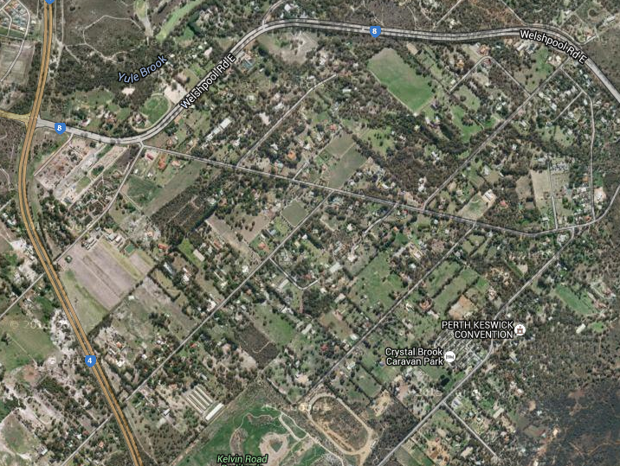
Source: https://www.google.com/maps/@32.0220559,116.0195394,2603m/data=!3m1!1e3?hl=en

The Board notes that given that the current boundary slices through the semi-rural landscape without consistently relating to the road network or other topographical features, the elector’s proposal creates a marginally better boundary between the Shire of Kalamunda and the City of Gosnells. Importantly, the saw-tooth boundary would be removed.

5.3 Demographic Trends
The comparative estimated resident population for the two local governments from 2004 to 2014 are as follows:
Table 6 Population Change 2004-2014
Year | Shire of Kalamunda | City of Gosnells
2004 | 49,909 | 90,120
2005 | 51,052 | 92,600
2006 | 51,423 | 94,958
2007 | 52,560 | 98,035
2008 | 53,540 | 101,907
2009 | 54,487 | 105,782
2010 | 55,572 | 109,250
2011 | 56,492 | 112,435
2012 | 58,191 | 116,939
2013 | 59,758 | 121,237
2014 | 60,743 | 123,993
Source: ABS http://www.abs.gov.au/AUSSTATS/abs@.nsf/DetailsPage/3218.02013-14?OpenDocument

Both local governments are experiencing a steady increase in population. The City of Gosnells, one of the fastest growing local governments in the metropolitan area, grew 2.3% from 2013 to 2014 (37.6% since 2000). The Shire of Kalamunda (1.6% between 2013 and 2014) has also grown significantly since 2000 (21.7%). The boundary change proposal would not have a significant impact on the overall population size of each local government, being less than 1% of the current Kalamunda Shire. The Shire consistently increases by more than this in any one year, so it would soon recover the population loss as a result of the proposed boundary change.
The Shire of Kalamunda adopted a Local Planning Strategy (LPS) and a Local Housing Strategy in October 2011 and March 2014 respectively. By 2031 the potential addition of 14,100 dwellings could potentially house an additional 35,250 persons in the shire. The State Government's Directions 2031 and Beyond, and Outer Metropolitan Perth and Peel Sub-Regional Strategy is referenced as identifying Wattle Grove as having "potential for future consideration as an urban investigation area. This is due to its proximity to the urban front and employment around the airport". (LPS 2011, p89)
Under the Shire’s adopted scenario to the year 2031, the semi-rural area of Wattle Grove could have an additional 1,150 lots and 2,875 people in the area south of Crystal Brook Road. The Shire of Kalamunda submitted to the Board that the area is flagged as an urban investigation area under the Shire’s Planning Scheme and that it was likely that urbanisation will occur post 2025 which is in accord with the draft Outer Metropolitan Regional Plans. The demographic trends under this scenario will see increased population and density post 2025.
The population of Wattle Grove is thus projected to grow (Table 7), reflecting the expected further urban and residential development in the area, although the timing may be slightly different to that envisaged by population analysts .id.
Table 7 Population Projections, Wattle Grove 2011-2036
Years | Wattle Grove,  Shire of Kalamunda
2011 | 4,393
2016 | 6,156
2021 | 6,917
2026 | 7,263
2031 | 7,694
2036 | 8,197
Source: .id http://forecast.id.com.au/kalamunda/population-households-dwellings?WebID=170

There are several particular demographic characteristics that the Board considers relevant when considering boundary amendment proposals of this nature, including population growth, age structure, and employment, household and dwelling type.
The affected area is quite different in age profile to Wattle Grove generally, being generally older. In this sense the area is most similar to the Shire of Kalamunda rather than the City of Gosnells (Table 8). The affected area is more characterised by older workers, pre-retirees, empty nesters and seniors seeking the semi-rural lifestyle, whereas the more urban part of Wattle Grove is more characterised by parents and homebuilders with young children and young workforce.
The proponent referenced some similarity between the population in the affected area and the neighbouring areas of Orange Grove and Martin, and the relevant demographic data is included in the tables to facilitate the comparison.
Couples with children are the most numerous household type in Wattle Grove. There are relatively fewer lone person households (Table 9). Relatively large percentages of workers in the affected area are engaged as managers and professionals, and there are fewer trades workers and labourers, although the available data is not complete (Table 10). Dwelling types, as at the 2011 Census, are predominantly separate houses (Table 11).
Table 8 Service age groups 2011
Service age group (years) | Wattle Grove | % Wattle Grove | Shire of Kalamunda % | City of Gosnells % | Affected Area No. | Affected Area % | Orange Grove % | Martin %
Babies and pre-schoolers (0 to 4) | 419 | 10.1 | 6.4 | 7.4 | 27 | 4.8% | 5.5 | 4.4
Primary schoolers (5 to 11) | 430 | 10.3 | 9 | 9.6 | 48 | 8.4% | 3.8 | 5.9
Secondary schoolers (12 to 17) | 318 | 7.6 | 9 | 8.5 | 60 | 10.6% | 7.2 | 10.8
Tertiary education and independence (18 to 24) | 423 | 10.2 | 9.2 | 10.4 | 67 | 11.7% | 7.5 | 10.1
Young workforce (25 to 34) | 802 | 19.3 | 11.7 | 15.7 | 27 | 4.8% | 9.1 | 9.2
Parents and homebuilders (35 to 49) | 965 | 23.2 | 21 | 21.4 | 110 | 19.3% | 24.6 | 20.5
Older workers and pre-retirees (50 to 59) | 432 | 10.4 | 13.3 | 11.7 | 108 | 18.9% | 22.6 | 17.1
Empty nesters and retirees (60 to 69) | 263 | 6.3 | 11.2 | 8.5 | 72 | 12.6% | 12.9 | 12.1
Seniors (70 to 84) | 99 | 2.4 | 7.9 | 5.7 | 45 | 7.8% | 5.1 | 7.8
Elderly aged (85 and over) | 12 | 0.3 | 1.4 | 1 | 6 | 1.1% | 1.5 | 2.1
Total population | 4163 | 100 | 100 | 100 | 571 | 100.0% | 650 | 1140
Source: .id, ABS
Table 9 Household type 2011
Tenure type | Number: Wattle Grove | % Wattle Grove | Shire of Kalamunda % | City of Gosnells% | Affected Area No. | Affected Area % | Orange Grove % | Martin %
Couples with children | 597 | 44.8 | 34.4 | 35.6 | 81 | 41.7% | 43.9 | 43.2
Couples without children | 367 | 27.5 | 29.7 | 24.1 | 53 | 27.1% | 25.2 | 40.5
One parent families | 99 | 7.5 | 10.3 | 11.8 | 12 | 6.0% | 23.5 | 10.8
Other families | 28 | 2.1 | 0.9 | 1.5 | na |  | 0 | 0.7
Group household | 47 | 3.5 | 2.5 | 3.3 | 3 | 1.5% | 22.4 | 8.1
Lone person | 161 | 12.1 | 18.2 | 19.1 | 32 | 16.4% | 1 | 2.1
Other not classifiable household | 30 | 2.3 | 3.3 | 3.9 | na |  | 2 | 1.3
Visitor only households | 3 | 0.3 | 0.8 | 0.6 | na |  | 5.4 | 4.2
Total households | 1333 | 100 | 100 | 100 | 194 | 100.0% | 100 | 100
Source: .id, ABS

Table 10 Occupation or employment 2011
Occupation | Number: Wattle Grove | % Wattle Grove | Shire of Kalamunda % | City of Gosnells% | Affected Area No. | Affected Area % | Orange Grove | Martin
Managers | 272 | 11.8 | 11.6 | 8.8 | 99 | 32.2% | 12.6 | 15
Professionals | 389 | 16.8 | 16.5 | 14.3 |  |  | 11.8 | 15.2
Technicians and Trades Workers | 421 | 18.2 | 17.8 | 18.3 | 51 | 16.7% | 16.1 | 18.2
Community and Personal Service Workers | 189 | 8.2 | 9 | 9.6 | na |  | 7.2 | 6.9
Clerical and Administrative Workers | 392 | 17 | 17.1 | 16.5 | na |  | 16.9 | 17.1
Sales Workers | 178 | 7.7 | 8.8 | 9.2 | na |  | 8.6 | 10.6
Machinery Operators And Drivers | 217 | 9.4 | 9 | 10.3 | na |  | 15 | 9.1
Labourers | 195 | 8.4 | 8.6 | 11.4 | 20 | 6.6% | 8.3 | 7.9
Inadequately described | 57 | 2.5 | 1.6 | 1.6 | na |  | 3.5 | 0
Total employed persons aged 15+ | 2309 | 100 | 100 | 100 | 308 | 100.0% | 100 | 100
Source: .id, ABS

Table 11 Dwelling structure 2011
Dwelling type | Number: Wattle Grove | % Wattle Grove | Shire of Kalamunda % | City of Gosnells% | Affected Area No. | Affected Area % | Orange Grove | Martin
Separate house | 1411 | 97.4 | 93.6 | 90.5 | 193 | 90.6% | 61.2 | 92.8
Medium density | 31 | 2.2 | 5.7 | 9 | 15 | 6.8% | 1.9 | 7.2
High density | 0 | 0 | 0.1 | 0.1 | 0 | 0.0% | 0 | 0
Caravans, cabin, houseboat | 6 | 0.4 | 0.6 | 0.3 | na |  | 36.9 | 0
Other | 0 | 0 | 0.1 | 0.1 | na |  | 0 | 0
Not stated | 0 | 0 | 0 | 0 | na |  | 0 | 0
Total Private Dwellings | 1448 | 100 | 100 | 100 | 213 | 100.0% | 100 | 100
Source: .id, ABS

The socio-economic status of residents of Wattle Grove is generally higher than both the Shire of Kalamunda and the City of Gosnells. It is similar to Martin; no data is available for Orange Grove. The socio-economic status of the affected area is even higher than Wattle Grove generally (Table 12).
Table 12 Index of Relative Socio-Economic Disadvantage 2011 Census
Index of Relative Socio-economic Disadvantage
Wattle Grove | 1068.2
Shire of Kalamunda | 1050.3
City of Gosnells | 1004.1
Affected Area | 1074
Martin | 1063.3
Orange Grove | na
Source: .id, ABS

5.4 Economic Factors
There are currently no major economic factors which have a significant bearing on the proposal. The rural Wattle Grove area is comprised of a mix of rural and agricultural uses including rural residential, hobby farms, agistment paddocks, nurseries, and pet kennels.
There are an estimated 244 rateable properties in the affected area, and in the context of the Shire of Kalamunda and City of Gosnells this is a relatively small number. They are largely zoned Special Rural and provides for small rural lots to accommodate land use activities compatible with rural residential living
The Rural Composite zone is found in a small area in Wattle Grove adjacent to Welshpool Road., the latter providing for a mix of semi-rural and commercial land use activities, include garden centres and related horticultural suppliers.
The foothills area including Wattle Grove is serviced by the Forrestfield District Centre, which is the principal shopping and service focus for the area. Forrestfield will be further activated by the proposed rail station.
The proponent acknowledged that rate assessments may differ as a result of the boundary change. The proponent also suggested that there could be some service efficiency obtained by streamlining the current higgledy piggledy provision of services forced on both local governments by the ad-hoc boundary that exists. These are matters considered below under the heading of local government viability and servicing.
The Shire of Kalamunda submitted that the removal of this section of Wattle Grove from the Shire of Kalamunda offers no tangible economic advantages to the community. Other respondents expressed some concern that there would be economic consequence for ratepayers as a result of a potential fall in land values, given the lower land prices in the City of Gosnells and Orange Grove in particular. The Board does not consider that this is a likely consequence of boundary changes generally. In any event, it is not a relevant consideration for the Board.
During the Inquiry the Board was advised by the City of Gosnells of the Maddington Kenwick Strategic Employment Area (MKSEA), an area planned for future industrial development. Some 95% of the area is in the City of Gosnells, and 5% is in the Shire of Kalamunda, south of Welshpool Road. The development of this area is of state significance. A MRS amendment has been initiated by the WAPC. The rationalisation of the municipal boundary in this precinct is favoured by the City of Gosnells to reflect the distinct community of interest of landowners who currently own rural land but which will soon be rezoned to industrial. The City submitted that should the Board consider making the proposed boundary change, there was a strong argument to include the Shire of Kalamunda portion of the MKSEA area. It would enable the costs of land purchase and infrastructure construction to be spread over the whole industrial area to ensue overall equalisation and fairness.

5.5. History of the Area
The table below outlines key changes in local government since their establishment.
Table 13 Local Government Boundary History
Shire of Kalamunda | Established as the Darling Range Road District on 30 April 1897  Renamed Shire of Kalamunda on 1 July 1961  Transfers to and from Armadale, Belmont, Canning, Mundaring, Swan between 1903 and 1979  Transfers to and from Gosnells 1912, 1913, 1975, 1981, 2008
City of Gosnells | Originally established as the Gosnells Road District on 26 April 1907  Renamed Shire of Gosnells on 1 July 1961  Renamed Town of Gosnells on 1 July 1973  Renamed City of Gosnells on 1 July 1977  Transfers to and from Armadale, Canning, Jandakot between 1913 and 1979  Transfers to and from Kalamunda 1912, 1913, 1975, 1981, 2008

There has been some previous local government boundary change in this locality. The Tonkin Highway was made the local government boundary in 1981, which resulted in some parts of Wattle Grove on the west side of the highway adjacent to Boundary, Brentwood and Victoria Roads being transferred from the Shire of Kalamunda to the City of Gosnells to straighten out the boundary. The locality boundary appears to have also changed subsequently.
Accordion to Wikipedia, despite a concerted campaign during the 1980s by the Save our Foothills action group, a section of the suburb bounded by Welshpool Road, Tonkin Highway and Roe Highway was rezoned as Urban Development by the Shire of Kalamunda, now known as cell 9. This area of Wattle Grove is now substantially developed with housing.
The Shire of Kalamunda submitted that Wattle Grove had been part of the Shire since its creation and therefore has a long and strong association with Kalamunda. Some respondents stressed their history was linked to residing in the Shire of Kalamunda. The proponent referenced a historical link in a former speedway which operated in the sixties though to 1975. Known as the Wattle Grove speedway, it was actually located in Orange Grove. One respondent suggested this was not a relevant consideration.

5.6 Transport and Communications
The Board’s Guiding Principles identifies that transport and communication linkages between towns and other areas may constitute significant barriers to movement and provide appropriate boundaries between local governments.
The presence of the Tonkin Highway is a consideration for this proposal, as the highway forms a significant barrier for residents in the affected area, as does Welshpool Road albeit perhaps to a lesser extent. The proponent referenced the trunk routes of Welshpool Road and Tonkin Highway ‘hemming us in and dividing us from the rest of the Shire of Kalamunda’. The same could be said for Tonkin Highway dividing communities from the rest of the City of Gosnells.
The major transport corridors in the Shire of Kalamunda are the Tonkin and Roe Highways which are reserved as “Primary Regional Roads” under the Metropolitan Region Scheme (MRS), according to the Shire of Kalamunda Local Housing Strategy. The Primary Distributors form the top level network for the urban region of Kalamunda, and provide important links to the residential suburbs of Wattle Grove, Forrestfield, Maida Vale and High Wycombe, and the industrial areas of Forrestfield. Welshpool Road is reserved as “Other Regional Roads” under the Metropolitan Region Scheme, and comprise the next highest category in the road classification system (District Distributors).
A proposal for what is now the Tonkin Highway was first made in 1955, as part of a network of arterial roads under the metropolitan-wide Stephenson Hepburn plan. The road reservation was formally gazetted in the 1963 Metropolitan Region Scheme. It was first named "Beechboro-Gosnells Highway". The highway was built in stages; it was initially constructed as a 3.3-kilometre-long dual carriageway, from Welshpool Road, Wattle Grove to Hardey Road in Cloverdale, which opened in June 1980. A further 12.2 kilometres linking to Albany Highway in Gosnells was completed in December 1980.
Wattle Grove is serviced by a number of bus routes:
279 Maddington to Kalamunda Bus Station (basically a school service, linking Kelvin Road to Welshpool Road)
282 Kalamunda Bus Station to Perth (via Welshpool Road)
283 Kalamunda Bus Station to Perth (via Welshpool Road and Crystal Brook Road)
The proposed Forrestfield rail station is located about 10km to the north, an estimated 12 minute road trip. Maddington rail station (located in the City of Gosnells) is slightly closer, at 8 kilometres (10 minutes).

5.7 Matters Affecting the Viability of Local Governments
The proponent acknowledged that rate assessments may differ as a result of the boundary change. They also suggested that the viability of the Shire of Kalamunda would not be materially affected by the boundary change.
A key consideration for ratepayers is the impact of the boundary change on the rates levied on property. The City of Gosnells has a slightly higher general GRV rate, and a slightly higher minimum, which means that the rates assessment will be slightly higher (1.1%) for GRV rated properties. However, the overall figure is likely to be lower than the Shire of Kalamunda when the refuse charge is taken into account. More importantly, Gosnells has a higher Rural GRV rate, which is likely to apply across most of the affected properties. The Shire of Kalamunda has a higher UV rate in the dollar, which means that UV rated properties would pay less in the City of Gosnells. Kalamunda UV ratepayers would have the benefit of a lower UV minimum, but again this is offset by the higher refuse charge (Table 14).
Table 14 Local Government rating
Rate in the dollar for 2015-16 | Shire of Kalamunda | Shire of Kalamunda Minimum | Rate in the dollar for 2015-16 | City of Gosnells | City of Gosnells  Minimum
General GRV | 5.5235 | 840 | General GRV | 5.5845 | 900
Industrial/ Commercial GRV | 5.660 | 980 | Rural GRV | 7.014 | 900
Vacant GRV | 7.250 | 695 | Other GRV | 6.345 / 6.721 / 11.105 | 900
General UV | 0.3090 | 840 | Rural UV | 0.2299 / 0.1839 | 900
Commercial UV | 0.3390 | 980
Residential Refuse charge | $487 |  |  | $275
Source: Budget 2015-16 Shire of Kalamunda, Budget 2015-16 City of Gosnells

The effect of the change in rating has been modelled as follows:
- 206 GRV Residential properties -would have rate increases of up to $578 or rate reductions of up to $152, for an average increase of $144 (ie there are more increases than reductions)
- 8 GRV Industrial/Commercial properties would have rate increases between $34 and $749, average of $447
- 15 GRV Vacant properties would have rate reductions between $40 and $70, average of $52 (assumes no refuse charge)
- 14 UV General properties and 1 UV Commercial property would have rate reductions between $1200 and $4200, average of $2268.
The Shire of Kalamunda estimated the total rate income for the 244 rateable properties in the affected area of Wattle Grove at $353,116 for 2014-15, representing less than 1.2% of the total rate income of the Shire, or less than 1% (0.66%) of the 2015/16 operating revenue of the Shire.
If the proposal were to proceed, the Board considers it would have a negligible impact on the viability of either local government, given the relatively small impact on overall revenue and expenditure levels, or the Financial Sustainability Scores (FSS) calculated by the WA Treasury Corporation (WATC) for the metropolitan local government review (Table 15).
Table 15 Local Government Financial Sustainability Scores
Local Government | FSS 2010-2013 | FSS 2010-2017
Shire of Kalamunda | 57 | 57
City of Gosnells | 87 | 88
Source: WA Treasury Corporation (2014)
Based on the Board’s previous experience with WATC assessments, the transfer of relatively small areas of territory, such as this transfer of a section of Wattle Grove to the City of Gosnells, does not generally impact the FSS scores and therefore the financial viability of affected local governments.

Relatively few services are provided directly into the area other than roads, waste collections, environmental and ranger services as required. An estimate of these costs provided by the Shire of Kalamunda are as follows:
Refuse removal - $78,442 (2014-15)
Maintenance of Roads and related infrastructure - $116,773 (2014-15)
Environment related expenditures - $29,495 (2014-15)
In the long term this situation could change significantly if the area is further developed for more intensive residential and/or commercial purposes.

The transfer of 18.695 kilometres of roads will have a minimal effect on the road grants received by either local government. Based on advice from the WA Local Government Grants Commission, the Shire of Kalamunda will lose an estimated $31,000 in the road grant component of the financial assistance grants. Given that the Commission’s funding model is also used to determine Roads to Recovery and Main Roads’ direct grant allocations, there will be further reductions of $6,000 and 2.84% respectively.
The impact on the City of Gosnells is not exactly the direct reverse. The increases in the respective road funding pools would be $28,000, $5,500 and 1.85% respectively.
The general purpose grant allocated by the Grants Commission will only be marginally different, at $20.26 per capita (2015-16 allocations), amounting to a reduction to Kalamunda and an increase to Gosnells of just over $11,500.
Table 16 Impact on grant funding
 | Shire of Kalamunda |  |  | City of Gosnells
 | Current | Estimate | Difference | Current | Estimate | Difference
FAGs | $1,230,945 | $1,219,377 | -$11,568 | $2,512,694 | $2,524,262 | $11,568
Road grant component | $1,085,502 | $1,054,728 | -$30,774 | $1,532,501 | $1,560,862 | $28,361
Direct Road Grants (MRWA) | $208,300 | $202,395 | -$5,905 | $297,100 | $302,598 | $5,498
Roads to Recovery |  |  | -2.84% |  |  | 1.85%
Source: WA Local Government Grants Commission

There are no major infrastructure assets of any significance other than the local roads and associated footpaths, kerbs and drainage. A total asset replacement value of $12.3 m is noted as follows (Table 17):

Table 17 Value of Shire of Kalamunda assets, affected area
Infrastructure Assets | Total Replacement Value ($) | Total Written Down Value ($) | %
Roads | $11,159,464 | $4,887,635 | 43.8%
Footpaths | $673,357 | $338,017 | 50.2%
Car Parks | $13,117 | $5,832 | 44.5%
Bus Stop | $56,000 | $44,803 | 80.0%
Stormwater Drains | $273,328 | $218,672 | 80.0%
Stormwater Pits | $190,530 | $152,431 | 80.0%
TOTAL | $12,365,795 | $5,647,389 | 45.7%
Source: Shire of Kalamunda
The Shire of Kalamunda submitted that the future urban population will add to the service demands of the Shire given proximity to Shire services. It would be unreasonable that the Shire become the service provider while the City of Gosnells would collect rates revenues under the boundary proposal being considered.

5.8 The Effective Delivery of Local Government Services
In light of the information included in section 5.7 above, the Board considers the proposal would have a negligible impact on service delivery for either local government.
The proponent suggested that there could be some service efficiency obtained by streamlining the current higgledy piggledy provision of services forced on both local governments by the ad-hoc boundary that exists, which results in City of Gosnells refuse collection vehicle having to drive through Kalamunda and past half the properties on a cul-de-sac.
The Shire of Kalamunda submitted that a majority of the community indicated they felt that service delivery would decline if they were folded into the City of Gosnells. The Shire concurred with that view given the Shire’s extensive array of community services and facilities that it has available to that community.
However, the Board considers that the effective delivery of local government services would largely be maintained by the proposed boundary change, given that the City of Gosnells have the capacity and resources to deliver services at least to a comparable standard to those currently provided. The capacity of the local government to service the community would be very strong. However, respondents indicated that they identified with the culture and operating principles of the Shire of Kalamunda.
The affected Wattle Grove area could be said to have ‘closer representation’ in the Shire of Kalamunda (given the lower ratio of electors per councillor), than what would be the case under the City of Gosnells (Table 18a and 18b). The latter currently operates with a district ward system (i.e. no wards) for election of councillors.
Table 18a Electors and elected members, current
Area | Resident Electors | No. of elected members | No. of resident electors per elected member
Shire of Kalamunda | 37,874 | 12 | 3,156
City of Gosnells | 65,776 | 11 | 5,980
Metropolitan total | 1,105,705 | 311 | 3,555

Table 18b Electors and elected members, proposed
Area | Resident Electors | No. of elected members | No. of resident electors per elected member
Shire of Kalamunda | 19,570 | 12 | 3,116
City of Gosnells | 5,985 | 11 | 6,024

The Board notes that Victoria Road, Wattle Grove is 9.7 km from the Kalamunda Shire office, an 11 minute journey. It is similar distance (9.6 km) and time (12 minute) to the City of Gosnells council office. Victoria Road, Wattle Grove is also 8.9 km from the Kalamunda Shire works depot in Raymond Road, Walliston, an 11 minute journey. It is similar distance (7.9 km) and time (11 minute) to the City of Gosnells works depot in Maddington.

5.9 Other Matters
Planning matters emerged as a major issue for this inquiry, with significant tension observed between the desire for preservation of rural lifestyles and the pressure for development. It came to be about the case for retaining tranquil rural lifestyles in the face of competing land use pressures.
The State Government's Directions 2031 and Beyond, and Outer Metropolitan Perth and Peel Sub-Regional Strategy has identified Wattle Grove as having "potential for future consideration as a urban investigation area. This is due to its proximity to the urban front and employment around the airport". (LPS 2011, p89)
The Board noted that the Shire of Kalamunda adopted a Local Planning Strategy and a Local Housing Strategy in October 2011 and March 2014 respectively. The Local Planning Strategy identified a number of scenarios which have different degrees of impact on Wattle Grove generally, and the affected area subject to the current inquiry. Population Scenarios 1 and 2 directly affects only the existing urban cell of Wattle Grove, with the adjacent area on the south side of Welshpool Road identified as an investigation area. Scenario 4 notionally forecasts the development of 1800 lots and 4500 people moving into the affected area.
As referenced above, Scenario 3 is the Shire’s adopted scenario to the year 2031, which entails growth by 25,000 people. They would be accommodated as in scenarios 1 and 2 plus Residential Bushland development R5 (R2.5) of Special Rural land to the east of Hawtin Road/Lewis Road (R5) and Wattle Grove south of Welshpool Road [adjacent to the existing urban cell] to a range of densities (R2.5, R5, R20 and R30 in centre) and including a Neighbourhood Centre in Wattle Grove (LPS 2011, p15).
The Shire’s rationale for the recommended scenario included:
- It best meets the expressed needs and wants of the community as discovered during the Land Use Planning Workshops held in each ward of the Shire.
- It provides for growth consistent with the State Government‘s key strategic planning documents (Directions 2031 and beyond).
- The introduction of new urban areas in Maida Vale South and Wattle Grove recognises the locational attributes of these areas for urban growth.
- These new urban areas are balanced through the introduction of a low density Residential Bushland zoning in the foothills areas of Maida Vale and Forrestfield with an emphasis on tree and vegetation retention and protection.
- The proposed urban areas will provide an appropriate mix of housing and lifestyle opportunities in areas only 15 -20 minutes from the Perth CBD.
- It represents a sustainable approach and achieves an appropriate balance between population growth, protection of the environment, jobs growth and economic development in the Shire. (LPS 2011, p11)
The Local Planning Strategy also notes that comprehensive planning and analysis of issues relating to bush fire risk, future servicing, biodiversity protection and other relevant planning considerations will be required prior to rezoning, subdivision and development of the land proceeding. Such developments do not occur without community concern. Community workshops expressed concern that Wattle Grove will lose its semi-rural appeal because of high density development, as well as the unique, irreplaceable rural foothills. (LPS 2011, p170)
The Board noted that that several sites have previously been proposed for the delivery of aged accommodation complexes in the Shire of Kalamunda:
- Lot 500 Gavour Road, Wattle Grove - Large privately owned site (14 ha) located between Gavour Road and Welshpool Road, in Wattle Grove. The single largest site available in the Shire for such a facility and could accommodate approximately 200 independent living units and a nursing facility for the frail.
- Lots 303, 53, 213 Brentwood Road, Wattle Grove – Large privately owned site comprising 10 ha. The land is vacant and was formerly used as a turf farm. The owner has previously submitted plans to develop the site as a private “lifestyle village”. The site is relatively unconstrained with good access to major arterial roads and can be serviced by the necessary utilities. (LPS 2011, p92)
The proposed rezoning of Lot 500 Gavour Road Wattle Grove (Amendment 57 to Local Planning Scheme No.3) from Special Rural to Special Use (Residential Aged care) to facilitate a group housing scheme for over 55 year olds has been a divisive issue that has consumed the Wattle Grove community. In 2012 the proposal was rejected by the Planning Minister, with the WA Planning Commission deeming the proposal inconsistent with the rural character of the area.
As one respondent to the inquiry noted, there is no guarantee that the City of Gosnells will preserve the special rural nature of the affected area any more than the Shire of Kalamunda can guarantee this to be the case. The Board acknowledges that urbanisation of the semi-rural portion of Wattle Grove is inevitable given key state planning documents
The draft sub-regional planning frameworks, part of the Planning Commission’s Perth and Peel@ 3.5million strategic suite of draft planning documents, aim to ensure that there will be sufficient suitable land identified for future housing and employment to accommodate population growth. The frameworks will also guide further detailed planning and decision-making by State Government agencies and local governments. The Draft North-East sub-regional planning framework includes the Shire of Kalamunda. It notes proposed urban expansion areas include land at Forrestfield, Kalamunda and Wattle Grove (Figure 5). These proposals represent a ‘rounding off’ of existing urban areas. Industrial expansion is also noted west of Tonkin Highway in the Wattle Grove locality.
The Draft South Metropolitan Peel sub-regional planning framework includes the adjacent lands in the City of Gosnells. Urban expansion and urban investigation areas have been identified in that sub-region include land identified at Orange Grove and (West) Martin (Figure 6). While the Board was advised of the City of Gosnells’ general intent to retain the area east of Tonkin Highway in a semi-rural state, the planning framework confirms the further advice to the Board that there would be some development in the wider Kelvin Road precinct. The City of Gosnells Foothills Rural Strategy (2004) is an expression of the City’s vision for rural land within and in the vicinity of the Gosnells foothills.

Figure 5 Draft North-East sub-regional planning framework (excerpt)

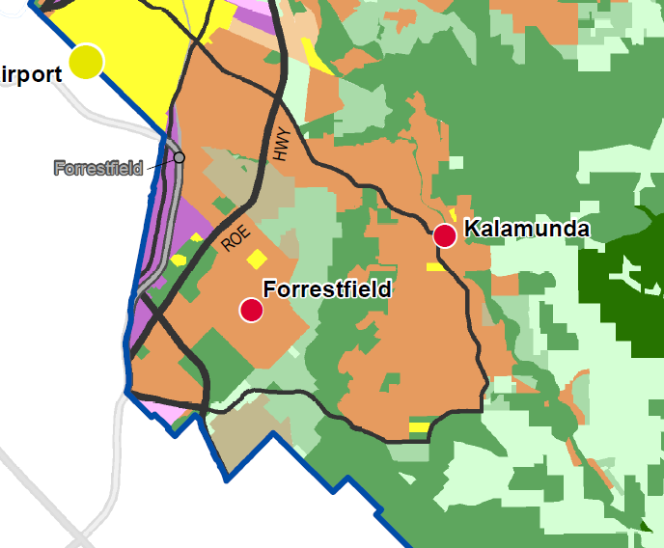
Source: http://www.planning.wa.gov.au/dop_pub_pdf/NESRSP_Plan1_ThePlanningFramework_A3.pdf
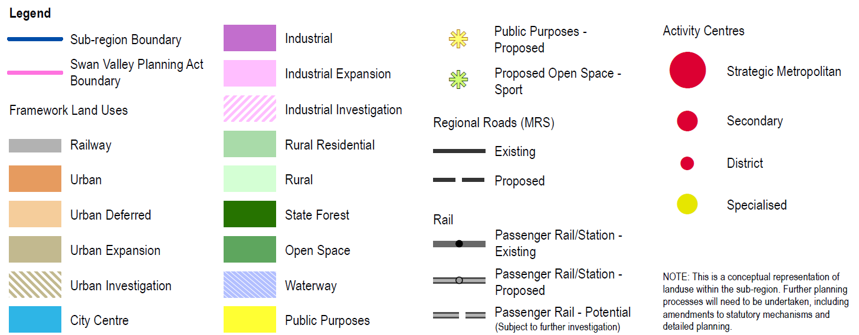

Figure 6 South Metropolitan Peel sub-regional planning framework (excerpt)

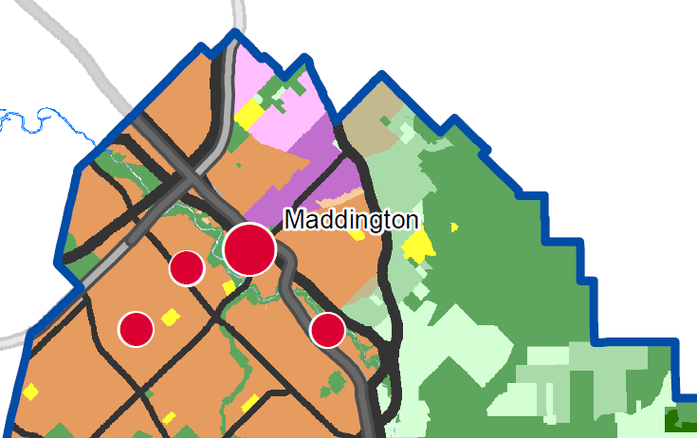
Source: http://www.planning.wa.gov.au/dop_pub_pdf/SMPSRSP_Plan1_ThePlanningFramework_A3.pdf

The Maddington Kenwick Strategic Employment Area (MKSEA) (Figure 2) will be an expansion of the existing industrial area in proximity to the Kewdale intermodal transfer facilities and freight routes linking with Fremantle, Kwinana and Perth Airport. The provision of industrial land within the MKSEA, which includes 343 ha in the City of Gosnells and 46 ha in the Shire of Kalamunda, has been an active planning matter for well over a decade. A Concept Plan has been prepared and adopted by the City of Gosnells, detailing the staging and development of this area, to provide industrial land on an ongoing basis for the next 10 to 15 years. The development of MKSEA is consistent with the State Government’s Economic and Employment Lands Strategy: non-heavy industrial (EELS), dating to April 2012.
The Board notes the significance of the MKSEA development, but ultimately it is not a relevant consideration for the Wattle Grove elector’s proposal to the Board.

6. Conclusion
The Board has conducted a full and proper inquiry into the Wattle Grove elector’s proposal to amend the boundary of the Shire of Kalamunda through the transfer of part of the locality of Wattle Grove to the City of Gosnells. The Board first satisfied itself that the proposal was a legitimate proposal in accordance with the relevant provisions of the Local Government Act. During the course of the inquiry the Board released an Issues paper and made the proponents proposal available on its webpage. The Board also conducted a public hearing, invited public submissions and met with the relevant local governments.
While the Board acknowledges that the petitioner’s proposal has some merit, the case for change is by no means compelling. Despite the proponent’s claim that the proposal reflects the desire of the majority of residents, the evidence available to the Board suggests that the majority of residents do not support the proposal.
Overall, taking into account the extent and number of submissions received which were against the proposal (184 of 205), and considering the number of people who attended both the Board’s public meeting at Woodlupine Community Centre on 23 February (approx 160) and the special meeting at the Shire of Kalamunda on 22 February (approx 100), it was apparent to the Board that there was very strong community opposition to the proposed move to the City of Gosnells
The primary reason for the proposal could be summarised as the desire of the petitioners to maintain the rural environment of the area. The Board concluded that this desire was a false hope, given that the area is clearly earmarked in State Government approved planning documents for further urban development. The Board considers these developments as highly likely to proceed, irrespective of which local government entity the area is governed by.
It appeared to the Board that those who were in favour of the proposal represented a relatively small group of Shire of Kalamunda residents who appear to be unhappy with the council in general, and more specifically with the nature of several development proposals.
If the desire of the proponents to preserve a rural lifestyle is the main motivating factor for this proposal, then it is an unlikely and optimistic goal, given that future urban development is already entrenched in planning frameworks. The Board recommends that the proposal be rejected.

7. Recommendation
RECOMMENDATION:
That in accordance with the clause 6(1)(a) of Schedule 2.1 of the Local Government Act 1995, the Minister for Local Government reject the proposal submitted by the electors of Wattle Grove to amend the City of Gosnells’ district boundary to include a portion of the suburb of Wattle Grove currently located in the Shire of Kalamunda.

WA Planning Commission (2015) Perth and Peel@3.5million: draft North-East Sub-regional Planning Framework p20.
WA Planning Commission (2015) Perth and Peel@3.5million: draft South-East Sub-regional Planning Framework p20.

